**.PRIMARY SEVEN SCIENCE TERM ONE**

**THEME: HUMAN BODY**

**TOPIC: SKELETAL AND MUSCULAR SYSTEM**

**Qn. What is a skeletal system?**

* A skeletal system is a system that supports the body of an animal.

**Qn. What is a skeleton?**

* A skeleton is the structure that supports the body of an animal.

**Qn. Mention the types of skeleton.**

* Endo skeleton
* Exo skeleton
* Hydrostatic skeleton

**Endo skeleton**

**Qn. What is an endo skeleton?**

* An endo skeleton is a type of skeleton found inside the body of an animal.

**Qn. Give examples of animals that have an endo skeleton.**

* Human beings / people
* Cows
* Dogs
* Cats
* Goats
* Lions
* Elephants
* Tiger

**Exo skeleton**

**Qn. What is an exo skeleton?**

* An exo skeleton is a type of skeleton found outside the body of an animal.

**Qn. Give examples of animals with an exo skeleton**

* Insects e.g. mosquitoes, houseflies.
* Arachnids e.g. spider, scorpion.
* Myriapods e.g. centipedes, millipedes.
* Crustaceans e.g. crab , lobster

**Qn. How do animals with an exo skeleton increase in size or grow?**

* By moulting or ecdysis

**Qn. What is moulting?**

* Moulting is the periodic loss of cuticles from arthropods.

**Hydrostatic skeleton**

**Qn. What is a hydrostatic skeleton?**

* A hydrostatic skeleton is a type of skeleton where the body of an animal is filled with fluids under pressure.

**Qn. Identify examples of animals with a hydrostatic skeleton.**

* Snails
* Slugs
* Worms
* Star fish
* Jelly fish
* Caterpillars
* Sea urchins.

**Qn. State the functions of the skeleton.**

* The skeleton gives the body shape.
* The skeleton helps in body movement.
* The skeleton protects the delicate body parts.
* The skeleton provides support to the body.
* The skeleton helps in manufacture of blood cells.
* The skeleton provides room for muscle attachment.

**Qn. Name the delicate body organs protected by the following parts of the skeleton.**

1. **skull**

* Brain
* Tongue
* Eyes
* Middle and inner ear.

1. **Back bone / spine / vertebral column**

* Spinal cord

1. **Rib cage / Ribs**

* Heart
* Lungs

1. **Pelvis / Hip girdle**

* Reproductive organs

1. **Eye Socket / Orbit**

* Eyes

**Human skeleton**

**Qn. What is a human skeleton?**

* A human skeleton is a frame work of bones in the body.

**Note:**

* An adult has 206 bones.
* A baby has 300 – 305 bones

**Qn. Why are babies said to have more bones than adults?**

* Babies are born with many cartilages which later join to form bones.

**Ossification**

**Qn. What is ossification?**

* Ossification is the process by which cartilages turn into bones.

**The structure of the human skeleton**

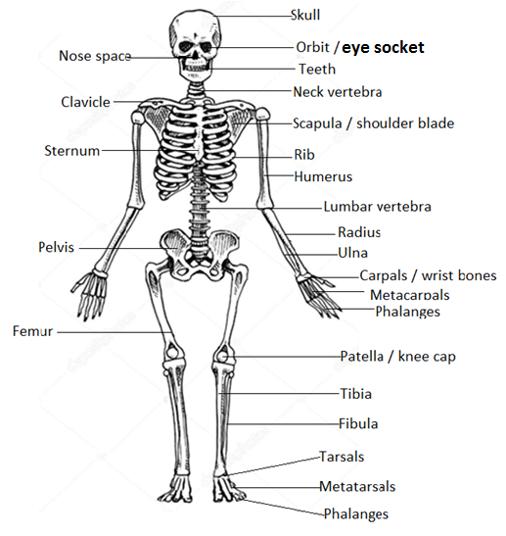

**Regions of the skeleton**

**Qn. Identify the two regions of the skeleton.**

* Axial region
* Appendicular region

**Axial Region**

**Qn. Mention the parts of the skeleton that make up the axial region.**

* Skull
* Back bone
* Ribs

**Appendicular Region**

**Qn. Name the parts that make up the appendicular region.**

* Girdles
* Limbs

**Bones**

**Qn. What is a bone?**

* A bone is the hardest tissue found in the body of an animal.

**Qn. Identify the different items / substance contained in bones.**

* Blood
* Blood cells
* Nerves

**Qn. Mention the mineral salts that make bones and teeth strong**

* Calcium
* Phosphorous

**Cartilage**

**Qn. What is a cartilage?**

* A cartilage is a connective tissue softer than a bone.

**Bone marrow**

**Qn. What is a bone marrow?**

* A bone marrow is a soft tissue found in a bone.

**Qn. Identify any parts of the body where we find a cartilage.**

* Pinna of the ear.
* At the end of the nose
* At the end of every bone.

**Qn. State the functions of cartilages in the body.**

* A cartilage reduces friction at a joint.
* A cartilage cushions bones.

**Types / classes / groups of bones**

**Qn. Mention the different types of bones**

* Long bones
* Short bones
* Flat bones
* Irregular bones

1. **Long bones**

* Long bones are the bones found mainly in the limbs.

**Qn. Give the different examples of long bones**

* Tibia
* Femur
* Fibula
* Humerus
* Radius
* Ulna

**Qn. Identify the longest and strongest bone in the body.**

* Femur

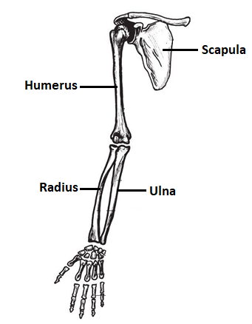**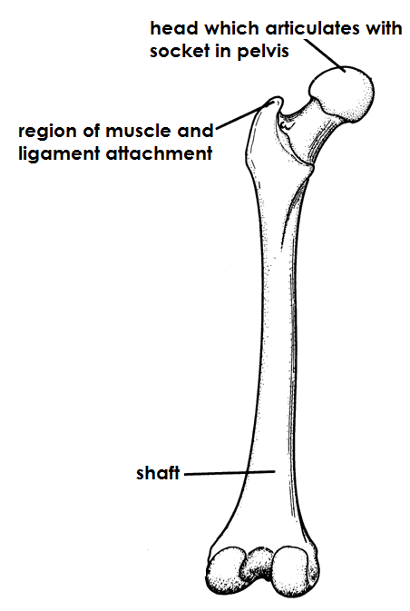Diagrams showing the long bones in the body**

1. **Short bones**

* Short bones are bones found mainly in the feet and hands.

**Qn. Give the different examples of short bones**

* Carpals
* Tarsals

**A diagram showing short bones**

1. 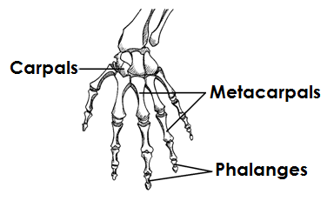**Hand**
2. 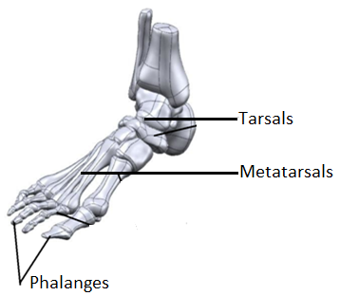**Foot**
3. **Flat bones**

**Qn. Identify the examples of flat bones in the body.**

* Bones of the skull
* Scapula / shoulder blade
* Jaw bones
* Sternum / breast bone
* Ribs

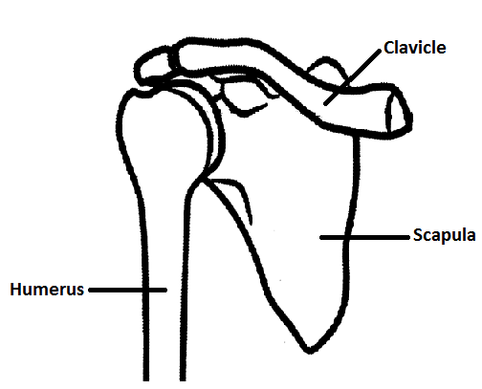**A diagram showing flat bones**

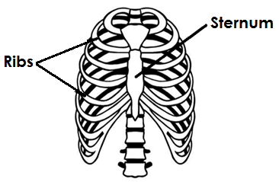

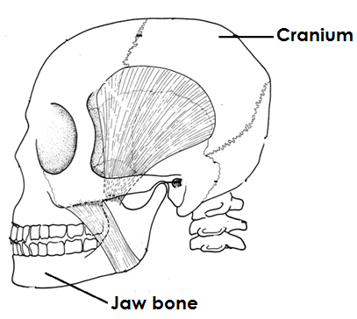

1. **Irregular bones**

**Qn. Give the examples of irregular bones in the body.**

* Vertebrae
* Pelvis

**An illustration showing irregular bones**

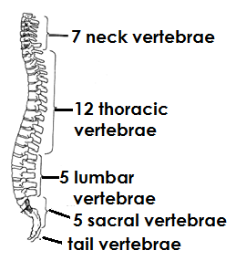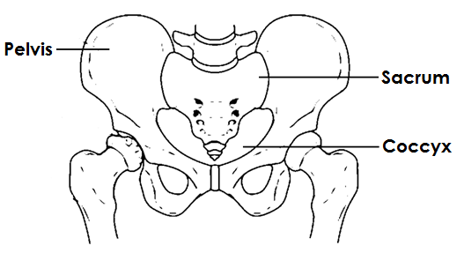

**JOINTS**

**Qn. What is a joint?**

* A joint is a place where two or more bones meet in the body.

**Types of joints**

**Qn. Name the two types of joints.**

* Movable joints
* Immovable joints

**Movable joints**

**Qn. What is a movable joint?**

* A movable joint is a joint that allows movement in the body.

**Qn. Identify the parts of a movable joint and their functions.**

1. **Ligament**

* A ligament is tough elastic fibre that joins a bone to a bone.

1. **Tendon**

* A tendon is tough elastic fibre that joins a bone to a muscle/tendon.

1. **Cartilage**

* A cartilage cushions bones in a joint.
* A cartilage reduces friction at a joint.

1. **Synovial membrane**

* Synovial membrane produces synovial fluid.

1. **Synovial fluid**

* Synovial fluid reduces friction at a joint.

**Qn. Identify the types / examples of movable joints.**

* Ball and socket joint.
* Hinge joint
* Pivot joint
* Gliding joint / plane joint.

**1. Ball and socket joint**

**Qn. What is a ball and socket joint?**

* A ball and socket joint is a joint that allows movement in all directions.

**Qn. Give the examples of the ball and socket joints in the body.**

* Shoulder joint
* Hip joint

**An illustration showing the ball and socket joint at the shoulder**

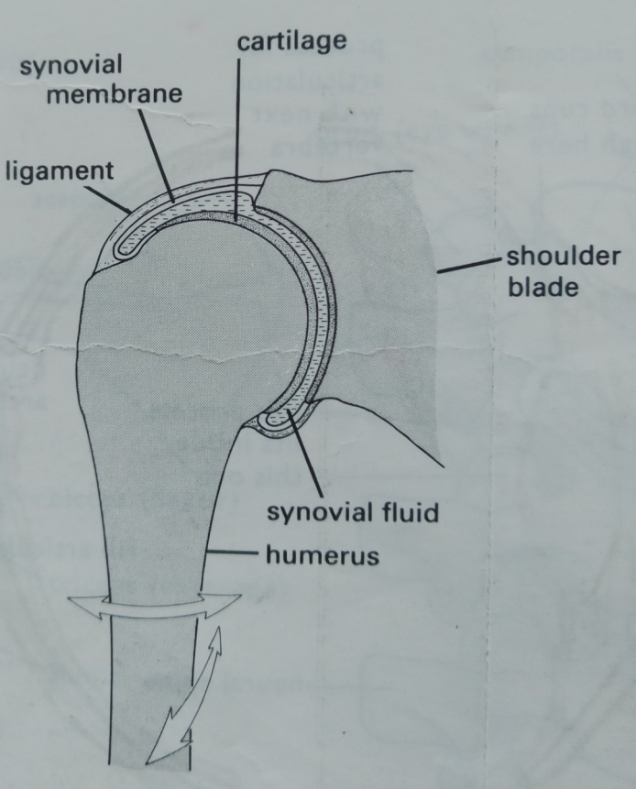

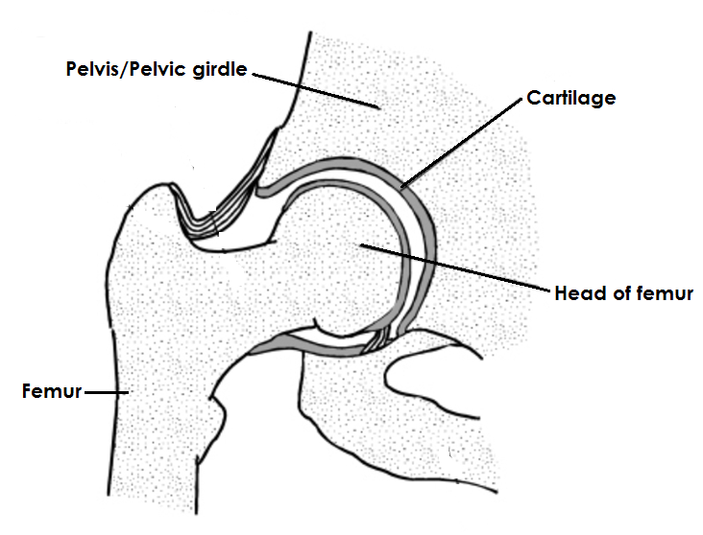**An illustration showing the ball and socket joint at the hip**

**2. Hinge joint**

**Qn. What is a hinge joint?**

* A hinge joint is a joint that allows movement in only one direction.

**Qn. Identify the different examples of hinge joints in the body.**

* Knee joint
* Elbow joint
* Knuckle joints

**A diagram showing a hinge joint at the knee.**

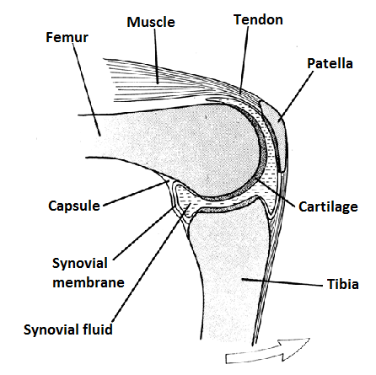

.

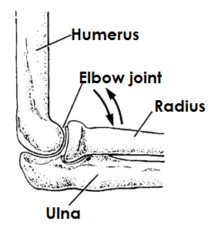**A diagram showing a hinge joint at the elbow**

**3. Pivot joint**

**Qn. What is a pivot joint?**

* A pivot joint is a joint that allows rotation of certain parts of the body on other parts.

**Qn. Identify examples of pivot joint in the body.**

* Neck vertebrae

**A diagram showing the pivot joints at the neck**

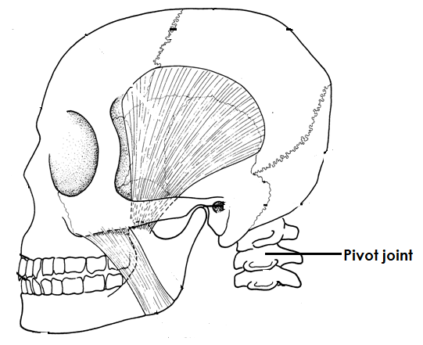

**4. Gliding joint / Plane joints**

**Qn. What are gliding joints?**

* Gliding joints are joints which allow bones to slide over each other.

**Qn. Identify the examples of gliding joint in the body.**

* Wrist joint
* Ankle joint

**A diagram showing gliding joints**

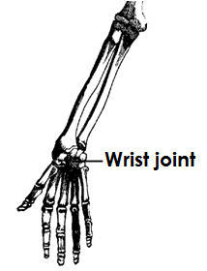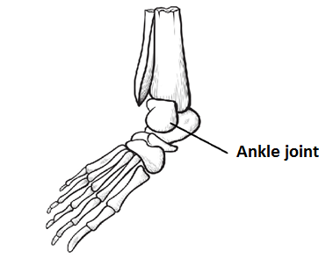

**Immovable joints / fixed joints**

**Qn. What are immovable joints?**

* Immovable joints are joints which do not allow movement in the body.

**Note:**

* Immovable joints do not allow movement because the bones are fixed together.

**Qn. Identify the examples of immovable joints in the body.**

* Suture joints.

**A diagram showing the suture joints**

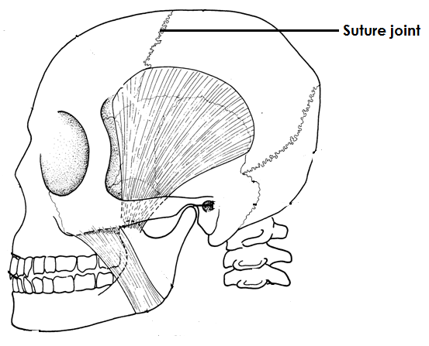

**Qn. State the functions of joints in the body.**

* Joints allow directional movement in the body.
* Joints allow non-directional movement in the body.

**Muscular system**

**Qn. What is a muscular system?**

* A muscular system is a system of the body consisting of muscle cells having contractile elements.

**Muscles**

**Qn. What are muscles?**

* Muscles are bundles of elastic substances found in the body of an animal.

**Types of muscles**

**Qn. Name the two types of muscles.**

* Voluntary muscles / skeletal muscles.
* Involuntary muscles / smooth muscles.

1. **Voluntary muscles**

**Qn. What are voluntary muscles?**

* Voluntary muscles are muscles whose movement can be controlled.

**Or**

* Voluntary muscles are muscles whose movement is under one’s will.

**Qn. State the characteristics of voluntary muscles.**

* Voluntary muscles are fibrous.
* Voluntary muscles get tired quickly.
* Movement of voluntary muscles is under one’s will.

**Qn. Identify the examples of voluntary muscles.**

* Biceps muscles (flexor muscles)
* Triceps muscles (Extensor muscles)
* Thigh muscles
* Quadriceps

**Note:**

* The biceps and triceps muscles are regarded as **antagonistic muscles.**

**Qn.What are antagonistic muscles?**

* Antagonistic muscles are muscles that work in pairs and have opposite effect on each other.

**Qn. Why are the triceps and biceps regarded as antagonistic muscles?**

* Biceps and triceps muscles work in pairs and have opposite effect on each other.

**A diagram showing the biceps and triceps muscles**

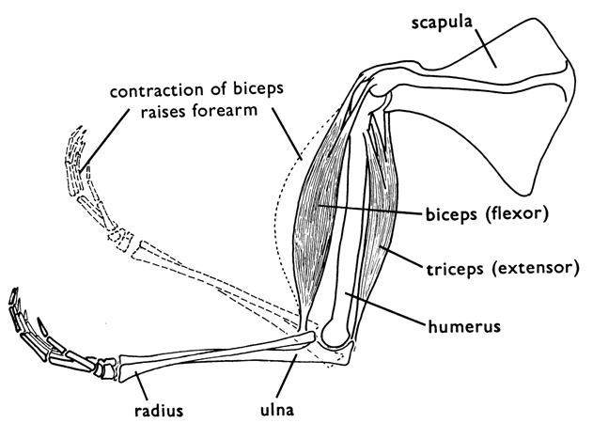

**Qn. State what happens to the following muscles when the arm is straight.**

1. **Biceps**

* The biceps relax.

1. **Triceps**

* The triceps contacts.

**Qn. State what happens to the following muscles when the arm is bent.**

**a) The biceps**

* The biceps contract.

**b) Triceps**

* The triceps relaxes.

**Note:**

* Biceps muscles are called flexor muscles because they bend the arm / leg.
* Triceps are called extensor muscles because they extend /stretch the arm / leg.

**b) Involuntary muscles.**

**Qn. What are involuntary muscles?**

* Involuntary muscles are muscles whose movement is not under our will.

Or

* Involuntary muscles are muscles whose movement cannot be controlled.

**Qn. State any characteristics of involuntary muscles.**

* Involuntary muscles work continuously.
* Involuntary muscles do not get tired quickly.
* Movement of involuntary muscles cannot be controlled.

**Qn. Give the examples of involuntary muscles in the body.**

* Muscles of the heart (cardiac muscles)
* Muscles of the diaphragm.
* Muscles of the stomach.
* Muscles of the intestines.
* Muscles of the eyelids
* Muscles of the excretory system
* Muscles of the reproductive system.

**Qn. Identify the ways how contraction of muscles is important in the body.**

* Contraction of muscles leads to the pumping of blood by the heart.
* Contraction of muscles leads to the exchange of gases in the body.
* Contraction of muscle causes movement of food in the alimentary canal.

**Qn. State the functions of muscles in the body.**

* Muscles join bones in the body.
* Muscles help in body movement.
* Muscles enable people to perform heavy activities.
* Muscles protect the organs they surround.

**Posture**

**Qn. What is posture?**

* Posture is the position of the body in every thing we do.

**Qn. In four statements, describe a good sitting posture.**

* Sit upright.
* Do not tighten the ankle / knees.
* Place both feet on the floor
* Sit on both buttocks.

**Qn. State the advantages of good posture.**

* Good posture promotes the proper growth of bones.
* Good posture promotes proper working of body organs.
* Good posture strengthens the muscles of the stomach , intestines and diaphragm.

**Qn. Identify the dangers of bad posture**

* Bad posture leads to growth of deformed bones.
* Bad posture leads to indigestion.
* Bad posture leads to backaches.

**Diseases of the skeletal system**

**Qn. Mention the different diseases that affect the skeletal system.**

* Polio
* Rickets
* Bone cancer
* Leprosy
* Osteomylitis
* Achondroplasia

a) Polio

**qn. Name the germ that causes polio.**

* Virus

**Qn. State the different ways how polio spreads**

* Through drinking contaminated water.
* Through eating contaminated food.

**Qn. Give the signs / symptoms of polio**

* Fever
* Paralysis

**Qn. Identify the different ways of preventing the spread of polio.**

* Immunizing children using polio vaccine.
* Always drink boiled water.
* Wash hands with clean water before eating food.
* Proper disposal of faeces

1. **Tuberculosis**

* Tuberculosis is caused by a bacterium called **mycobacterium.**

**Qn. How is tuberculosis spread?**

* By droplet infection through air.
* By drinking unboiled milk from a cow having tuberculosis.

**Qn. State the signs of tuberculosis.**

* Persistent cough
* A lump grows on the spine.
* Failure to walk.

**Qn. State the symptoms of tuberculosis.**

* Long lasting backache.
* Paralysis in the bones.
* Pain in the backbone.

**Qn. Identify the different ways of controlling and preventing tuberculosis.**

* Immunizing children at birth using BCG vaccine on the right upper arm.
* Isolating infected people.
* Treating infected people.

1. **Rickets**

* Rickets is a deficiency disease causes by lack of vitamin D in the diet.

**Qn. State the different signs of rickets.**

* Oxbow legs
* Knock knee legs

**Qn. Give the best way of preventing rickets.**

* Eating foods rich in vitamin D.

**Disorders of the skeletal system**

**Qn. Mention the examples of disorders to the skeletal system.**

* Dislocation
* Fracture
* Skull deformity
* Osteoporosis (weak bones)

1. **Dislocation**

**Qn. What is dislocation?**

* Dislocation is the displacement of bones at a joint.

**Qn. State the signs and symptoms of dislocation.**

* Swelling of the affected part.
* Pain around the injured part.
* Difficulty in moving the injured part / limb.

**Qn. State the first aid given to a dislocation.**

* Apply RICE (Raise the injured part, ice the injured part, compress the injured part and Elevate the injured part.)

1. **Fractures.**

**Qn. What is a fracture?**

* A fracture is a cracked or broken bone in the body.

**Qn. Identify the different types of fractures.**

* Simple fracture (closed fracture)
* Compound fracture (open fracture
* Green stick fracture
* Comminuted fracture

**Qn. Give the signs and symptoms of a fracture.**

* Swelling of the injured part.
* Bleeding of the injured part.
* Pain around the injured part.
* The broken bone tears the flesh incase of a compound fracture.

**Qn. State the first aid given for a fracture.**

* Tie splints around the injured part.
* Provide crutches for the victim to move.
* Use a stretcher to carry the victim to hospital.

**A diagram showing crutches**

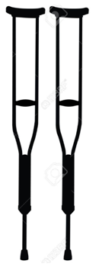

**A diagram showing a stretcher**

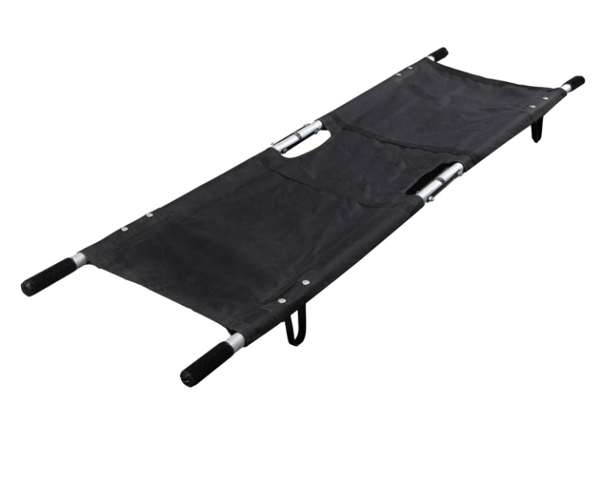

**Diseases of the muscular system**

**Qn. Mention the different diseases of the muscular system.**

* Polio
* Tetanus

**Tetanus**

* Tetanus is caused by bacterium called **clostridium tetani**

**Qn. State the signs and symptoms of tetanus.**

* Stiff muscles all over the body.
* Spasm when touched.
* The baby stops suckling the mother’s breasts.

**Qn. Identify one way how tetanus germs enter the body.**

* Through open cuts and wounds on the body.

**Qn. Give the different ways of preventing /controlling tetanus.**

* Immunize children using DPT vaccine at 6, 10 and 14 weeks on the left upper thigh.
* Always cover open wounds using sterilized bandages.

**Qn. Mention the disorders of the muscular system.**

* Sprain
* Strain
* Muscle cramps
* Cuts
* Wounds

**Sprains**

**Qn. What is a sprain?**

* A sprain is a torn or stretched ligament.

**Strains**

**Qn. What is a strain?**

* A strain isa torn or overstretched muscle.

**Qn. State the signs and symptoms of sprains and strains.**

* Pain around the injured part.
* Swelling around the injured part.
* Difficulty when moving the injured part.

**Qn. What first aid is given for a sprain or strain?**

* Apply an ice pack or a cold compress around the injured part.

**Qn. Identify the different ways of maintaining the proper functioning of the skeletal muscular system.**

* Have regular physical exercises.
* Feed on a balanced diet.
* Immunize children against killer diseases.
* Maintaining proper body posture.
* Having enough rest and sleep.

**Qn. State the advantages / importance of having regular physical exercises.**

* Physical exercises promote the proper functioning of the body organs.
* Physical exercises make the heart muscles to grow stronger.
* Physical exercises enable the joint to become flexible.
* Physical exercises reduce the amount of fats in the body.
* Physical exercises reduce risks of heart diseases.
* Physical exercises enable digestion of food to be carried out smoothly.
* Physical exercises make ligaments and tendons strong.

**THEME: MATTER AND ENERGY**

**TOPIC 2: ELECTRICITY AND MAGNETISM**

**Qn. What is a magnet?**

* A magnet is a substance which has the ability to attract other magnetic substances.

**Magnetism**

**Qn. What is magnetism?**

* Magnetism is the force of attraction contained in a magnet.

**Magnetic and non-magnetic substances**

**Qn. What are magnetic substances?**

* Magnetic substances are substances that can be attracted by a magnet.

**Qn. Give four examples of magnetic materials**

* Steel
* Iron
* Nickel
* Cobalt

**Qn. What are non-magnetic substances?**

* Non-magnetic substances are substances that cannot be attracted by a magnet.

**Qn. Mention the examples of non-magnetic substances.**

* Rubber Copper
* Glass Zinc
* Wood
* Plastic
* Clothes
* Aluminium

**Types of magnets**

**Qn. Mention the two types of magnets.**

1. Natural magnet
2. Artificial magnets
3. **Natural magnets**

**Qn. What are natural magnets?**

* Natural magnets are magnets that exist on their own.

**Qn. Identify two examples of natural magnets.**

* The earth
* Lode stone (magnetite)

**Qn. Give a reason why the earth is called a magnet.**

* The earth has the North and South Pole.

**b) Artificial magnets.**

**Qn. What are artificial magnets?**

* Artificial magnets are magnets made by people.

**Qn. Identify the two groups of artificial magnets.**

* Artificial temporary magnets.
* Artificial permanent magnets.

**Artificial temporary magnets.**

**Qn. What are artificial temporary magnets?**

* Artificial temporary magnets are magnets that keep their magnetism for a short time.

**Qn. Give the examples of artificial temporary magnets.**

* Electro magnet.

**A diagram of an electro magnet.**

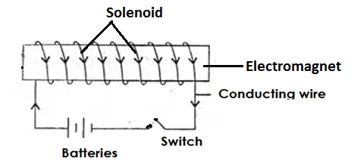

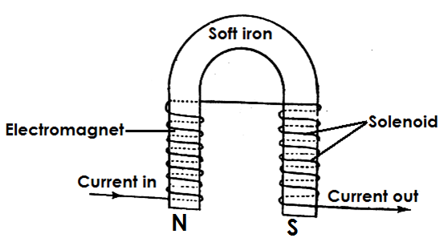

**Artificial permanent magnets**

**Qn. What are artificial permanent magnets?**

* Artificial permanent magnets are magnets that keep their magnetism for a long time.

**Qn. Give the examples of permanent magnets.**

* Bar magnet
* Horse shoe magnet.
* Cylindrical magnet
* Needle magnet

**Illustrations**

**a) Bar magnet**

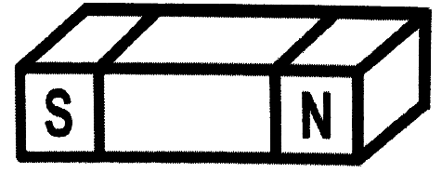

1. 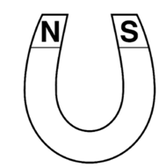**Horse shoe magnet**
2. **Cylindrical magnet**

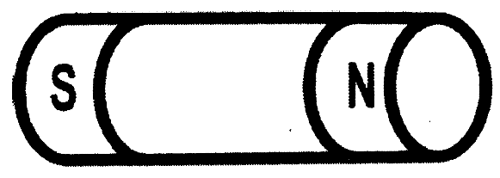

1. 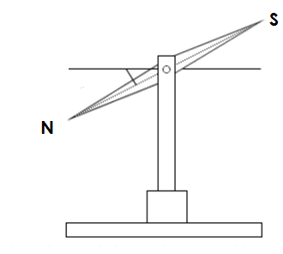**Needle magnets**

**Properties of magnets**

**Qn. Identify the different properties of magnets.**

1. A freely suspended bar magnet will always rest with its poles facing in the north-south direction.

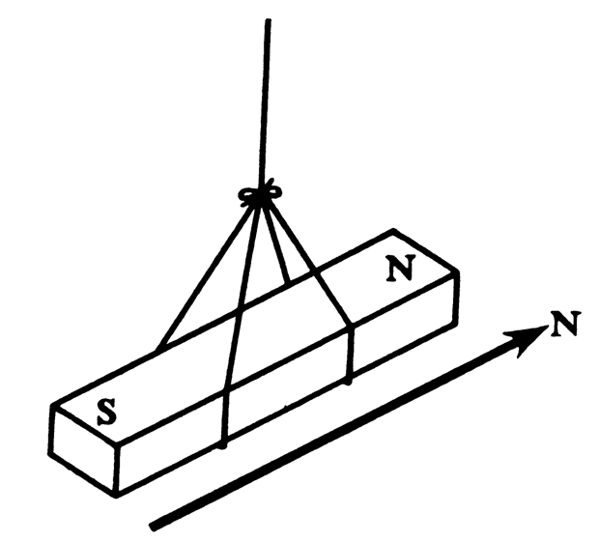**An illustration**

**Note:**

* It points to the north – south direction because it is influenced by the magnetic forces of the earth.

b) Magnetic lines of force in a magnetic field run from North pole to South pole.

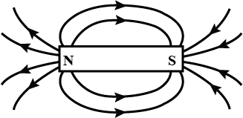**An illustration**

**Qn. What is a magnetic field?**

* A magnetic field is an area around a magnet where forces of magnetism act.

c) Unlike poles of a magnet attract each other.

**Illustrations**

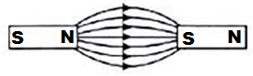

d) Like poles of a magnet repel each other.

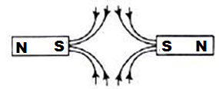**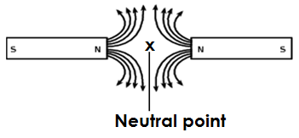Illustrations**

**Qn. What is a neutral Point?**

* A neutral point is a point where magnetic force due to two magnets is zero.

e) Magnetism is strongest at the poles.

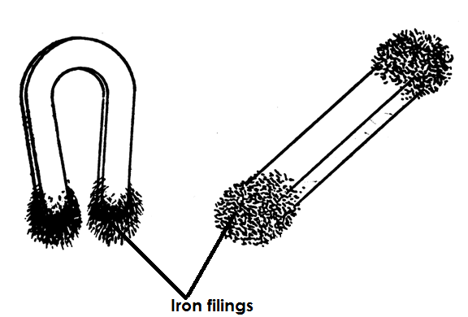**Illustration**

1. Magnetism can pass through non-magnetic materials.

**Illustration**

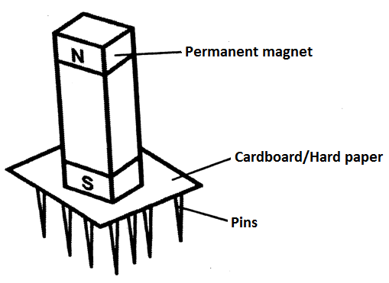

f) When a bar magnet is broken, each piece becomes an independent magnet.

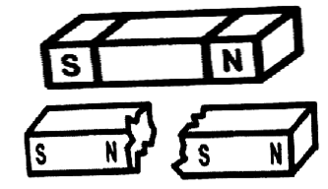**Illustration**

h) Magnets become weaker with age.

**Note:**

* This can be prevented by keeping magnets in iron keepers.

**Qn. State why magnets are kept in iron keepers.**

* To prevent magnets from losing their magnetism.

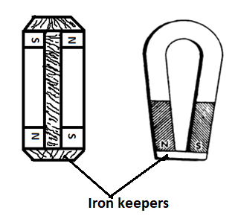**An illustration showing magnets in iron keepers**

**Qn. How do iron keepers prevent magnets from losing their magnetism?**

* Iron keepers absorb magnetism.

**Qn. State the law of magnetism.**

* Like poles of a magnet repel while unlike poles of a magnet attract each other.

**Qn. State the laws of a magnetic field.**

* Magnetic lines of force run from the North Pole to the South Pole.
* Magnetic lines of force do not intersect within each other.
* There is no line of force within the magnet itself.

**Qn. State the differences between iron and steel as magnetic materials.**

* Iron gains magnetism easily while steel takes long to gain magnetism.
* Iron loses magnetism easily while steel takes long to lose magnetism.
* Iron is used to make temporary magnets while steel is used to make permanent magnets.

**Magnetisation**

**Qn. What is magnetisation?**

* Magnetisation is the way of making a magnet.

**Qn. State the methods of making magnets.**

* Stroking or touch method
* Induction method
* Electrical method

1. **Stroking method**

**Qn. What is stroking method?**

* Stroking method is a method of making a magnet where a permanent magnet is used to stroke a magnetic material.

**Qn. State the two groups of stroking method.**

* Single touch method.
* Double touch method.

1. **Single touch method**

**Qn. What is single touch method?**

* Single touch method is a method of making a magnet where one permanent magnet is used to stroke a magnetic substance.

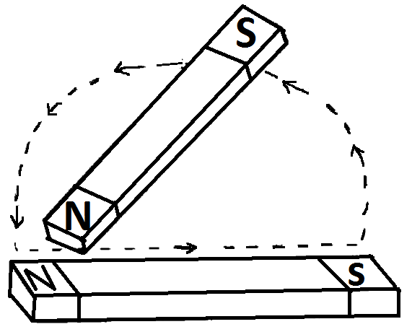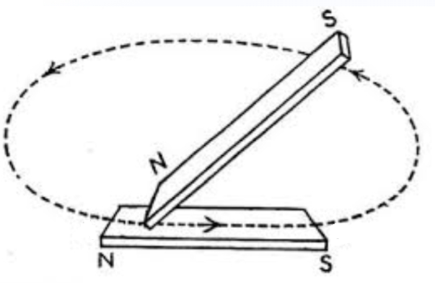**An illustration showing the single touch method**

1. **Double touch method.**

**Qn. What is double touch method?**

* Double touch method is a method of making a magnet where two permanent magnets are used to stroke a magnetic substance.

**An illustration showing double touch method**

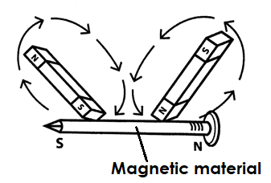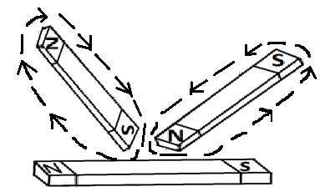

**2. Induction method.**

**Qn. What is induction method?**

* Induction method is a method of making a magnet where a magnetic substance is attached on a permanent magnet and left to stay for some time.

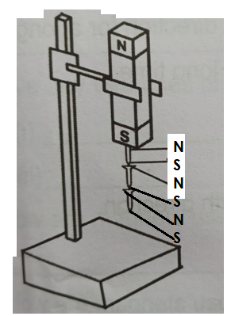**A diagram showing the induction method**

**Qn. Name the magnet made by the induction method.**

* Induced magnet.

**3. Electrical method.**

**Qn. What is electrical method?**

* Electrical method is a method of making a magnet using electricity.

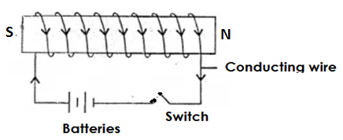**An illustration showing the electrical method.**

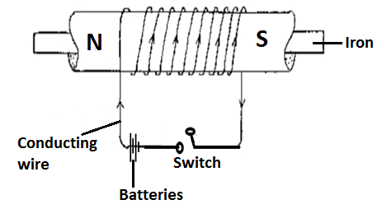

**Qn. Name the magnet made by using the electrical method.**

* Electro magnet

**Qn. State the factors that determine the strength of an electro magnet.**

* The amount of current used.
* The number of turns in a coil.
* The magnetic substance used.

**Qn. Give any two ways of increasing the strength of an electro magnet.**

* By increasing the voltage.
* By increasing the number of turns in a coil.

**Qn. State the use of electro magnets.**

* Electro magnets are used in electric bells.
* Electro magnets are used in cranes to lift metal scrap.

**Demagnetisation**

**Qn. What is demagnetisation?**

* Demagnetisation is a way of making a magnet lose its magnetism.

**Qn. Write down the different ways of demagnetising a magnet.**

* By hammering a magnet.
* By heating a magnet.
* By leaving a magnet to rust.
* By keeping a magnet with like poles near each other for a long time.
* By keeping a magnet while facing in the East to West direction.
* By passing alternating currents through a magnet.
* By boiling a magnet in water.

**Qn. State the ways of keeping a magnet safe.**

* Keeping magnets in iron keepers.
* Painting magnets
* Storing magnets with their poles facing in the North – South direction.

**Qn. Give the uses of magnets**

* Magnets are used in radios.
* Magnets are used in microphones.
* Magnets are used in loudspeakers.
* Magnets are used in generators to produce electricity.
* Magnets are used in dynamos to produce electricity.
* Magnets are used by doctors to remove magnetic substances from delicate body organs.
* Magnets are used by watch repairers to hold tiny nails.
* Magnets are used in doors of refrigerators.
* Magnets are used in cranes to list scrap.
* Magnets are used to hold cutlery on walls.
* Magnets are used in electric bells.

**An Electric Bell**

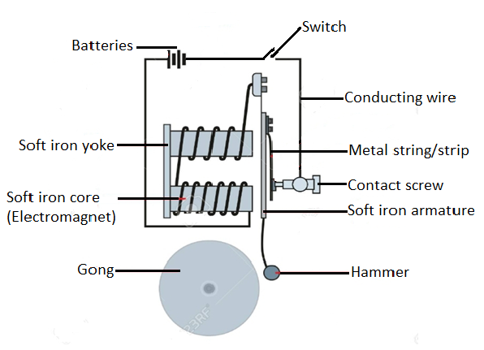

**Qn. How does an electric bell work?**

* When the switch is pressed, current starts flowing and the soft iron core gains magnetism.
* When the soft iron core gains magnetism, it attracts the soft iron armature.
* The hammer attached to the soft iron armature hits the gong and sound is produced.
* The metal strip is pulled away from the contact screw and the electro magnet becomes demagnetised.

**Qn. Name the appliances that use both magnets and electricity.**

* Radios
* Electric bells
* Loud speakers
* Electric motors
* Refrigerators
* Television sets.

**Qn. Give examples of appliances that use magnets only**

* Magnetic compasses.
* Magnetic tapes

**ELECTRICITY**

**Qn. What is electricity?**

* Electricity is the form of energy that involves electric charges.

**Qn. What is a molecule?**

* A molecule is the smallest part of a substance that can take part in a chemical reaction.

**Note:**

* Molecules are made up of **atoms**.

**Qn. What is an atom?**

* An atom is the smallest indivisible particle of matter.

**Qn. Name the particles of an atom.**

* Protons
* Electrons
* Neutrons

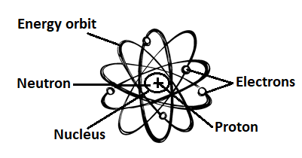**The structure of an atom**

**Qn. What are protons?**

* Protons are positively charged particles found in a nucleus of an atom.

**Qn. What are neutrons?**

* Neutrons are uncharged particles found in the nucleus of an atom.

**Qn. What are electrons?**

* Electrons are negatively charged particles orbiting around an atom.

**Types of electricity**

**Qn. Mention the two types of electricity.**

* Current Electricity
* Static electricity

**Current electricity**

**Qn. What is current electricity?**

* Current electricity is the type of electricity formed when electrons flow from one source to another through a conductor.

**Qn. Mention the two groups of current electricity.**

* Direct current Electricity. (D.C)
* Alternating current electricity (A.C)

**Qn. What is Direct Current Electricity?**

* Direct current electricity is a type of electricity that flows in one direction.

**Qn. Name the sources of direct current electricity.**

* Dry cells
* Simple cells / wet cells
* Car batteries.

**Note:**

* Direct current electricity cannot be **stepped up** or **stepped down.**

**Alternating Current Electricity**

**Qn. What is alternating current electricity?**

* Alternating current electricity is the type of current electricity that flows in both directions i.e. forward and backwards.

**Note:**

* Alternating current electricity can be**stepped up** or **stepped down**.

**Qn. Name the sources of alternating current electricity.**

* Fast running water.
* Hot springs
* Fossil fuels
* The sun
* Uranium

**Qn. Give the examples of current electricity.**

* Hydro electricity.
* Geothermal electricity
* Thermal electricity
* Solar electricity
* Atomic orNuclear electricity
* Chemical electricity.

1. **Hydro Electricity**

**Qn. What is hydro electricity?**

* Hydro electricity is electricity produced by fast running water.

**Qn. Name the common dams where hydro electricity is generated.**

* Nalubaale dam (Owen falls dam)
* Bujjagali dam

**Qn. Mention the type of energy possessed by water in the reservoir.**

* Potential energy.

**Qn. Mention the type of energy possessed by falling water that turns turbines at a water fall.**

* Kinetic energy.

**Qn. What are turbines?**

* Turbines are big wheel like structures which rotate when hit by water.

**Note**

* Turbines are connected to generators which turn mechanical energy into electric energy.

**Qn. How does electricity generated from power stations reach other places?**

* Through conducting wires
* Through transmission wires/lines.

1. **Geothermal Electricity**

**Qn. What is geothermal electricity?**

* Geothermal electricity is the type of electricity got from hot springs.

1. **Thermal Electricity**

**Qn. What is thermal electricity?**

* Thermal electricity is the type of electricity got by burning fossil fuels.

**Qn. Give examples of fossil fuels that can be burnt to produce electricity**

* Coal
* Petrol
* Diesel

1. **Solar Electricity**

**Qn. What is solar electricity?**

* Solar electricity is the type of electricity got from the sun.

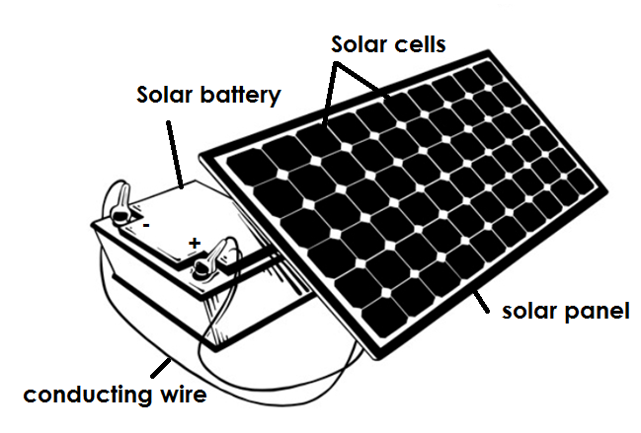**A diagram showing the different parts of a solar panel**

**Qn. State the function of the following parts of a solar panel.**

**i) Solar panel**

* The solar panel traps sunlight.

**ii) Solar cells**

* Solar cells charge sunlight energy into solar electricity.

1. **Solar batteries**

* Solar batteries store solar electricity.

**Qn. Why is the solar panel painted black?**

* To absorb sunlight.

**Qn. Why is the solar panel put on the top of a building?**

* To trap sunlight.

1. **Atomic orNuclear Electricity**

**Qn. What is nuclear electricity?**

* Nuclear electricity is the type of electricity got by burning uranium.

1. **Chemical Electricity**

**Qn. What is chemical Electricity?**

* Chemical electricity is the type of electricity produced by batteries (dry cells and wet cells)

**Qn. State the different ways in which mechanical energy is produced.**

* By wind turning wind mills.
* By using machines to turn dynamos.

**A table showing the examples of alternating current electricity and the sources**

|  |  |
| --- | --- |
| **Type of electricity** | **Source of energy** |
| * Hydro electricity | * Fast running water |
| * Thermal electricity | * Fossil fuels |
| * Geothermal electricity | * Hot springs * Geothermal heat. |
| * Mechanical electricity | * Wind * Machines |
| * Atomic electricity | * Uranium |
|  | * Nuclear power |
| * Chemical electricity (chemo electricity | * Batteries (wet cells and dry cells * Chemicals |

**Electric current**

**Qn. What is electric current?**

* Electric current is the flow of electrons.

**Qn. Name the instrument used to measure electric current.**

* Ammeter

**Qn. In which units is electric current measured?**

* Amperes / amps

**A diagram showing the flow of current**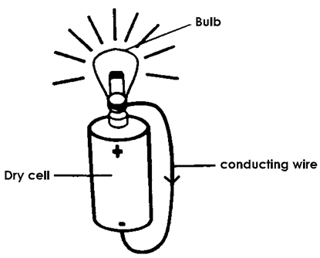

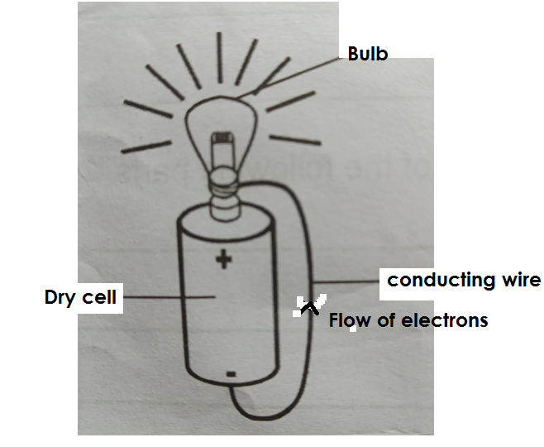**A diagram showing the flow of electrons**

**Electric circuit**

**Qn. What is an electric circuit?**

* An electric circuit is the path followed by electricity.

OR

* An electric current is a path taken by electricity.

|  |  |
| --- | --- |
| **Components of an electric circuit and their symbols** | **Symbols** |
| Dry cell |  |
| Switch |  |
| Bulb (load) |  |
| A fuse |  |
| Ammeter | C:\Users\Lab8\Desktop\P.7 SCIENCE PICS\MEMPHIS\Img-1594367882684.pngC:\Users\Lab8\Desktop\P.7 SCIENCE PICS\MEMPHIS\Img-1594367957180.png |
| Voltmeter |  |
| Conductors connected |  |
| Conductor crossing | C:\Users\Lab8\Desktop\P.7 SCIENCE PICS\MEMPHIS\Img-1594367812073.png |

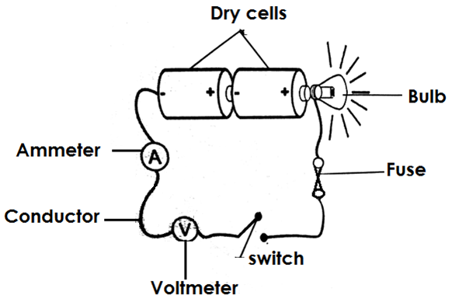**A diagram showing an electric circuit**

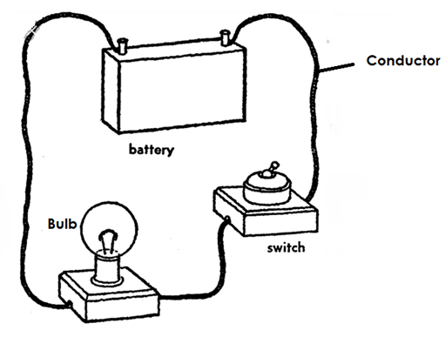

**Qn. State the function of each of the parts of an electric circuit.**

1. **Switch**

* The switch breaks and completes the circuit at the user’s will.

1. **Ammeter**

* The ammeter measures electric current.

1. **Conductor**

* The conductor transmits electricity through the circuit.

1. **Dry cells**

* The dry cells produce electricity for the appliance.

**Qn. Name the form of energy stored in a dry cell.**

* Chemical energy

**Qn. What energy charge takes place when the circuit is complete?**

* Chemical energy changes to electric energy.

1. **Bulb**

* The bulb gives light.

**Qn. Identify the form of energy stored in an electric bulb,**

* Electric energy.

**Qn. State the energy change that takes place in an electric bulb when the circuit is complete.**

* Electric energy changes to light energy.

**Qn. Identify the two forms of energy produced by an electric bulb when the circuit is complete.**

* Heat energy
* Light energy

**Qn. State two cases that can make a bulb fail to give out light in a circuit when the switch is pressed.**

* Poor arrangement of dry cells.
* When the conductor is not connected properly.
* When the bulb is not fixed properly.

**Qn. Identify the instances / factors that can make a bulb to stop giving light even when the circuit is complete.**

* When the dry cells are used up.
* When the filament burns out.
* When the fuse blows.

1. **Fuse**

* A fuse breaks the circuit incase of too much flow of current.

**Qn. How does the fuse work?**

* By melting and breaking the circuit incase of too much flow of current.

**Qn. How is a fuse adapted to its function?**

* A fuse has a low melting point.

**Qn. Give the factors that can make a fuse wire to blow.**

* When the fuse is too old.
* When there is a short circuit.
* Over loading of the circuit

**Note:**

* A fuse is made up of an alloy of tin and lead which has a low melting point.

**Electric resistance**

**Qn. What is electric resistance?**

* Electric resistance is the opposition to the flow of current in a circuit.

**Qn. Which instrument is used to measure electric resistance?**

* Ohmmeter

**Qn. In which units is electric resistance measured?**

* Ohms

**Electric pressure or electromotive force (e.m.f)**

* Electric pressure is the force that drives current through the resistance of the circuit.

**Qn. Name the instrument that measures electric pressure.**

* Voltmeter

**Qn. In which units is electric pressure measured?**

* Volts

**Qn. Why are most electric heaters coiled?**

* To increase the electric resistance.

**Qn. Write e.m.f in full.**

* Electromotive force.

**Conductors and insulators**

**Qn. What are conductors?**

* Conductors are materials that allow electricity to pass through them.

**Qn. Give the different examples of conductors of electricity.**

* Silver
* Aluminium
* Tin
* Lead
* Tungsten
* Copper
* Iron
* Wet wood.
* Salt solution
* Acids e.g. hydrochloric acid
* Undistilled water / water containing mineral salts.
* Carbon rod.

**Qn. Name the non-metallic conductor of electricity.**

* Carbon rod

**Qn. Give a reason why distilled water does not conduct electricity.**

* Distilled water lacks mineral salts

**Note:**

* Silver is the best conductor of electricity.

**Qn. Why are most overhead conductors of electricity made of copper and not silver?**

* Copper is cheaper than silver.
* Copper is readily available while silver is rare.
* Copper is light while silver is heavy.

**Qn. State the uses of conductors**

* Conductors are used to make electric circuits.
* Conductors are used to make electric wires.

**Qn. What are insulators?**

* Insulators are substances that do not allow electricity to pass through them.

**Qn. Give examples of insulators.**

* Rubber
* Plastics
* Clothes
* Dry wood
* Dry paper
* Porcelain
* Distilled water

**Qn. Give reasons why electric wires are covered with rubber during electrical installation.**

* To prevent short circuits

**Qn. State the uses of insulators**

* Insulators are used to cover electric wires during electrical installation.
* Insulators are used to cover handles of electric irons / flat irons.

**Short circuit**

**Qn. What is a short circuit?**

* A short circuit is an electric path with low resistance to the flow of current
* 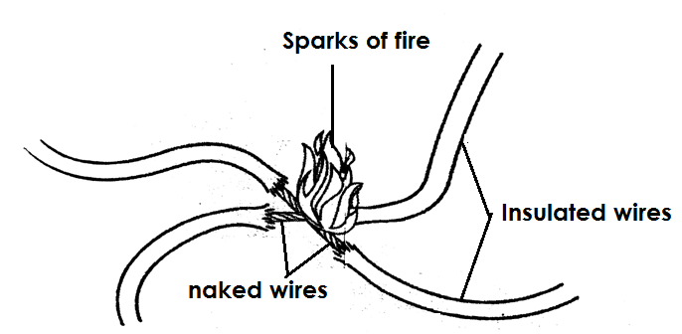**An illustration of a short circuit**

**Qn. State the main cause of a short circuit.**

* A short circuit is mainly caused when two naked wires carrying current meet.

**Qn. Give the other causes of short circuit.**

* Improper connection of electric wire.
* Overloading of circuit.
* Pushing metallic objects into electric circuits.
* Pouring water in electric appliances.
* Damage done by rat to the insulating wires.
* Bad weather conditions that may lead to damage of electric poles.

**Qn. State the dangers of short circuits.**

* Short circuits lead to destruction of electric appliances.
* Short circuits lead to destruction of buildings.
* Short circuits lead to death of people and animals.

**Qn. Identity the ways of preventing short circuit.**

* Electric wires should be well insulated.
* Installation of electricity should be done by experts.
* Repair of electric appliances should be done by experts.
* Old electric wires should be replaced by new ones.
* Avoid overloading of circuits.
* Avoid pushing metallic objects into sockets.

**Electric cells**

**Qn. What is an electric cell?**

* An electric cell is a device that stores and produces electricity due to a chemical reaction.

**Qn. Identify the two types of electric cells**

* Primary cells
* Secondary cells

1. **Primary cells**

**Qn. What are primary cells?**

* Primary cells are cells that cannot be recharged when used up.

**Qn. Give the examples of primary cells**

* Dry cells
* Wet cells / simple cells

**Dry cell**

**Qn. How does a dry cell produce electricity?**

* A dry cell produces electricity by changing chemical energy to electric energy.

**Note:**

* A dry cell produces an electromotive force of 1.5 volts.

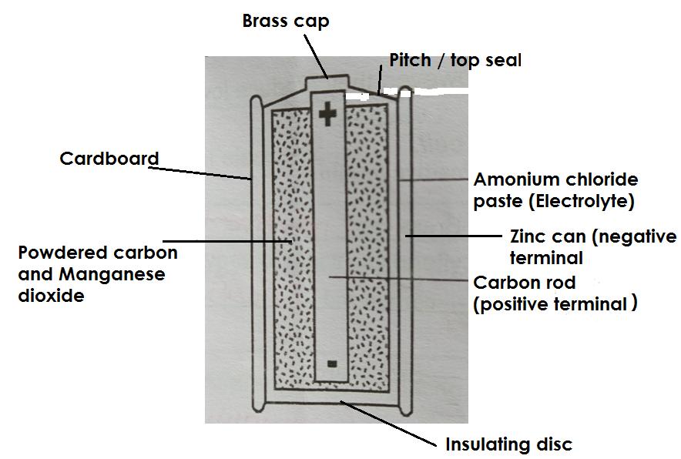**A diagram of a dry cell**

**Qn. State the function of each part of a dry cell.**

**a) Brass cap**

* A brass cap is the contact to the positive terminal.

1. **Pitch / Top seal**

* The pitch prevents the electrolyte from drying up.

1. **Insulating cardboard**

* The insulating cardboard protects the inside parts of a dry cell.

1. **Zinc can**

* The zinc can act as the negative terminal.

1. **Electrolyte (Ammonium chloride paste)**

* Electrolyte helps in the transfer of electrons.

1. **Powdered carbon and manganese dioxide.**

* Powdered carbon and manganese dioxide act as a depolarizing agent.

**OR**

* Powdered carbon and manganese dioxide prevent bubbles of hydrogen gas from building up around the carbon rod.

1. **Carbon rod**

* The carbon rod acts as a positive terminal.

**Note:**

* The carbon rod is a non-metallic conductor of electricity found in a dry cell.
* The carbon rod is made from **graphite.**

**Qn. What is depolarization?**

* Depolarization is when hydrogen gas bubbles are prevented from building up around the carbon rod.

**Qn. State the advantages of using dry cells.**

* Dry cells are portable (easy to carry).
* Dry cells are affordable (cheap to buy)
* Dry cells can be used in any position.

**Qn. Give the disadvantages of using dry cells.**

* Dry cells cannot be recharged.
* Dry cells produce electricity for a short time.
* Dry cells produce less current that cannot run big machines.
* Used up dry cells can spoil devices.

**Simple cells / wet cells**

**Qn. What is a simple cell?**

* A simple cell is a cell that consists of a copper plate (positive) and zinc plate (negative) dipped into dilute sulphuric acid.

**Note:**

* Dilute sulphuric acid acts as the **electrolyte**.
* The zinc plate and copper plate act as **electrodes.**

**Qn. What is an electrode?**

* An electrode is a piece of metal which allows electric current to enter and leave a cell when dipped in an electrolyte.

**Or**

* An electrode is a piece of metal that conducts electricity.

**Qn. What is an electrolyte?**

* An electrolyte is a liquid that conducts electricity.

**Qn. Give examples of electrolytes.**

* Lemon juice
* Urine
* Undistilled water
* Salt solution
* Dilute sulphuric acid
* Dilute hydrochloric acid

**The structure of a wet / simple cell**

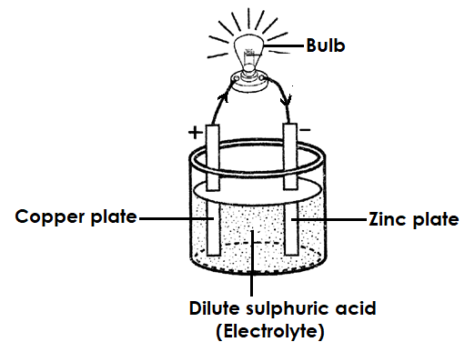

**Qn. Identify the form of energy stored in a wet cell.**

* Chemical energy

**Note**

* Chemical energy stored in a wet cell is converted to electric energy.

**The structure of a home made wet cell.**

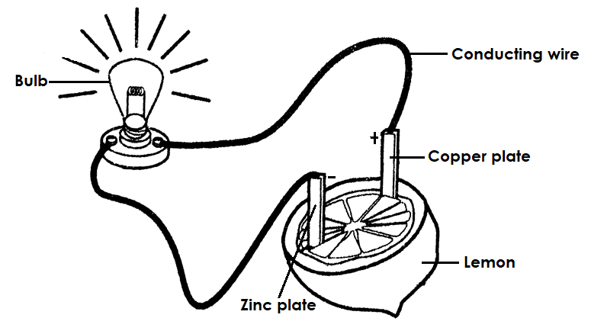

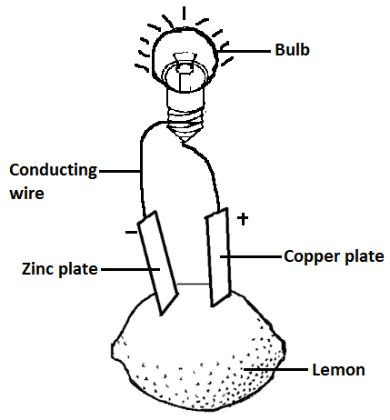

**Qn. State the factors that affect the efficiency of a wet / simple cell.**

* Polarization
* Local action

**Qn. What is polarization?**

* Polarization is the formation of hydrogen gas bubbles on a copper plate of a simple cell.

**Note:**

* When hydrogen bubbles cover the copper plate, they reduce the e.m.f of the cell and the bulb will stop giving light.

**Local action**

**Qn. What is local action?**

* Local action is when hydrogen bubbles are seen coming off from the zinc plate.

**Qn. Identify the disadvantages of using wet cells.**

* Simple cell produce electricity for a short time.
* Simple cells are bulky (not easily carried).
* Simple cells are only used in an upright position.

**b) Secondary cells**

**Qn. What are secondary cells?**

* Secondary cells are cells that can be recharged once used up.

**Note:**

* Recharging is the process of replacing lost energy in a cell.

**Qn. Give the examples of secondary cells.**

* Car batteries / lead acid batteries / accumulates.
* Phone batteries / mobile phone batteries.

**Qn. State the advantages of using secondary cells.**

* Secondary cells can be recharged.
* Secondary cells have a high voltage.
* Secondary cells can be used in running heavy / strong machines.

**Qn. State the disadvantages of using secondary cells.**

* Secondary cells are expensive.
* Secondary cells are bulky.
* Secondary cells are not easy to maintain.

**A car battery**

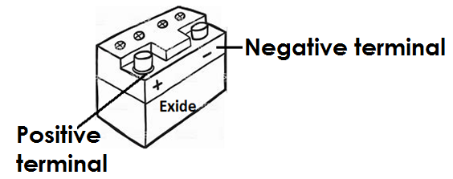

**An electric bulb**

**Qn. What is an electric bulb?**

* An electric bulb is a device that changes electric energy into heat and light energy.

**A diagram of an electric bulb**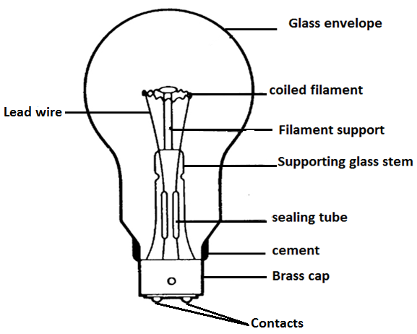

**Qn. State the energy change that takes place in a bulb?**

* Electric energy is converted to heat and light energy.

**Qn. State the function of each part of a bulb.**

**a) Glass envelope**

* The glass envelope protects the inside parts of the bulb.
* The glass envelope prevents nitrogen and organ gases from escaping.

**Note:**

* The glass envelope is transparent.

**Qn. Why is the glass envelope transparent?**

* To allow light to pass through.

**Qn. Why is argon and nitrogen used in bulbs?**

* To prevent evaporation of tungsten.
* To prevent oxygen from mixing with the coiled filament.
* To enable the filament burn at a high temperature with out blowing.

**Note:**

* Oxygen cannot be used in an electric bulb because it leads to melting and blowing of the filament.

**b) Brass cap**

* The brass cap enables the bulb to be fixed properly in the lamp holder.

**c) Coiled filament**

* The coiled filament produces light.

**Qn. Why is the filament coiled?**

* To increase electric resistance.

**Qn. From which metal is a coiled filament made?**

* Tungsten

**Qn. Why is the coiled filament made of tungsten?**

* Tungsten has a high melting point.

**Qn. Name the mineral from which tungsten is made?**

* Wolfram

**d) Supporting glass stem and filament support.**

* The supporting glass stem and filament support hold the filament in position.

1. **Lead wire**

* Lead wires conduct electricity from the contact to the filament.

1. **Sealing tube**

* The sealing tube enables air to be removed from the bulb.

1. **Contacts**

* The contacts transmit electricity from the lamp holder to the bulb.

**OR**

* The contacts connect the bulb to the source of electricity from the lamp holder.

1. **Cement**

* The cement provides support to the inside parts of the bulb.

**A torch**

* A torch is a device that uses dry cells in series arrangement to produce light.

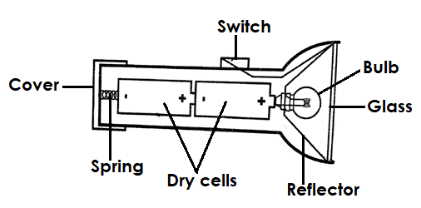**A diagram of a torch**

**Qn. State the functions of the parts of a torch.**

**a) Bulb**

* The bulb gives out light.

**b) Switch**

* The switch breaks and completes the circuit at one’s will or wish.

1. **Dry cells**

* Dry cells produce electricity.

1. **Reflector**

* The reflector directs light into diverging beam.

**e) Glass**

* The glass protects the reflector and bulb from damage.

**f) Cover and spring**

* The cover and spring keep the dry cells tightly fixed and closed.
* The cover and spring complete the circuit.

**Qn. Give the factors that can make a torch fail to give out light.**

* Poor arrangement of dry cells.
* When the cover is not fixed properly.
* When the bulb is not fixed properly.
* When some parts of a torch are spoilt / rusted.
* When the switch is faulty.

**Qn. Identify the factors that can make a torch stop giving out light.**

* When the dry cells get used up.
* When the filament in the bulb burns out.

**Types of electric circuit cells arrangement.**

**Qn. State the two types of electric circuit cells arrangement.**

* Series electric circuit cells arrangement.
* Parallel electric circuit cells arrangement.

**Parallel electric circuit cells arrangement**

* Parallel electric circuit cells arrangement is the type of arrangement where all positive terminals of cells are connected together by one conductor and all the negative terminals to another.

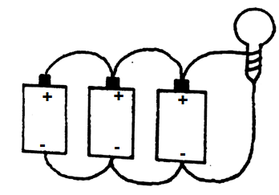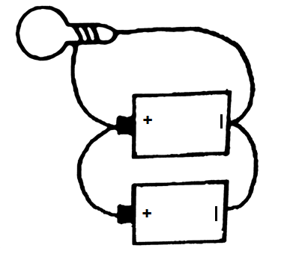**An illustration**

**Series electric circuit cells arrangement**

* 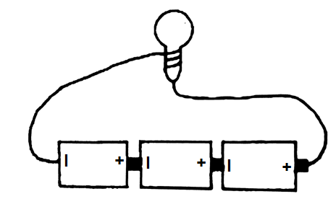Series electric circuit cells arrangement is the type of arrangement where the positive terminal of one cell is connected to the negative terminal of another cell.

**Plugs**

**Qn. What is a plug?**

* A plug is a device that connects an electric appliance to the main source of electricity.

**Qn. Mention the types of plugs.**

* Two pin plug
* Three pin plug

**A two pin plug**

* A two pin plug consists of two wires.

1. Neutral wire

ii) Live wire

**Qn. State the uses of the following wires in a plug.**

**a) Neutral wire (Blue or Black)**

* The neutral wire takes back current to the source.

**b) Live wire (Red or brown)**

* The live wire brings current from the source to the appliance.

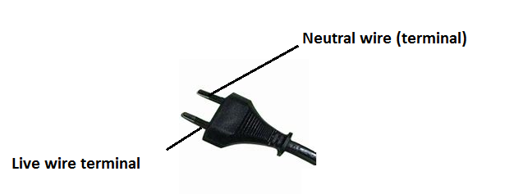**An illustration of a two pin plug.**

**Qn. Give examples of devices that use a two pin plug.**

* DVD players
* Telephones
* Electric fans
* Televisions
* Electric radios

**A three pin plug**

* A three pin plug consists of three wires i.e.

1. Neutral wire.
2. Live wire
3. Earth wire

**Qn. State the importance of the following wires in a three pin plug.**

**i) Neutral wire (Black Blue)**

* The neutral wire takes current from the appliance back to the source.

**ii) Live wire (Red Brown)**

* The live wire brings current from the source to the appliance.

1. **Earth wire (Yellow or Green)**

* The earth wire takes current in the soil incase of two much flow.
* The earth wire prevents electric shock.

**Note**

* The cablegrip holds the wires together.

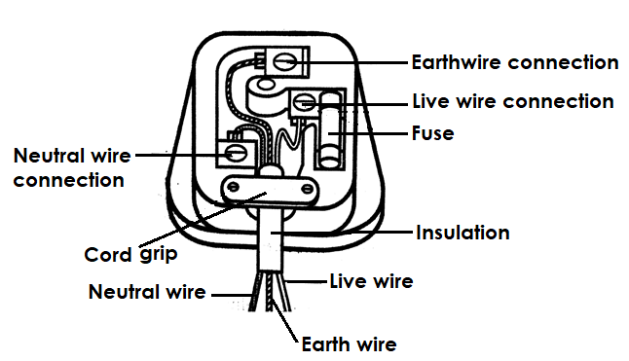**An illustration of a three pin plug.**

**Qn. Give examples of devices that use a three pin plug.**

* Electric flat iron
* Electric kettle
* Water heater
* Refrigerator
* Electric cooker
* Hot plates

**Domestic electricity**

* The electricity we use in our homes is connected to an electric meter with both the live and neutral wires.

**Qn. State the function of the electric meter.**

* The electric meter measures electricity used in a house / building.

**Qn. In which units is electricity measured?**

* Kilowatt hours (KWH).

**Devices connected to electricity**

**Qn. Mention the devices connected to electricity.**

* Generator
* Transformer
* Dynamo
* Electric motor

1. **Generator**

* A generator is a device that produces electricity by changing mechanical energy to electric energy.

**Qn. How is a generator able to produce electricity?**

* By rotating coils of wires in a magnetic field.

**Qn. Identify the types of generators.**

* Alternating current generator (A.C Generator)
* Direct Current Generator (D. C. Generator)

**Qn. How can a generator be made to produce more electricity?**

* By increasing the number of turns in a coil.
* By increasing the magnetic field.
* By increasing the speed of rotation.

1. **Dynamo**

**Qn. How does a dynamo produce electricity?**

* By changing mechanical energy to electric energy.

**Qn. Give examples of devices that use dynamos.**

* Bicycle
* Vehicles

**An illustration of a dynamo**

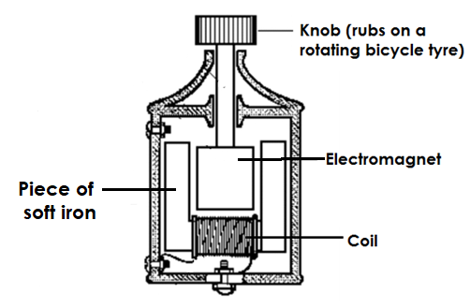

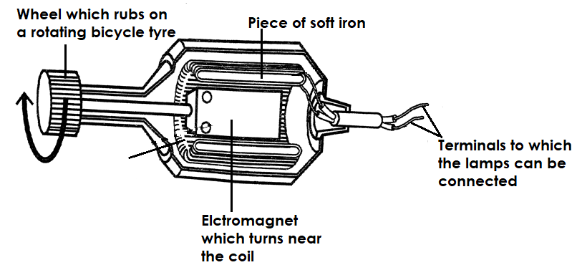

**Qn. How does a dynamo work?**

* A dynamo works by changing mechanical energy in form of kinetic energy to electric energy.

**Qn. State how electric current of a dynamo can be increased.**

* By increasing the speed of pedaling.

**Qn. State the importance of dynamos.**

* Dynamos in vehicles are used to charge batteries.
* Dynamos are used to produce electricity for lighting.

1. **Transformer**

* A transformer is a device that steps up or steps down voltage of electricity produced.

**Qn. Identify the types of transformers.**

* Step up transformers.
* Step down transformers.

1. **Electric motor**

* An electric motor is a device that changes electric energy to mechanical energy.

**Qn. State the uses of electric motors**

* Electric motors are used to start car engines.
* Electric motors are used in radios.
* Electric motors are used in sewing machines.
* Electric motors are used in fans.

**Electricity transmission in Uganda**

**Qn. Name the organization that supervises electricity in Uganda.**

* Electricity Regulator Authority (ERA).

**Note:**

* E.R.A replaced Uganda Electricity Board (U.E.B)

**Qn. Mention the three companies of E.R.A**

* Uganda Electricity Generation Company Limited (UEGCL)
* Uganda Electricity Transmission Company Limited (UETCL)
* Uganda Electricity Distribution Company Limited (UEDCL)

**Qn. State the role of UEGCL**

* To generate electricity from power station.

**Qn. State the roles of UETCL**

* To transmit electricity from the power station to different parts of Uganda.
* To buy electricity from generation companies to distribution companies.
* UETCL constructs and maintains sub-stations in Uganda.
* UETCL is responsible for importing and exporting electricity in Uganda.

**Qn. State the roles of UEDCL (UMEME)**

* UMEME connects and distributes electricity to customers from pole (grid).
* UMEME disconnects electricity from electricity defaulters.

**Qn. Identify the problems faced by UMEME.**

* Corruption by UMEME workers.
* Illegal connection by customers.
* Bush burning that may lead to destruction of poles.
* Delayed payments by customers.
* Stealing of electric poles and wires.
* Siphoning of oil from transformers.

**Qn. State the roles of ERA**

* ERA gives licences to the companies that may wish to generate electricity.
* ERA supervises and monitors the generation transmission and distribution companies.
* ERA controls the quality of electricity in Uganda.

**Qn. How does electricity generated from power stations reach the consumer?**

* Through transmission lines / wires/cables.

**Rural Electrification**

**Qn. What is rural electrification?**

* Rural electrification is the extending of electricity to rural areas.

**Qn. Why is the government carrying out rural electrification?**

* To control the massive cutting down of trees for wood fuel.

**Static electricity**

**Qn. What is static electricity?**

* Static electricity is the type of electricity which does not involve the flow of electrons.

**Note:**

* Static electricity involves stationary charges.

**Qn. Identify the charges of static electricity.**

* Positive charges
* Negative charges

**Qn. How is static electricity produced?**

* Static electricity is produced by friction after rubbing two insulators together.

**Qn. State the different ways of creating static electricity in daily life.**

* By rubbing a ball point pen with hair.
* By rubbing a plastic ruler against a cloth or hair.
* By rubbing polythene against cloth / hair.
* By rubbing a plastic comb against hair.

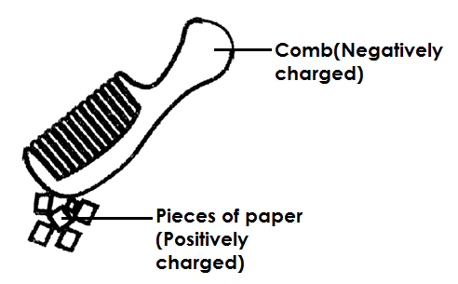**An illustration**

**Note:**

* Static electricity is produced under the law of electrostatics.

**Qn. State the law of electrostatics**

* Like charges repel each other and unlike charges attract each other.

**Qn. State the difference between static electricity and current electricity.**

|  |  |
| --- | --- |
| **Static Electricity** | **Current Electricity** |
| * Does not involve the flow of electrons. * Occurs in insulators. * The charges are on the surface of the insulator. | * Involves the flow of electrons * Occurs in conductors. * The charges are inside the conductor |

**Lightning**

**Qn. What is lightning?**

* Lightning is a huge light seen when positively charged clouds meet the negatively charged clouds during a storm.

**Note:**

* Lightning is a form of static electricity in nature.

**Qn. Why is lightning said to be electricity?**

* Lightning involves electric charges.

**Qn. What causes lightning?**

* Lightning is caused by charges of static electricity in clouds.

**Thunder**

**Qn. What is thunder?**

* Thunder is the sound that is suddenly produced when surrounding air becomes strongly heated expands and contracts during lightning.

**Qn. How is thunder caused?**

* Thunder is caused by the sudden expansion and contraction of air between opposite charged clouds.

**Note:**

* The continuous noise or sound heard during thunder is due to echoes.

**Qn. Why is lightning seen before thunder is heard?**

* Light travels faster than sound.

**Qn. How is lightning useful in the environment?**

* Lightning fixes nitrogen in the soil.

**Qn. State the dangers of lightning.**

* Lightning strikes people and animals to death.
* Lightning sets buildings on fire.
* Lightning can lead to forest fires.
* Lightning can damage people’s property.

**Qn. State ways of preventing dangers of lightning.**

* Putting lightning conductors on tall buildings.
* Never stand under trees when it is raining.
* Switch off electric appliance when it is raining.
* Always wear rubber shoes when it is raining.
* Avoid swimming in open water when it is raining.
* Never stand in open places when it is raining.

**A diagram showing a lightning conductor**

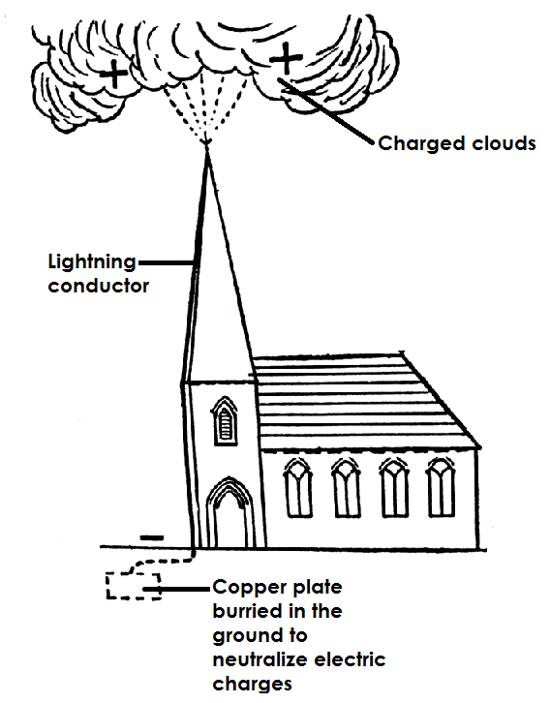

**Qn. How does a lightning conductor control lightning?**

* A lightning conductor directs electric charges to the metal strip in the ground without damaging the building.

**Qn. State the uses of electricity.**

* Electricity is used for cooking.
* Electricity is used for ironing clothes.
* Electricity is used for lightning bulbs.
* Electricity is used for washing.
* Electricity is used to run some machines.

**Qn. Give the advantages of using electricity.**

* Electricity is quick.
* Electricity provides clean work.
* Electricity controls the cutting of trees.
* Electricity does not pollute the environment.

**Qn. State the dangers of electricity.**

* Electricity shocks and kills people.
* Electricity can burn buildings.

**Qn. Identify the safety precautions when handling electricity.**

* Never touch an electric socket with wet hands.
* Never push metallic objects in electric sockets.
* Switch off electric appliances when it is raining.
* Never repair electric appliances if you are not an expert.
* Never through objects on electric wires.
* Never touch electric wires that have fallen down.
* Avoid over loading the circuit.

**THEME: ENVIRONMENT**

**TOPIC: ENERGY RESOURCES IN THE ENVIRONMENT**

**Qn. What is energy?**

* Energy is the ability to do work.

**Qn. What is a resource?**

* A resource is anything people use to meet their needs.

**OR**

* A resource is the component of the environment used to satisfy people’s needs.

**Qn. Mention the two types of resources.**

* Renewable resources.
* Non-renewable resources.

**Qn. What are renewable resources?**

* Renewable resources are components of the environment that can be replaced naturally when used up.

**Qn. Give the examples of renewable resources.**

* Animals
* Plants
* Soil
* Water
* Air / wind
* Sun

**Qn. What are non – renewable resources?**

* Non – renewable resources are things that cannot be replaced naturally once used up.

**Qn. Give the examples of non-renewable resources.**

* Minerals
* Rocks
* Fossil fuels

**Energy resources**

**Qn. What are energy resources?**

* Energy resources are things that provide people with useful energy.

**Qn. Identify the examples of energy resources.**

* Plants
* Animals
* Wind
* Sun
* Minerals
* Fossil fuels

**Qn. Name the two types of energy resources.**

* Renewable energy resources.
* Non-renewable energy resources.

**Renewable energy resources.**

**Qn. What are renewable energy resources?**

* Renewable energy resources are things that provide useful energy and can be replaced naturally once used up.

**Qn. Give the examples of renewable energy resources.**

* Plants
* Animals
* Wind
* Water
* The sun

**Qn. What are non-renewable energy resources?**

* Non- renewable energy resources are things that provide useful energy to people and cannot be replaced naturally when used up.

**Qn. State the examples of non-renewable energy resources.**

* Minerals
* Fossil fuels

**Animals are energy resource**

**Qn. How are animals used as energy resources?**

* Some animals are used for transport.
* Some animals are used for ploughing.
* Animal wastes are used in the production of biogas.

**Qn. What are beasts of burden?**

* Beasts of burden areanimals that provide us with cheap labour.

**Qn. Give the examples of beasts of burden.**

* Oxen
* Donkeys
* Camels

**Qn. Identify the different ways of conserving animals.**

* Proper feeding of animals.
* Treating sick animals
* Vaccinating animals
* Gazetting animals in game parks.
* Banning illegal hunting of animals.

**Qn. How can animals be replaced naturally once used up.**

* Through reproduction.

**Plants as energy resources**

**Qn. How are plants used as energy resources?**

* Plants provide us with wood fuel.
* Some plants wastes are used in the production of biogas.

**Qn. State the different ways of conserving plants.**

* Afforestation.
* Re-afforestation.
* Agro – forestry.
* Using energy saving stoves.
* Using other alternative sources of energy e.g. biogas instead of wood fuel

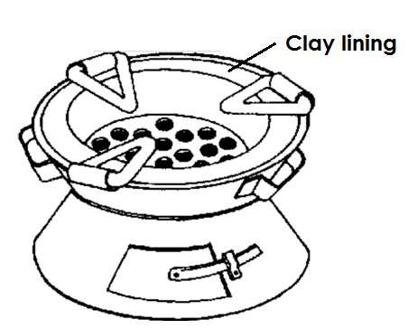**A diagram showing an energy saving stove.**

**Qn. How do energy saving stoves conserve the environment?**

* Energy saving stoves use less charcoal.

**Qn. Why does energy saving stoves use less charcoal?**

* Energy saving stoves keep heat for a long time.

**Qn. State the importance of the clay lining found on a charcoal saving stove.**

* The clay lining keeps heat for a long time.

**Qn. Give at least two examples of wood fuel.**

* Firewood
* Charcoal
* Wood shavings
* Saw dust
* Briquettes

**Qn. Mention the form of energy stored in charcoal.**

* Chemical energy.

**Qn. State the energy change that takes when wood burns to ash.**

* Chemical energy changes to heat energy.

**The sun as an energy resource.**

* The sun is the main source of heat and light energy as forms of energy on earth.

**Qn. How is the sun used as an energy resource?**

* The sun provides us with light that enables us to see.
* Heat from the sun dries washed clothes.
* Heat from the sun helps to generate solar electricity.
* Head from the sun helps to dry harvested crops.
* Light from the sun is used for photography.
* Light from the sun enables plants to make food.

**Qn. In which way is solar electricity friendly to the environment?**

* Solar electricity reduces the cutting down of trees for wood fuel.
* Solar electricity does hot pollute the environment.

**Water as an energy resource.**

**Qn. How is water used as an energy resource?**

* Fast running water helps to generate hydro electricity.
* Steam from hot springs is used to generate geothermal electricity.
* Tides are used to generate tidal electricity.

**Qn. Give the examples of useful energy resources got from water.**

* Hydro electricity.
* Geothermal electricity
* Tidal electricity

**Qn. What is a tide?**

* A tide is a regular rise and fall of water in the sea or ocean.

**Qn. What causes a tide?**

* A tide is caused by the attraction of the moon and earth.

**Wind as energy resource**

**Qn. What is air?**

* Air is a mixture of gases.

**Qn. What is wind?**

* Wind is air in motion or moving air.

**Note:**

* Wind possesses kinetic energy that makes things move.

**Qn. State the ways how wind is used as an energy resource.**

* Wind is used in winnowing.
* Wind is used to sail boats.
* Wind is used to turn wind mills.
* Wind is used to fly kites.
* Wind helps to dry washed clothes.
* Wind helps in seed dispersal.

**Qn. State the dangers of wind.**

* Strong wind destroys crops.
* Strong wind destroys buildings.
* Strong wind capsizes boats.

**Qn. How does wind help to dry clothes?**

* By speeding up the evaporation process.

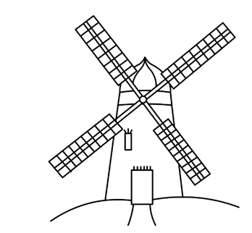**A diagram of a windmill.**

**Qn. Give the uses of a windmill**

* A wind mill is used to generate electricity.
* A wind mill is used to pump water from underground.
* A wind mill is used to grind grains.

**Qn. How is wind formed?**

* Wind is formed when air in a certain area is heated faster than air in another area.

**Qn. Write down different ways of conserving renewable resources.**

* Afforastation.
* Re-afforestation
* Agro forestry
* Using energy saving stoves.
* Using other alternative sources of energy e.g. biogas instead of wood fuel.
* Proper feeding of animals.
* Treating animals when they are sick
* Gazetting animals in games reserves
* Banning illegal hunting of animals.

**Energy resources from fossil fuels**

**Qn. What are fossils?**

* Fossils are remains of plants and animals that lived thousands of years ago.

**Qn. What are fossil fuels?**

* Fossil fuels are fuels that were formed from the remains of plants and animals that lived thousands of years ago.

**Qn. Give the examples of fossil fuels.**

* Petroleum
* Coal

**Petroleum / crude oil**

**Qn. What is petroleum?**

* Petroleum is a fossil fuel that was formed from the remains of animals thatdied many years go.

**Qn. Give the examples of products of petroleum.**

* Petrol
* Diesel
* Jet fuel
* Paraffin / kerosene
* Natural gas

**Qn. State the importance of petroleum products.**

* Petroleum products can generate power that can run big machines.
* Petroleum products are burnt to produce heat and light.

**Qn. Identify the process by which petroleum products or crude oil is separated.**

* Fractional distillation.

**Coal as an energy resource.**

**Qn. What is coal?**

* Coal is a hard black material formed from the remains of plants that lived thousands of years ago.

**Qn. State the importance of coal.**

* Coal is used to generate thermal electricity.
* Coal is used to make tar for surfacing roads.
* Coal is used as fuel in steam engines.

**Qn. Give the other products from petroleum.**

* Plastics
* Polythenes
* Dye
* Vaseline
* Paint
* Fertilizers

**Qn. Give the other products from coal.**

* Paint
* Perfumes
* Fertilizers

**Minerals as energy resources (uranium)**

**Qn. How are minerals (uranium) used as an energy resource?**

* Uranium is burnt to produce atomic electricity.
* Uranium is used as fuel in nuclear powered sub-marines.
* Uranium is used to make atomic bombs.

**Qn. State the ways of conserving non-renewable energy resources.**

* By having controlled mining of minerals.
* By using other alternative sources of fuel e.g. biogas instead of petroleum.
* By walking distances which are not too long to conserve petroleum products.
* By riding bicycles in short distances than driving cars to save fuel.
* By repairing vehicles which are under dangerous mechanical conditions in order to save fuel.

**Biogas production**

**Qn. What is biogas?**

* Biogas is a methane that is produced from rotting organic matter.

**Qn. What is biomass?**

* Biomass is the amount of living matter found in an area.

**Qn. Identify the materials used to produce biogas.**

1. Plant materials

* Banana peelings
* Sweet potato peelings
* Seed residues

1. **Animal materials**

* Cow dung
* Urine
* Chicken droppings
* Human faeces
* Goat droppings

**Qn. How is biogas produced?**

* Biogas is produced by putting animal and plant materials in a proper sealed container called biogas digester which is buried underground.
* Plant and animal waste in the biogas digester are broken down by anaerobic bacteria during the process of fermentation.
* During fermentation, methane gas called biogas is produced.

**A diagram showing biogas digester.**

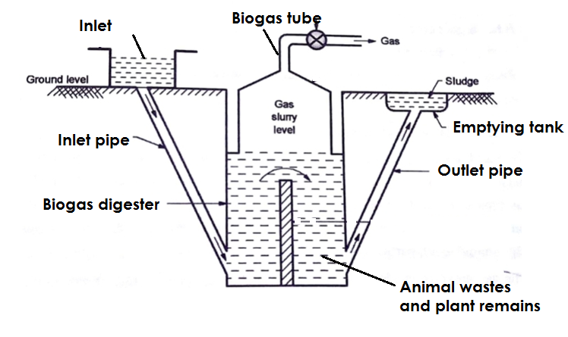

**Qn. State the uses of the parts of a biogas digester.**

**i) Inlet**

* The inlet is used for putting in plant and animal matter.

**ii) Inlet pipe**

* The inlet pipe allows plant and animal matter into the digester.

**iii) Outlet**

* The outlet is used for removing old or used up matter from the digester.

1. **Emptying tank**

* The emptying tank is where used up matter is collected before it is taken to the garden as manure.

1. **Biogas tube**

* The biogas tube traps and takes biogas to the heating or lightning equipment.

1. **Biogas digester.**

* A biogas digester is where animals and plants waste are put to ferment.

**Qn. Why is the biogas digester tightly sealed?**

* To prevent the entry of oxygen.

**Qn. State the uses of biogas.**

* For cooking
* For lighting
* For heating

**Qn. Give the advantages of using biogas**

* Biogas is cheap.
* Biogas does not pollute the environment.
* Materials for making biogas are readily available.

**Qn. State the disadvantages of using biogas.**

* Biogas may not be efficient.
* Biogas contains impurities.

**Qn. What is an effluent?**

* An effluent is a liquid substance obtained after production of biogas.

**Qn. What is sludge?**

* Sludge are waste materials removed from a biogas digester.

**Qn. What is slurry?**

* Slurry is a mixture of dung and water that enters a biogas plant in a semi liquid form.

**Environmental conservation**

**Qn. What is environmental conservation?**

* Environmental conservation is the protection and preservation of resources in the environment.

**Qn. Give reasons for conserving resources.**

* For future use.
* To prevent extinction of resources.

**TERM TWO**

**THEME: MATTER AND ENERGY**

**TOPIC 4: MACHINES AND FRICTION**

**Qn. What is a machine?**

* A machine is a device that simplifies work.

**Qn. Give the different ways how machines simplify work**

* By increasing the speed of doing work.
* By reducing the effort needed to do work.
* By changing the direction of force.

**Qn. State the advantages of using machines.**

* Machines increase the speed of doing work.
* Machines reduce the effort needed to do work.
* Machines change the direction of force.
* Machines enable us to apply force easily.

**Work**

**Qn. What is work?**

* Work is the product of force and distance moved in the direction of force.

**Force**

**Qn. What is force?**

* Force is a pull or push on an object.
* Force is measured in Newtons.

**Work done**

**Qn. What is work done?**

* Work done is when a force is used to move a load through a distance.

**Qn. When is work done?**

* Work is done when force is used to move another force through a distance.

**Or.**

* Work is done when a force is used to move the load through a distance.

**Note:**

* Work done depends on two things i.e.

i) The force applied

ii) The distance moved

Work done = force x Distance

WD = F x D

**Qn. In which unit is work done measured?**

* Joules (J)

**Qn. What is a joule?**

* A joule is the work done when a force of 1Newton is moved through a distance of 1 metre.

**Note:**

1kg = 10Newtons

**Power**

**Qn. What is power?**

* Power is the rate at which work is done.

**Qn. In which units is power measured?**

* Power is measured in watts (W)

**Distance**

**Qn. What is distance?**

* Distance is the length through which an object moves when work is done.
* Distance is measured in metres (M)

**Calculations on work done**

**Examples**

1. Find the work done by a man who carries a log of wood of 25N through a distance of 7m.

**Solution:**

Work done = Force x Distance

WD = F x D

WD = (25 x 7) Joules

WD = 175 Joules

1. A woman carries a baby of 6kg through a distance of 9m.Find the work done.

**Solution**

Work done = Force x Distance

**Or**

W.D = F x D

Note: 1kg =10N

F = (6 x 10) N

F = 60N

WD = (60 x 9) Joules

WD = **540 Joules**

1. If Musa pushed a wheel barrow of 320 Joules through a distance of 8m, how much force did he use?

Solution

Force = Work done

Distance

F = WD

D

40

F = ~~320~~

~~8~~

1

F = 40N

4. Find the distance moved by Suzan who carried a basket of 450 joules using an effort of 5kg.

**Solution**

Distance = work done

force

D = WD

**Note:**

1kg = 10N

5kg = (5 x 10)N

5kg = 50N

F

9

D = ~~450~~

~~50~~

1

D = 9M

**Activity:**

1. Find the work done by Joshua who lifted a basket of mangoes using a force of 65N through a distance of 5m.

2. Calculate the work done by Otim who pushed a load of 75kg through a distance of 4 metres.

3. Find the force needed by Aisha to push a box of 280 joules through a distance of 7 metres.

4. Samuel pushed a log of wood of 600 joules through a distance of 10m. Calculate the force he used.

5. Find the distance covered by Shukra if she pushes a load of 30N to do work of 900 joules.

6. If stone of 80N is lifted through a certain distance, the amount of work done is 720 joules. Find the distance through which the stone is lifted.

**Types of machines**

**Qn. Identify the two types of machines.**

* Complex machines
* Simple machines

1. **Complex machines**

**Qn. What are complex machines?**

* Complex machine are machines that are made up of many parts and need training to use them.

**Qn. Give the examples of complex machines.**

* Tractors
* Vehicles
* Sewing machines
* Aeroplane

**b) Simple machines**

**Qn. What are simple machines?**

* Simple machines are machines that are made up of few parts and do not need training to use them.

**Qn. Give the examples of simple machines.**

* A claw hammer
* A water pump
* A weighing scale
* A see saw
* A pair of scissors
* A bottle openers
* An axe
* Wheel barrow
* Spade
* Trowel
* Razor blade
* Rake
* Hoe
* Panga

**Qn. Identify the group / classes of simple machines.**

* Levers
* Wedges
* Inclined planes / slopes
* Pulleys
* Screws
* Wheel and axle

**LEVERS**

* A lever is a stiff / rigid bar that turns freely on a fixed point called a **fulcrum / pivot**.

**Parts of a lever**

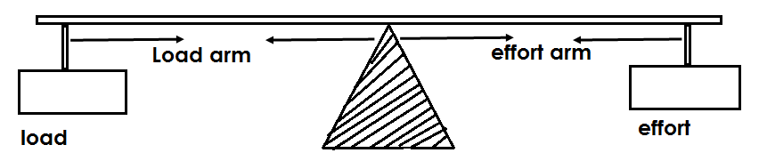

**Describe these terms:-**

1. **Load**. This is the object to be moved.
2. **Effort**. This is the force needed to move the load.
3. **Pivot / fulcrum**. This is the turning point of a machine.
4. **Load arm**. This is the distance between the load and the pivot.
5. **Effort arm**. This is the distance between the effort and the pivot.

**Note:**

* A lever works best when the load arm is shorter than the effort arm.

**Use the diagram below to answer the questions that follow:**

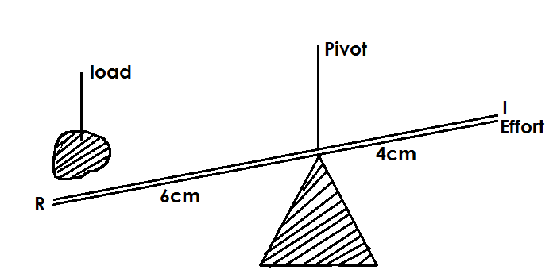

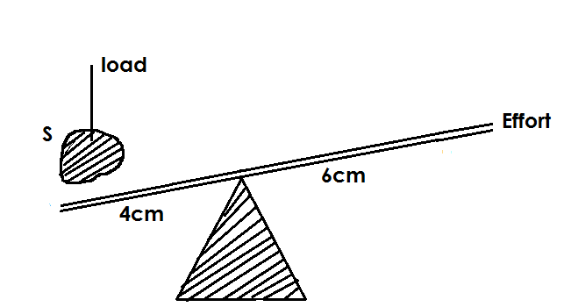

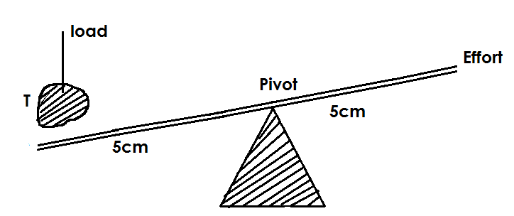

**Qn. Which of the diagram above will help you to do work easily?**

* Diagram S.

**Qn. Give a reason to support the answer above.**

* The effort arm is longer than the load arm.

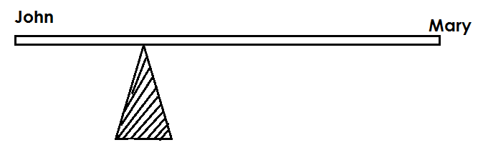**Qn. John and Mary sat on a see-saw and they were at equilibrium as shown below:**

1. **Who is heavier?**

* John is heavier.

1. **Give a reason to support your answer above.**

* John is seated nearer to the fulcrum and the nearer to the fulcrum, the heavier the object.

**c) Who of the two is lighter?**

* Mary is lighter.

**d) Give a reason to support your answer above?**

* Mary is seated far away from the fulcrum and the far away from the fulcrum, the lighter the object.

**Classes of levers**

**Qn. Identify the three classes of levers.**

* First class levers.
* Second class levers
* Third class levers

**i) First class levers.**

**Qn. What are first class levers?**

* First class levers are machines where the pivot is in between the load and the effort.

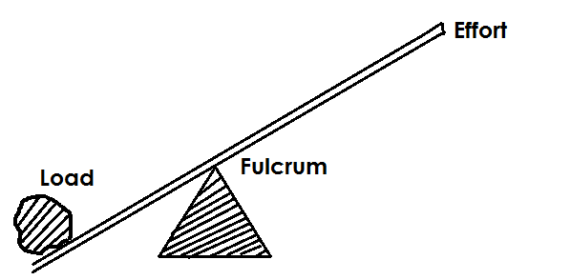**(L.P.E ) OR (E.P.L)**

**Note:**

* In the first class, the effort arm is longer than the load arm.

**Qn. State the advantage of using machines in the first class levers.**

* Less effort is used.

**Qn. How do first class levers simplify work?**

* The load and effort move in different directions.
* By increasing the effort arm and reducing the load arm.

**Qn. Give the examples of machines in the first class.**

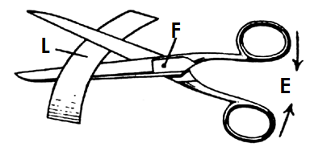**a) Pair of scissors.**

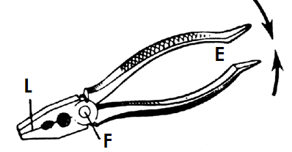**b) Pliers / Pair of pliers**

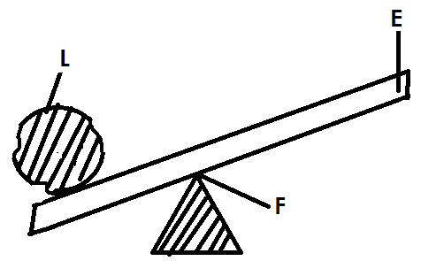**c) A crow bar**

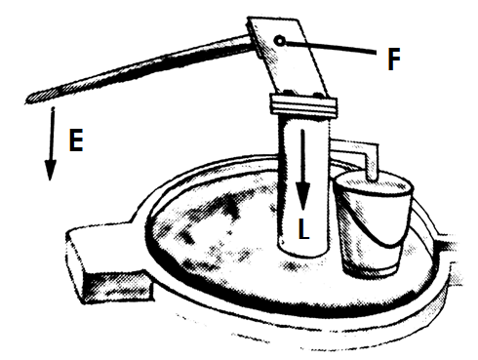**d) A borehole / water pump**

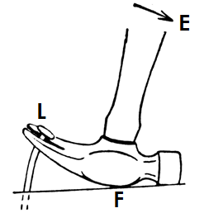**e) Claw hammer**

1. 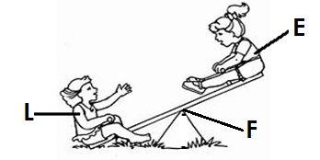**A see saw**
2. 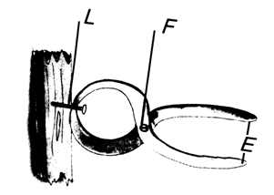**Pincers**
3. **Weighing scale**

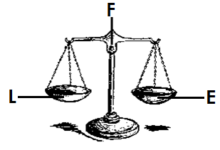

1. 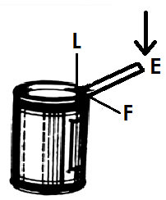**Lid opener**

**2. Second class levers**

**Qn. What are second class levers?**

* Second class levers are levers in which the load is in between the pivot or fulcrum and the effort.

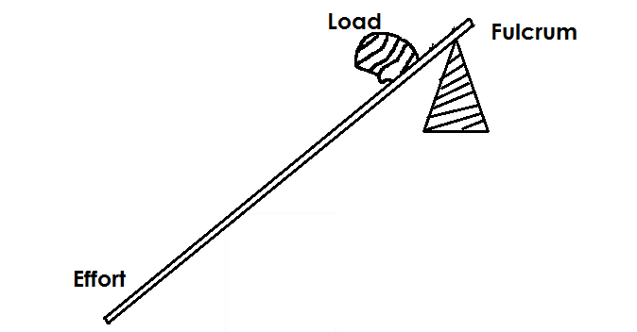**(ELF OR FLE)**

**Note:**

* In the second class levers, the load is closer to the fulcrum than the effort.

**Qn. State the advantages of using second class levers.**

* Less effort is used compared to the load.

**Qn. How do second class levers simplify work?**

* By making the load and effort move in the same direction.

**Qn. Give examples of machines in the second class levers.**

**a) A wheel barrow**

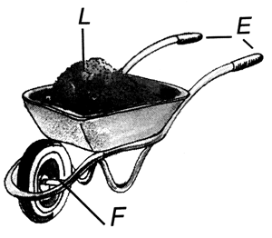

**b) Nut cracker**

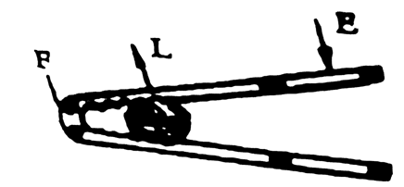

1. **Bottle opener**

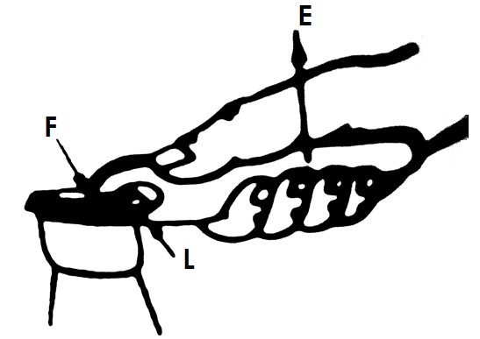

1. **Human foot**

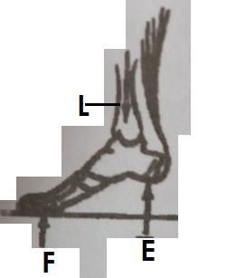

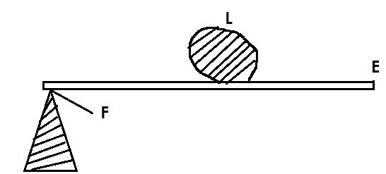**e) Craw bar**

**3. Third class levers**

**Qn. What are third class levers?**

* Third class levers are levers where the effort is in between the pivot and the load. (LEP) or (PEL)

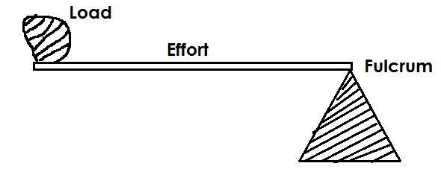**Illustration of a third class lever.**

**Qn. Give examples of machines in the third class levers.**

**a) Spade**

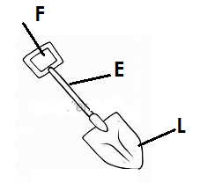

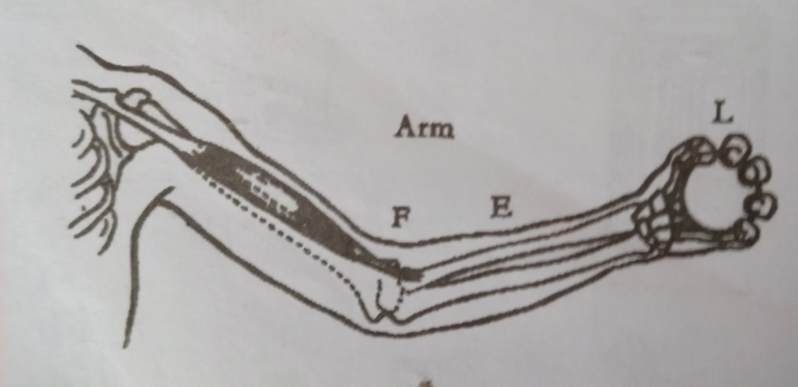**b) Human arm**

**c) Broom**

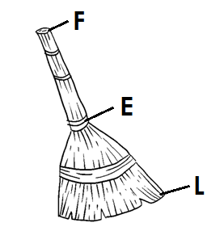

**d) Pair of tongs (sugar tongs)**

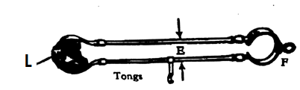

**e) A fishing rod**

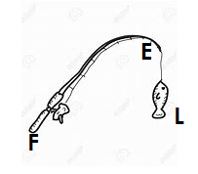

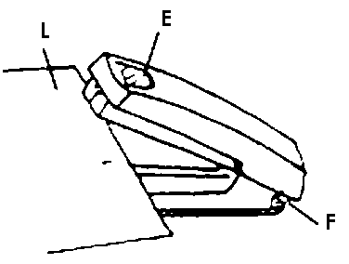**f) Stapler**

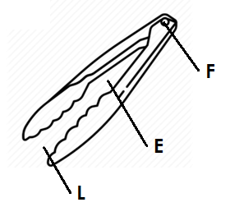**g) Tweezers**

**g)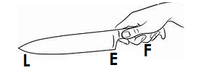Table knife**

**Qn. State the advantage of using machines in the third class levers.**

* The effort moves through a short distance.

**Note:**

* The formula PLE or FLE can be used to determine the class of levers.

**Laws and levers / laws of moments**

**Qn. State the law of levers / law of moments.**

* The law of levers states that load force multiplied by the load arm is equal to the effort force multiplied by the effort arm.

**OR**

* The law of levers states that the sum of the clockwise moments about any point is equal to the sum of anticlockwise moments. i.e.

**Load X load arm = Effort X Effort arm**

**Or**

**L X LA = E X EA**

**Qn. What is a moment?**

* A moment is a turning force of a machine.

**Calculations on levers**

1. James who weighs 60kgf sits 2m away from the fulcrum and balances with Joan who weigh 30kg from a see saw. How far from the fulcrum does Joan sit?

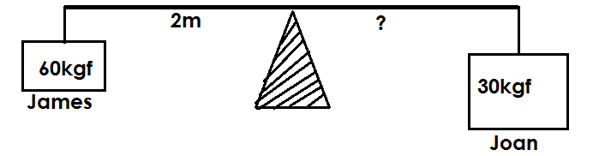**Solution**

**Let the effort arm be K.**

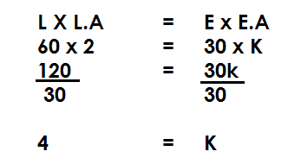

**∴**Joan sits 4 metres away from the fulcrum.

2. Annet is 35kg, if she sits 2cm away from the fulcrum and balances with Opio who sits 5cm away from the fulcrum, what is Opio’s weight?

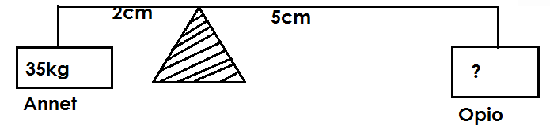**Solution**

**Let Opio’s weight be n.**

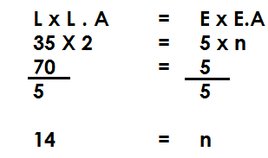

∴ Opio’s weight is 14kg

1. Moses is 50kg. He sits 4m away from the fulcrum to balance with Jane who wighs 25kgs on a see saw. How far is Jane from Musa?

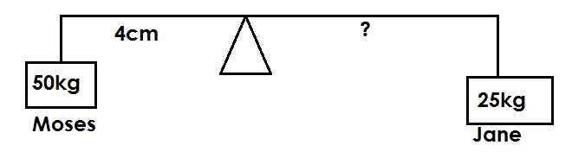

**Solution**

**L x L.A = E x E.A**

**50 x 4 = 25 x h**

**200 = 25h**

**~~25~~ ~~25~~**

**8 = h**

**4m + 8m = 12m**

∴Jane sits 12m away from Moses.

4. Find the value of P on the diagram below.

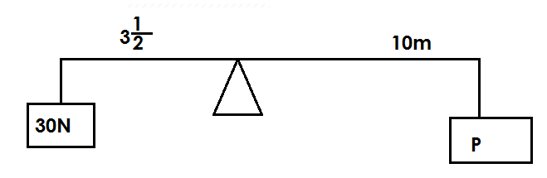

**Solution**

**LXL.A = EXE.A**

**30X3 $\frac{1}{2}$ = PX10**

**30X $\frac{7}{2}$ = 10P**

**15X7 = 10P**

**105 = 10P**

**10 10**

**10.5 = P**

Therefore **P = 10.5**

5. Calculate the value of Y.

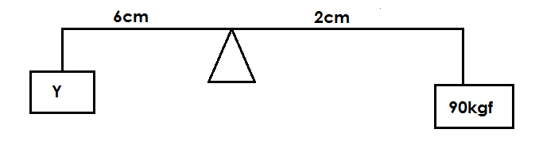

**Solution**

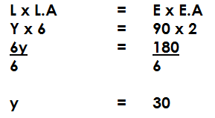

**∴ y = 30kgf**

6. Find the value of P.

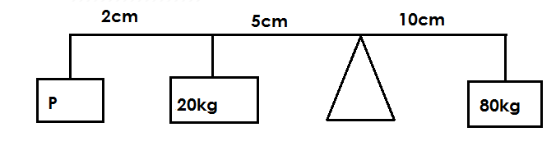

**Solution**

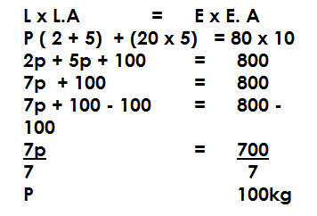

7. Find the value of R.

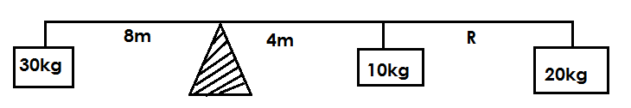

**Solution:**

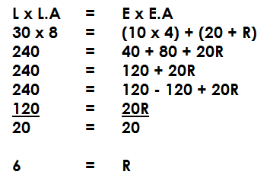

**∴ R = 6M**

**Activity:**

1. Charity weighs 90kgf. If she sits 3m away from the pivot of a see saw, how far Joel whose weight is 30kgf will sit in order to balance.

2. Darius weighs 50kg andsits 4m away from the fulcrum. Regina weighs 40kg. How far from the fulcrum will Regina sit in order to balance with Darius.

b) How far will Regina be from Darius?

3. John and Jane sat on a see saw as shown below.

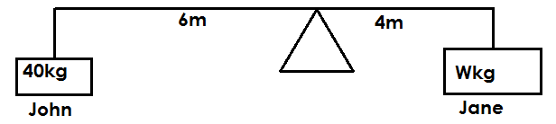

**Find Jane’s weight.**

1. Find the value of P.

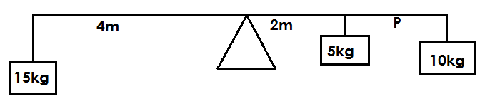

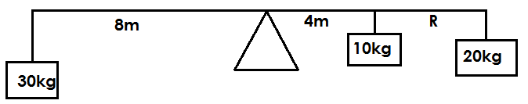6. Find the value of R.

7. Using a see saw below, calculate the value of W.

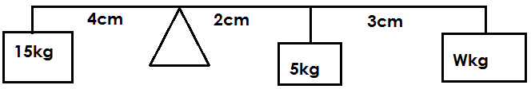

**Mechanical Advantage**

**Qn. What is mechanical advantage?**

* Mechanical advantage is the number of times a machine eases work.

**OR**

* Mechanical advantage is the radio of the load to the effort.
* Mechanical advantage = Load

Effort

M.A = L

E

**Note:**

* Mechanical advantage has no units because it is a ratio of forces.
* If mechanical advantage is greater than I, less effort is used.
* It mechanical advantage is less than I, more effort is used.

**Qn. Mention the force that affects the efficiency of the mechanical advantage of a machine.**

* Friction

**Calculations of mechanical advantage.**

1. **Calculate the mechanical advantages of a boy who carries a bucket of water of 400N using a force of 100N.**

Solution

M.A = Load

Effort

M.A 400N

100N

M.A = 4

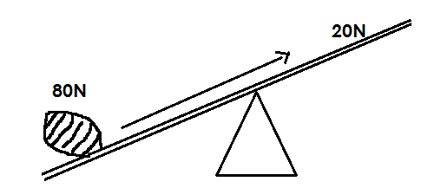**2. Find the mechanical advantage of the crow bar below.**

**Solution:**

M.A = L

E

M.A = 80N

20N

**M.A = 4**

**3. Find how many times a see saw simplifies work given the load of 600N and the effort of 30N.**

Solution:

M.A = L

E

M.A ~~600~~N

30N

M.A = 20

**∴The see saw simplifies work 20 times.**

**4. What will be the load if the mechanical advantage of a machine is 2 and the effort is 30N?**

Solution:

M.A = L

E

2 = L

30N

2 X 30N = L X 30N

30N

60N = L

**∴The load will be 60N**

1. **A machine with a mechanical advantage of 3 carries a load of 90N. Find the force required to move the load.**

**Solution**

M.A = L

E

3 = 90N

E

3 x E = 90NX E

E

3E = 90N

3 3

E = 30

**∴The force required is 30N**

**Activity:**

1. Find the mechanical advantage of a woman who pushed a log of wood 120g using 40kg.

2. Calculate the mechanical of the machine below.

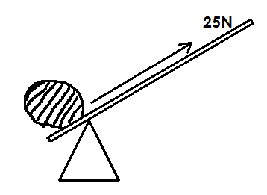

3. Find the effort needed by a machine of mechanical advantage 4 that carries a load of 100N.

4. Calculate the load of a machine with mechanical advantage 5 and its effort 3kg.

**Efficiency of machines**

**Qn. What is efficiency of a machine?**

* Efficiency of a machine is the ratio of work output to work input of a machine.

**Qn. What is work out put?**

* Work out put is the work done on the load by a machine.

**Qn. What is work input?**

* Work input is the work done on the effort by a machine.

Efficiency = work output x 100%

Work input

**Note:**

* Efficiency of a machine is expressed in percentage and it is always less than 100%.

**Qn. Why is the efficiency of a machine always less than 100%?**

* It is due to friction.

**Qn. How can the efficiency of a machine be increased?**

* By oiling machines to reduce friction.
* By greasing machines to reduce friction.
* By repairing damaged machines.

**Calculations of efficiency**

1. Calculate the efficiency of a machine whose effort is 30N and move through a distance of 15m to overcome a load of 120N through a distance of 3m.

**Solution**

Efficiency = work out put x 100%

Work input

= 120N x 3m x 100

30N X 15m

= 4 x 20

= 80%

**∴ Efficiency = 80%**

**Velocity ratio**

Qn. What is velocity ratio?

* Velocity ratio is the ratio of the distance moved by the effort to the ratio of distance moved by the load.

Velocity ratio = Distance moved by effort

Distance moved by the load

V.R = D.E

D.L

**Calculation of velocity ratio**

1. Calculate the velocity ratio of a lever whose distance of the effort is 12m and that of the load is 3m.

**Solution:**

V.R = DE

DL

V.R = 13m

3m

**V.R = 4**

**INCLINED PLANES / SLOPES**

**Qn. What is an inclined plane?**

* An inclined plane is a slanting or sloping surface.

**Note:**

* The longer the inclined plane, the less effort used to move the load.
* The shorter the inclined plane, the more effort used to move the load.

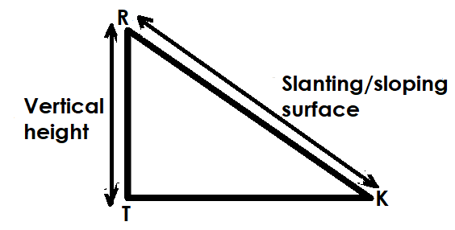**An illustration of an inclined plane**

**Note:**

* Vertical height (RT) – distance moved by the load.
* Slanting surface (RK) – distance moved by the effort
* TK – Ground level.

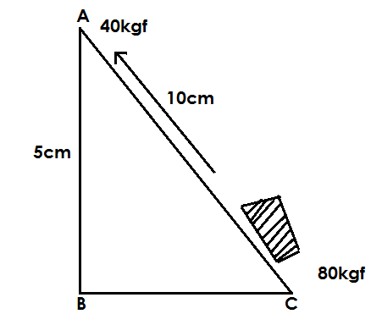**Use the diagram below to answer the questions that follow:-**

**a) Name the simple machine above.**

* An inclined plane / a slope.

**b) What is the distance moved by:-**

i) Load = 5cm

ii) Effort = 10cm

**c) Find the mechanical advantage of the machine.**

M.A = L

E

M.A = 80kgf

40kgf

M.A = 2

**Or**

M.A = DE

DL

M.A 10cm

5cm

M . A = 2

**d) State the ways one can use less effort to raise the load on the diagram above.**

* By increasing the distance moved by the effort.
* By decreasing the distance moved by the load.
* By lowering the angle of the inclined plane.

**Qn. State the examples of inclined planes.**

* Winding roads
* Stair cases / steps
* Ramp
* Ladders

**Illustrations**

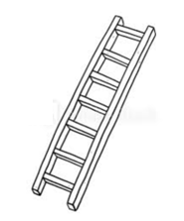**a) A ladder**

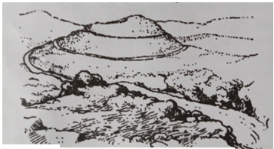**b) Winding roads**

1. 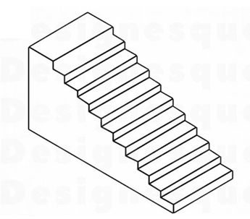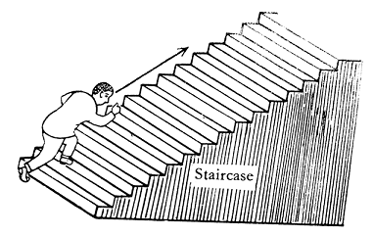**Stair cases**

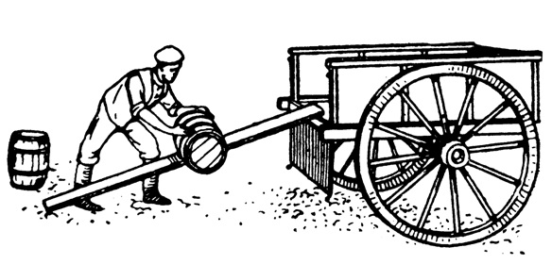**d) A ramp**

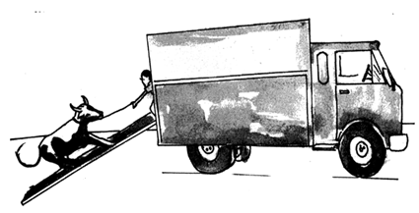

**Qn. Give the uses of inclined planes.**

* Inclined planes are used to climb tall buildings.
* Inclined planes are used to load and off load heavy goods on lorries.
* Inclined planes are used to climb tall trees.
* Inclined planes enable vehicles to climb steep hills.
* Inclined planes enable builders to carry building material from a lower level to a higher level.

**Qn. State the advantages of using inclined planes.**

* Inclined planes reduce the effect of gravity as one raises the load.
* Inclined planes enable people to use less effort to raise a load from a lower level to a higher level.

**Work done on inclined planes.**

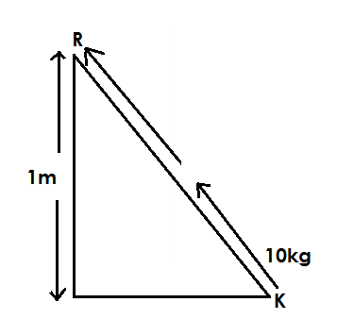1. Calculate the work done by an inclined plane below if the load from K to R is as shown.

**Solution:**

1kg = 10N

10kg = (10 x 10)N

= 100N

Work done = force x Distance

WD =F x D

WD = (100 x 1) Joules

**∴Work done is 100 Joules**

**Activity:**

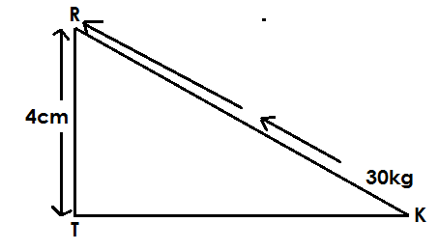1. Calculate the work done by the inclined plane shown below:-

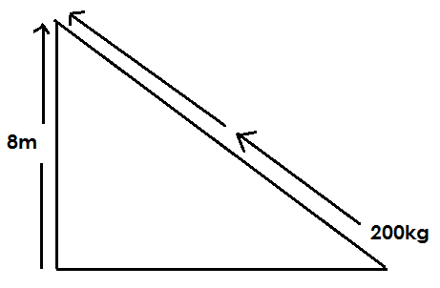2. Calculate the work done by the inclined plane.

**WEDGES**

**Qn. What is a wedge?**

* A wedge is a tool with a narrow point that gradually becomes wider.

**Note:**

* A wedge can also be called a double inclined plane.

**Qn. Why are wedges said to be double inclined planes?**

* Wedges have two sloping surfaces joined together.

**An illustration of a wedge.**

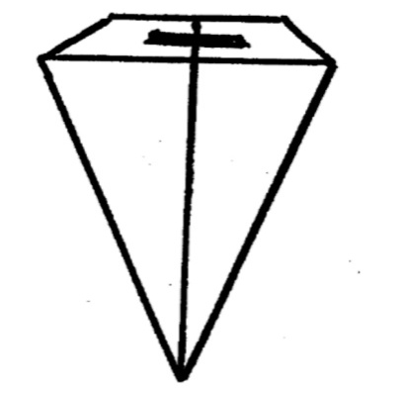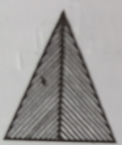

**Qn. Give the examples of wedges**

* Razor blades
* Axe
* Hoe
* Spear
* Knife
* Panga
* Needle
* An arrow
* A bullet

**Diagram showing the different examples of wedges.**

1. 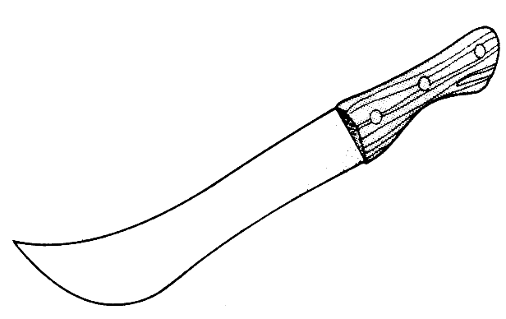**Panga**
2. 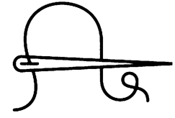**Needle**
3. 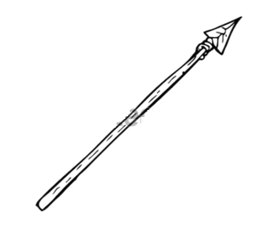**Spear**
4. 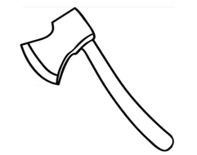**An Axe**
5. **Razor blade**

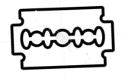

1. **Hoe**

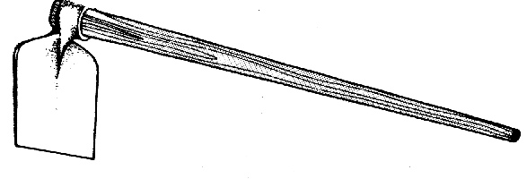

**Qn. State the uses of wedges.**

* Wedges are used to peel food.
* Wedges are used to cut food.
* Wedges are used to split wood.
* Wedges are used for sewing.
* Wedges are used for trimming hair.
* Wedges are used for cutting firewood.

**SCREWS**

**Qn. What is a screw?**

* A screw is an inclined plane wound around a rod.

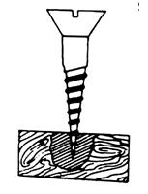**A diagram of a screw**

**Note:**

* The distance between two successional thread is called pitch.

**Qn. Identify the examples of screws.**

* Bolts
* Nuts
* Car jack / screw jack
* Engineers vice / clamp
* Screw nail
* Screw driver
* Spiral stair cases

**Diagram showing the examples of screws.**

1. 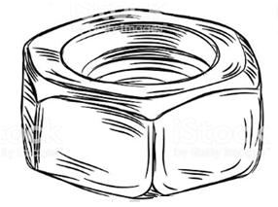**Nut**
2. 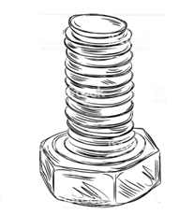**Bolt**
3. **Car jack**

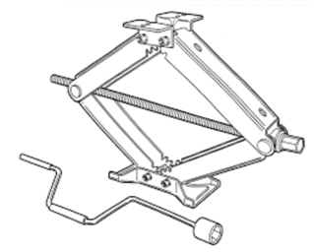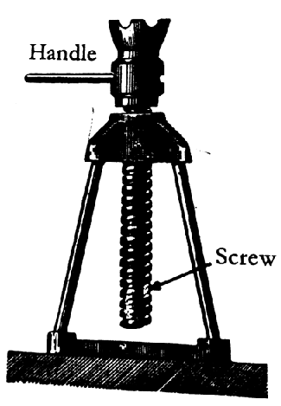

1. **Screw driver**

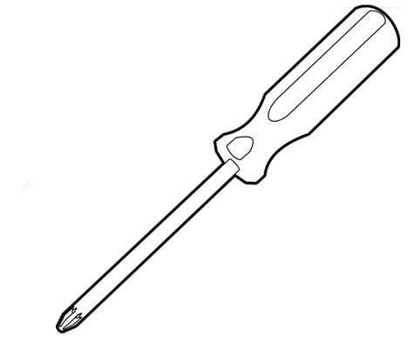

1. 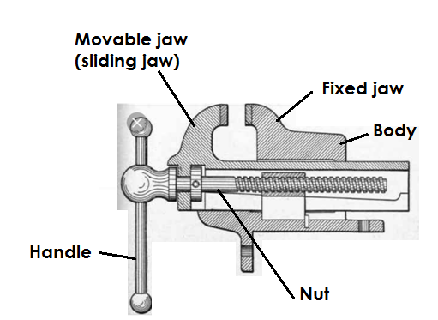**Engineers vice / clamp**
2. **Spiral stair cases**

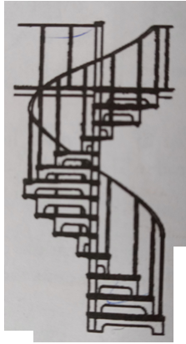

**Qn. Give the uses of screws**

* Screws are used to lift heavy vehicles.
* Screws are used to hold things tightly together e.g. bolts and nuts.
* Screws are used to fasten things together e.g. screw nails.
* Screws are used to make movements upstairs easy e.g. spiral stair cases.

**PULLEYS**

**Qn. What is a pulley?**

* A pulley is a free rotating wheel with a grooved rim.

**Qn. Why are pulleys grooved?**

* To prevent the rope /chain from sliding off the rim.

**Note:**

* A pulley has a rope /chain that is passed over the groove.
* The frame to which the pulley is fixed is called a block.
* 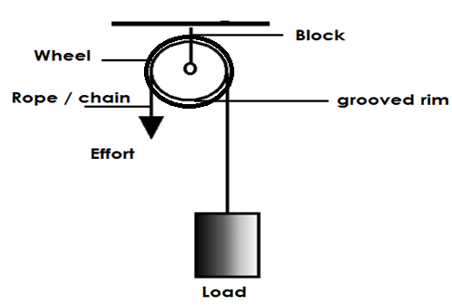**An illustration**

**Qn. Identify the two forces overcome by pulleys**

* Friction
* Force of gravity

**Types of pulleys**

**Qn. Mention the three types of pulleys**

* Single fixed pulleys.
* Single movable pulleys
* Block and tackle pulley e.g. (Fixed movable pulley)

**A single fixed pulley**

**Qn. What is a single fixed pulley?**

* A single fixed pulley is a type of pulley which is fixed on a frame and does not move.

**A diagram showing a single fixed pulley.**

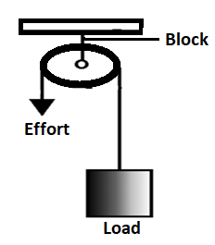

**Qn. State the characteristics of a single fixed pulley.**

* A single fixed pulley has a mechanical advantage of 1 (one).
* In a single fixed pulley the load is equal to the effort.
* A single fixed pulley changes direction of force.
* In a single fixed pulley the distance moved by the load is equal to the distance moved by the effort.
* A single fixed pulley is operated from down.

**Qn. State the advantage of using a single fixed pulley.**

* A single fixed pulley changes direction of force.

**Calculations on a single fixed pulley.**

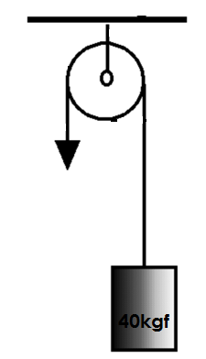**1. Find the force required to move the load in the diagram below.**

**Solution**:

M.A = L

E

I = 40kgf

E

I X E = 40kgf x E

E

E = 40kgf

**2. Find the effort applied to overcome the load of 50kgf using a single fixed pulley.**

**Solution**

M.A = Load

Effort

I = 50kg

E

I X E = 50kgf x E

E

E = 50kgf

**∴ The effort is 50kgf**

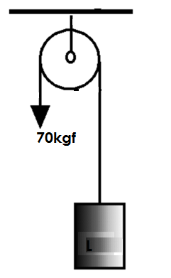**3. Find the load using the pulley below.**

**Solution:**

M.A = L

E

I = L

70kgf

70kg x I = L x 70kgf

70kgf

70kgf = L

**∴ Load = 70kgf**

**Note:**

* A single fixed pulley works as a first class lever.

**b) Single movable pulleys.**

**Qn. What is a single movable pulley?**

* A single movable pulley is a type of pulley supported by two ropes.

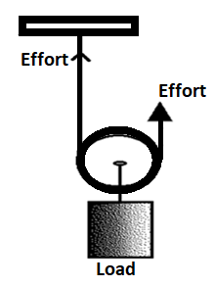**A diagram showing a single movable pulley**

**Qn. State the characteristics of a single movable pulley.**

* A single movable pulley has mechanical advantage of 2.
* In a single movable pulley,the effort applied is half the load.
* A single movable pulley is operated from up.
* In a single movable pulley, the distance moved by the effort is half the distance moved by the load.

**Qn. Give the advantage of using a single movable pulley.**

* A single movable pulley uses less effort to overcome the load / less effort is used to move the load.

**Calculations of single movable pulleys.**

1. 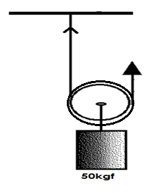Find the force required to move the load using the pulley below.

**Solution**

M.A = L

E

2 = 50kgf

E

2 x E = 50kgf x E

E

2E = 50kgs

2

**E = 25kgf**

1. **Mark used a single movable pulley to raise a load of 90kgf. what effort did he use?**

Solution

M.A = Load

Effort

2 = 90kgf

E

2E =90kgf

2 2

E = 45kgf

**He used an effort of 45kgf**

1. 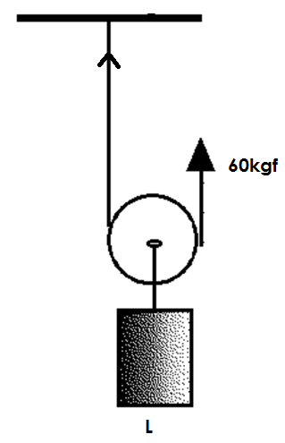Find the load using the pulley below.

**Solution**:

M. A = L

E

2 = L

60kgf

2 x 60kgf = L x 60kgf

60kgf

120kg =L

**∴Load = 120kgf**

**Note:**

* A single movable pulley acts as a second class lever.

**Qn. State the differences between a single fixed pulley and a single movable pulley.**

|  |  |
| --- | --- |
| Single fixed pulley | Single movable pulley |
| * There is change in direction of force. * Work is done faster * Effort applied is equal to the load. | * There is no change in the direction of force. * Work is slowly. * Effort applied is a half the load. |

1. **Block and tackle system (Movable fixed pulley)**

**Qn. What is a block and tackle system?**

* A block and tackle system is the type of pulley system which consists of both a fixed and movable pulleys.

**Note:**

* The mechanical advantage of a block and tackle system depends on the number of pulleys used.

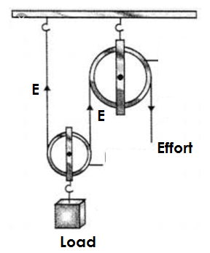**An illustration showing a block and tackle system**

**Qn. State the advantages of using block and tackle system or fixed movable pulleys.**

* Fixed movable pulleys change direction of force.
* Fixed movable pulleys use less effort to overcome the load.
* Fixed movable pulleys make work to be done faster.

**Qn. Identify the uses of pulleys in daily life.**

* Pulleys are used in cranes to lift heavy loads.
* Pulleys are used to raise and lower flags on flag poles.
* Pulleys are used for towing vehicles.
* Pulleys are used to move window curtains.
* Pulleys are used to lift heavy loads from one level to another during construction.
* Pulleys are used in lifts and elevators.
* Pulleys are used in scaffolds by painters to paint tall buildings.

**Wheel and axle**

**Qn. What is a wheel and Axle?**

* A wheel and axle is machine made up of an axle and a wheel.

**Note:**

An axle is a rod on which the wheel turns.

**Qn. Give examples of machines that use the wheel and axle.**

* Car steering wheel
* Wheels of a bicycle pedal
* Egg beaters
* Sewing machine
* Windlass / winch
* Door knobs
* Brace

**Diagram showing machines using a wheel and axle.**

1. **A windlass winch**

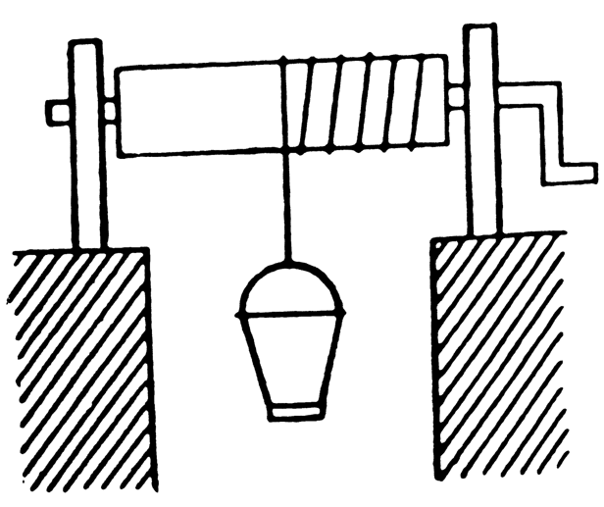

1. 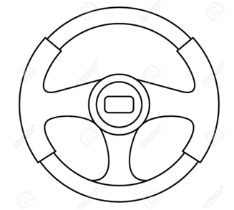**Car steering wheel**
2. **Handles of bicycles**

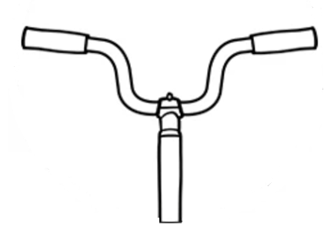

1. 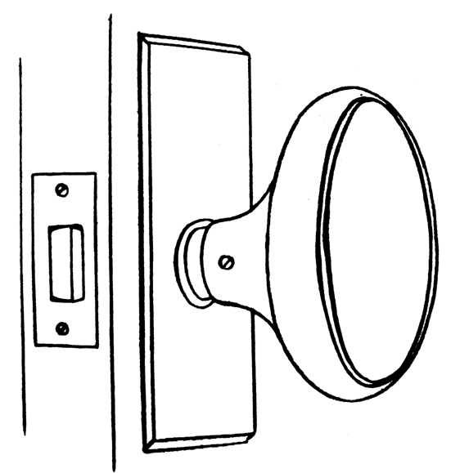**Door knob**
2. **Egg beater**

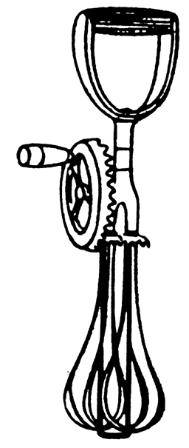

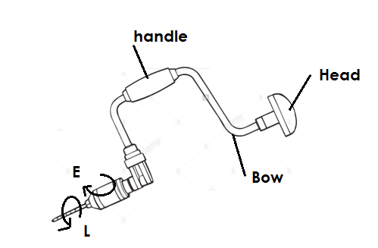**g) Brace**

**Qn. Give the uses of wheel and axle in daily life.**

* A windlass is used to draw water from underground.
* Egg beaters are used for preparing eggs for trying.
* Door knobs are used for opening and closing doors.
* Car steering wheels are used for steering cares while driving.
* Bicycle pedals are used to move bicycles.
* Braces are used to drill holes in wooden material.

**Gear wheels / cog wheels / toothed wheels.**

* Gear wheels are special machines of wheel and axle.
* Gear wheels have teeth around them that help to multiply the force.

**Diagram showing gear wheels / toothed wheels**

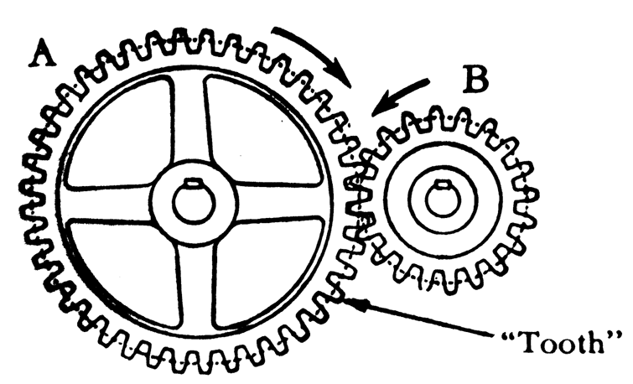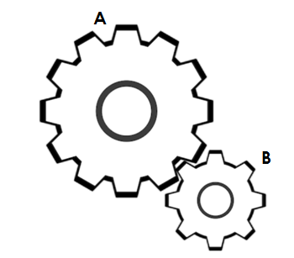

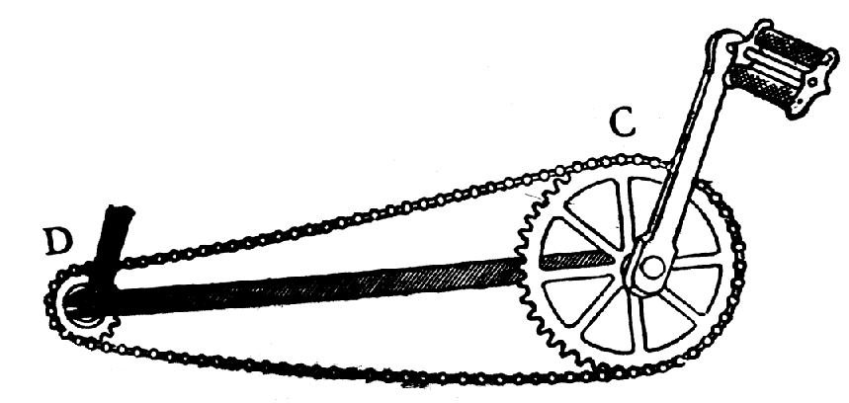**Chain and sprocket of a bicycle**

**Qn. Gear wheel A has 60 teeth and gear wheel B has 30teeth, how many turns will gear wheel B make in one revolution?**

**Solution**

Number of turns = No of teeth of gear wheel A

No of teeth of gear wheel B

= 60 teeth

30 teeth

= 2 turns

**Qn. State the uses of gear wheels.**

* Gear wheels are used to multiply force.
* Gear wheels are used to multiply speed in vehicles.
* Gear wheels are used to change direction of vehicles e.g. making reverse in vehicles.

**Belt drives**

**Qn. What are belt drives?**

* Belt drives are special forms of wheels and axle that transmit motion from one wheel to another.

**Note:**

* Wheels driven by belt drives move in the same direction.

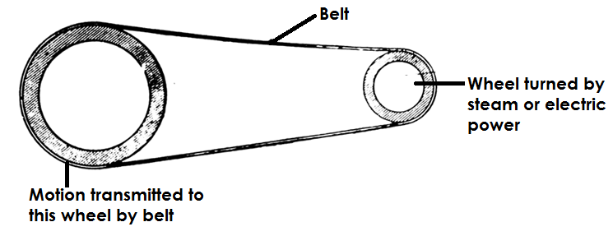**A diagram showing a belt drive**

**A conveyor belt**

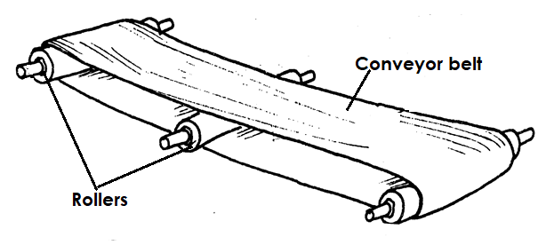

**Qn. Identify the uses of belt drivers.**

* Belt drives are used in factories to transport manufactured goods e.g. in bottling companies.
* Belt drives are used to transfer motion from one wheel to another e.g. bicycles.

**Qn. Give the examples of machines that uses gear wheels and belt drivers.**

* Bicycles
* Cars
* Vehicles
* Sewing machines
* Motorcycles
* Grinding mills.

**FRICTION**

**Qn. What is friction?**

This is the force that opposes motion.

**Qn. Write down at least two properties of friction.**

* The rougher the surface. The greater the force of friction.
* The smoother the surface the less the force of friction
* Friction produces heat.
* Friction occurs in all the three states of matter.
* The greater the load, the greater the force of friction.

**Types of friction**

**Qn. Identify any three types of friction.**

* Static friction.
* Viscosity friction
* Rolling / sliding / kinetic friction.

**Qn. What is static friction?**

* Static friction is the type of friction that occurs in objects fixed in one position.

**Qn. State at least two examples of static friction.**

* A nail fixed in a wall.
* Children standing on the assemble ground.
* A baby at the mother’s back.
* A screw nail fixed in a nut.
* A car packed.
* A book placed on a table.
* A person seated on a chair.

**Qn. What is viscosity friction?**

* This is the type of friction that occurs in liquid and gases.

**Qn. Identify at least two examples or situation where viscosity friction is applied.**

* A fish swimming.
* A bird flying.
* An aeroplane flying.

**Qn. What is sliding friction?**

This is the type of friction that occurs between two objects that are in sliding contact.

**Qn. Give example of situations where sliding friction occurs.**

* Rubbing both hands together.
* A stone rolling on a hill.
* A ball rolling on the ground.
* A coaster sliding against the table.
* A person sliding down the slide.

**Qn. State the different ways in which friction is a useful force or advantages of friction.**

* Friction enables us to write.
* Friction helps us to walk without sliding.
* Friction helps us to brush teeth.
* Friction helps in lighting match sticks.
* Friction helps to climb mountains.
* Friction helps to stop bicycles when brakes are applied.
* Friction helps grinding millet on a grinding stone.
* Friction helps in sharpening objects e.g. panga, knife etc.
* Friction helped early man to make fire.

**Qn. State the ways in which friction is a nuisance force (Disadvantages of friction)**

* Friction causes wear and tear of objects e.g. shoe soles, car tyres.
* Friction causes unnecessary noise in machines.
* Friction causes unnecessary heat.
* Friction reduces efficiency of machines.
* Friction delays work.
* Friction reduces speed of movement.

**Qn. Identify the different ways of increasing friction.**

* By putting treads on shoe soles and car tyres.
* By making smooth surfaces rough.
* By putting spikes on sports shoes.
* By putting tarmac on road surfaces.
* By putting grips on handles of bicycles.

**Diagrams showing materials that increase friction.**

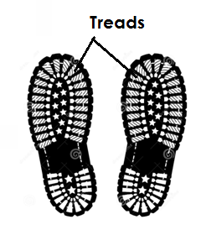**a) Treads on shoes.**

1. **Spikes on shoes**

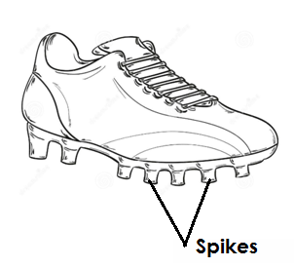

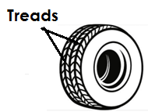**c) Treads on a tyre.**

**d) Grips on bicycle handles**

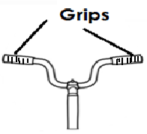

**Qn. Give the different ways of reducing friction.**

* By lubricating i.e. greasing or oiling.
* By use of ball bearings.
* By use of rollers.
* By making rough surfaces smooth.
* By streamlining bodies of objects e.g. aeroplanes cars.

**Qn. How do ball bearings reduce friction?**

* Ball bearings keep the moving parts of a machine separated from each other.

**Qn. How do rollers reduce friction?**

* Rollers decrease the areas of friction between moving parts.

**Qn. Identify the materials used to reduce friction.**

* Ball bearings
* Grease
* Oil
* Rollers
* Sand paper

**Diagram showing some objects that reduce friction.**

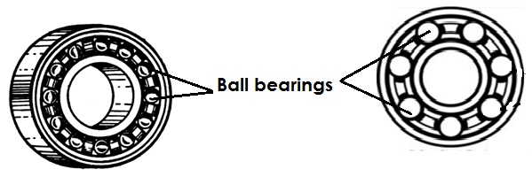**a)Ball bearings**

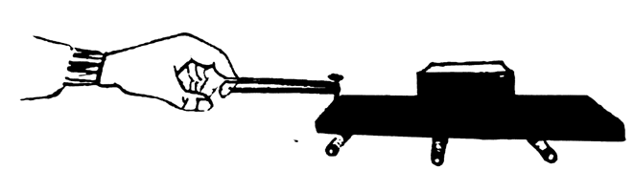**b) Rollers**

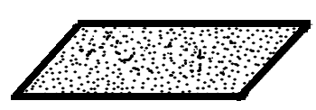**c) Sand paper**

**THEME: HUMAN BODY**

**TOPIC 5: EXCRETORY SYSTEM**

**Qn. What is an excretory system?**

* An excretory system is a system that helps to remove waste products from the body before they become toxic.

**Qn. What is excretion?**

* Excretion is the removal of waste products from the body before they become toxic.

**Qn. Write down the four major examples of excretory organs in the body.**

* The kidneys
* The lungs
* The skin
* The liver

**Qn. Give at least one example of waste material removed from the body by each of the following excretory organs.**

**1. Kidneys**

* Urine

**Qn. Identify the components of urine.**

* Excess water
* Excess salts
* Excess sugar
* Urea
* Uric acid

**2. The lungs**

* Carbon dioxide.
* Water vapour

**3. The skin**

* Sweat
* Lactic acid

**Qn. Mention the components of sweat.**

* Excess water
* Excess salts

1. **The Liver**

* Bile pigment

**The kidneys**

* The kidneys belong to the urinary and excretory systems.
* The kidneys are two in the body of a normal human being.
* The kidneys are bean shaped and reddish in colour due to a large number of blood vessels they contain.

**Qn. State the functions of the kidneys**

* Kidneys filter blood.
* Kidneys regulate the levels of water, salts and sugar in the body.
* Kidneys excrete urine
* Kidneys regulate body temperature.

**Qn. Why is the left kidney located slightly higher than the right kidney?**

* The left kidney is found under the spleen while the right kidney is found under the liver which is the largest internal organ of the body.

**The structure of the urinary system**

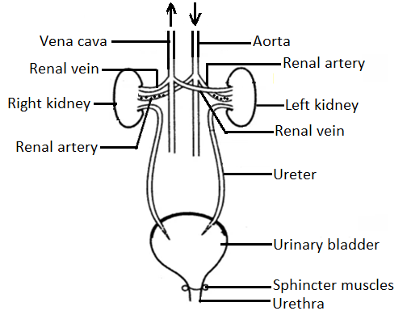

**The structure of the kidney**

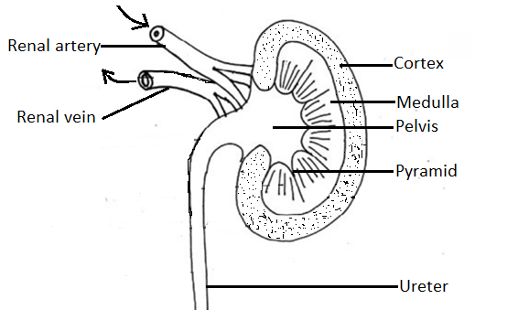

**Qn. State the function of each part.**

**i) Kidney wall**

* The kidney wall protects the internal parts of the kidney.

**ii) Cortex**

* It is where filtration of blood takes place.

**iii) Medulla**

* It is where re-absorption of excess water, salts and sugar takes place.

**iv) Pyramids**

* Pyramids are the holes through which urine pours to the pelvis.

**v) Pelvis**

* It is where urine collects before it is taken to the urinary bladder.

**vi) Ureter**

* The ureter is the passage of urine from the pelvis to the urinary bladder.

**OR**

* The ureter transports urine from the pelvis to the urinary bladder.

**Vii)Renal artery**

* The renal artery transports oxygenated blood from the heart to the kidney.

1. **Renal vein**

* The renal vein transports de-oxygenated blood from the kidney to the heart.

1. **Urinary bladder**

* The urinary bladder stores urine for a short time.

**X) Sphincter muscles**

* The sphincter muscles control the opening and closing of the urinary bladder.

**xi) Urethra**

* The urethra is the passage of urine out of the body.

**Qn. Identify the diseases and disorders of the urinary system.**

* Bilharziasis
* Gonorrhoea
* Kidney cancer
* Kidney stones
* Kidney failure
* Nephritis or inflammation of the kidneys

**Qn. State the different ways of maintaining the proper function of the kidney.**

* Doing daily physical exercises.
* Always drink boiled water.
* Avoid holding back urine for a long time.
* Avoid taking a lot of alcohol.
* Feeding on a balanced diet.
* Avoid taking a lot of salt in food.
* Avoid dangerous games that may cause harm to the kidneys.
* Go for regular medical check ups.

**THE LUNGS**

* The lungs are both excretory and respiratory organs.

**Qn. Why are the lungs regarded as excretory organs?**

* The lungs excrete / remove carbon dioxide and water vapour from the body.

**Qn. Why are the lungs regarded as respiratory organs?**

* Lungs allow oxygen into the body for the process of respiration.

**Qn What is respiration?**

* Respiration is the process by which the body uses oxygen and digested food to produce energy, carbon dioxide and water vapour.

**Qn. Mention the raw materials needed by the body for respiration.**

* Digested food
* Oxygen

**Qn. Identify the products of respiration?**

* Energy
* Carbon dioxide
* Water vapour

Summary

**Food + Oxygen------Energy + carbon dioxide + water vapour**

**Note:**

* Energy is a useful product.
* Carbon dioxide and water vapour are waste materials.

**Qn. Where does respiration take place in the body?**

* In the body cells.

**Qn. State the role of oxygen during respiration.**

* Oxygen burns down food to produce energy.

**OR**

* Oxygen oxidizes food for the body to produce energy.

**Qn. State the importance of respiration to the body.**

* Respiration enables the body to gain energy.
* Respiration enables the body to release water vapour.

**Types of respiration**

**Qn. Mention the two types of respiration**

* Aerobic respiration
* Anaerobic respiration**.**

**Qn. What is aerobic respiration?**

* Aerobic respiration is the type of respiration that takes place in the presence of oxygen.

**Qn. What is anaerobic respiration?**

* Anaerobic respiration is the type of respiration that does not use oxygen.

**The structure of the lungs.**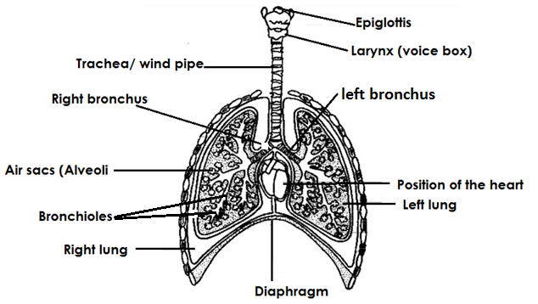

**Qn. State the functions of the parts**

1. **Nose**

* The nose is the passage of air into the lungs.
* The nose contains mucus and tiny hair called cilia.

**Qn. State the importance of the cilia in the nose.**

* To trap dust and other foreign bodies.
* To trap bacteria.

**Qn. Give the function of mucus in the nose.**

* Mucus moistens air.

**Qn. What happens to air in the nose?**

* Air is moistened.
* Air is filtered.
* Air is warmed.

**Qn. Why is the nose said to be the best passage of air into the lungs?**

* Air through the nose is warmed, filtered and moistened.

**Qn. Why is it not advisable to breathe through the mouth?**

* Air through the mouth is cold and may chill the lungs.

**OR**

* Air through the mouth is not warmed, filtered and moistened.

**b) Epiglottis**

* The epiglottis prevents food and other foreign bodies from entering the trachea.

**c) Larynx /Voice box**

* The larynx contains vocal cords which vibrate and produce sound.

**d) Wind pipe / trachea**

* The trachea allows air into the lungs.

**Qn. Why is the tracheamade of rings of cartilage?**

* To keep it open all the time.

**OR**

* To prevent it from closing.

**Qn. Why should the trachea be kept open all the time?**

* To prevent it from collapsing which leads to suffocation.

**e) Bronchi (two) Bronchus – (one)**

* The bronchi take air from the trachea to each part of the lungs.

**f) Bronchioles**

* Bronchioles are tubes which supply air to the air sacs.

**g) Air sacs / Alveoli**

* It is where exchange of gases takes place.

**Qn. How are air sacs adapted to their function?**

* Air sacs are many in number.
* Air sacs are thin walled.
* Air sacs are surrounded by a net work of blood capillaries.

**Qn. Why are air sacs many?**

* To increase the surface area for gaseous exchange.

**Qn. Why are air sacs thin walled?**

* To allow easy diffusion of gases.

**Qn. Why are air sacs surrounded by a network of blood capillaries?**

* To supply air sacs with oxygen and digested food.

1. **Diaphragm**

* The diaphragm separates the chest cavity from the abdominal cavity.

**BREATHING**

**Qn. What is breathing?**

* Breathing is the taking in of air rich in oxygen and taking out air rich in carbon dioxide.

**Qn. Mention the two types of breathing.**

* Breathing in / Inhalation / inspiration
* Breathing out / Exhalation / Expiration.

**Qn. What is inhalation?**

* Inhalation is the taking in of air rich in oxygen.

**Qn. State what happens to the following during inhalation or breathing in:-**

**a) Lungs**

* The lungs expand.

**Qn. Why do lungs expand during breathing in?**

* To create space/room for the incoming air.

**b) The volume inside the chest.**

* The volume inside the chest increases.

**c) The diaphragm.**

* The diaphragm contracts.

**d) The ribs**

* The ribs move upwards and outwards.

**e) Intercostal muscles**

* The intercostals muscles contact.

**Exhalation / Expiration / Breathing out**

**Qn. What is exhalation?**

* Exhalation is the taking out of air rich in carbon dioxide.

**Qn. Briefly explain what happens to the following parts during exhalation.**

**a) The lungs**

* The lungs return to their original size.

**b) The volume inside the chest**

* The volume inside the chest decreases.

**c) The diaphragm**

* The diaphragm relaxes.

**d) The ribs**

* The ribs move downwards and inwards.

**e) Intercostal muscles**

* The intercostal muscles relax.

**Qn. State one difference between the air we breathe in and that one we breathe out.**

* The air we breathe in has more oxygen than the air we breathe out.
* The air we breathe out has more carbon dioxide than the air we breathe in.
* The air we breathe in has more density than the air we breathe out.

**Qn. Why does the air we breathe in contain more oxygen than the air we breathe out?**

* Part of oxygen is used during respiration.

**Qn. Why does the air we breathe out contain more carbon dioxide than the air we breathe in?**

* More carbon dioxide is produced during respiration.

**Qn. Why does nitrogen remain unchanged during respiration?**

* No process in the body uses nitrogen.

**Diseases of the respiratory system**

**Tuberculosis**

* It is an airborne disease caused by **mycobacterium**.

**Qn. Write down any three signs and symptoms of tuberculosis.**

* Chromic cough.
* Coughing and spitting mucus with blood stains.
* Persisted fever.
* A lamp grows on the spine
* Pain in the backbone.

**Qn. State the ways of preventing and controlling tuberculosis.**

* Immunize children at birth using B.C.G vaccine.
* Isolate infected people.

**Diphtheria**

* It is a bacterial disease spread through air.

**Qn. Write down the signs and symptoms of diphtheria.**

* Swollen neck.
* Sore throat
* Prolonged fever

**Qn. Give different ways of preventing and controlling diphtheria.**

* Immunize children at 6, 10 and 14 weeks using DPT vaccine.
* Isolate infected people.

**Whooping cough (Pertussis)**

**Qn. Name the germ that causes whooping cough.**

* Whooping cough is caused by bacteria and it is spread through air.

**Qn. State the signs and symptoms of whooping cough.**

* Coughing that result into vomiting.
* Runny nose
* Gasp for breathe

**Qn. Identify the different ways of controlling and preventing whooping cough.**

* Immunize children at 6, 10 and 14 weeks using DPT vaccine.
* Isolate infected people.

1. **Pneumonia**

**Qn. Name the germ that causes pneumonia.**

* Pneumonia is caused by bacteria called streptococcus pneumoniae.

**Qn. State the sign and symptoms of pneumonia.**

* Coughing and spitting mucus with blood stains.
* Difficulty in breathing.
* Chest pain.
* Sudden feeling of coldness.
* Fever

**5. Influenza.**

**Qn. Name the germs that cause influenza.**

* Influenza is caused by a virus and is spread through air.

**Qn. State the signs and symptoms of influenza.**

* Runny nose
* Congested nose
* Fever
* Muscle pain

**Qn. Give the ways of controlling and preventing influenza.**

* Avoid staying and living in crowded places.
* Avoid living in very cold places.

**Qn. Write down any two smoke related respiratory diseases.**

* Lung cancer
* Emphysema
* Bronchitis.

**Other respiratory diseases**

* Asthma
* Pleurisy

**Qn. Identify the different ways of maintaining the proper functioning of the respiratory system.**

* Avoid smoking
* Having regular physical exercises.
* Immunize children against childhood killer diseases.
* Avoid staying in crowded places.
* Avoid staying in very cold places.
* Feeding on a balanced diet.
* Always breathe through the nose but not through the mouth.

**THE HUMAN SKIN**

* The skin is an organ that covers the body.
* The skin is the largest body organ.

**Qn. What does the skin excrete?**

* Sweat
* Lactic acid

**Qn. Identify the components of sweat.**

* Excess water.
* Excess salts.

**Qn. Name the two main layers of the skin.**

* Epidermis (outer layer)
* Dermis (Inner layer)

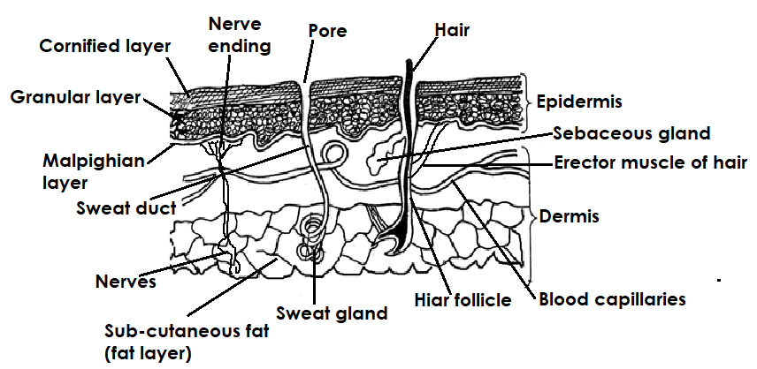**The structure of the skin**

**Qn. State the functions of the different parts of the skin.**

**Epidermis**

* The epidermis protects the inner layer of the skin.
* The epidermis prevents dirt, germs and water from entering into the body.

**Note:**

* The epidermis is further divided into three other layers.

**Qn. Name the three layers of the epidermis**

* Cornified layer
* Granular layer
* Malpighian layer.

**a) Cornified layer**

* The cornified layer is made up of dead cells.

**Qn. State the functions of the cornified layer.**

* The cornified layer protects the body from fungal, viral and bacterial infections.
* The cornified layer prevents the loss of water from the body by evaporation.

1. **Granular layer**

* The granular layer is made up living cells which continuously grow to form the malpighian layer.

**c) Malphighian layer**

**Qn. Name the pigment contained in the malpighian layer.**

* Melanin

**Qn. State the functions of melanin.**

* Melanin determines the skin colour.
* Melanin protects the body from the direct rays from the sun.

**Qn. Identify the condition that results from lack of melamin in the body.**

* Albinism

**2. Dermis**

* The dermis is the inner layer of the skin.

**Qn. Identify the parts that make up the dermis.**

**a) Hair follicle**

* Hair follicles are the pockets from which hair grows.

**b) Hair**

* The hair controls body temperature.

**Qn. How does the hair control body temperature?**

* By standing up when it is cold.
* By lying flat on the skin when it is hot.

**c) Erector muscle.**

* The erector muscle makes the hair stand upright.

**d) Sebaceous glands**

* The sebaceous gland produces sebum.

**Note:**

* Sebum is the oil that keeps the skin oily and moist.

**e) Sweat glands.**

* The sweat glands produce sweat.

**f) Sweat duct**

* The sweat duct lets out sweat from the sweat glands.

**g) Sweat pores**

* The sweat pores let out sweat from the body.

**h) Nerve endings.**

* The nerve endings enable us to feel cold, hot, touch and pain.

1. **Blood vessels / blood capillaries.**

* Blood vessels /blood capillaries supply the skin with food and oxygen.

1. **Fat layer**

* The fat layer prevents heat loss from the body.

**Qn. State the different ways how the skin controls body temperature on hot days.**

* By sweating.
* By vasodilation
* By the hair on the skin lying flat (the hair on the skin lies flat)

**Qn. What is vasodilation?**

* Vasodilation is the widening of blood vessels to allow flow of blood to the skin surface.

**Qn. Give the different ways the skins controls body temperature on cold days.**

* By shivering
* By vasoconstriction.
* By production of goose pimples.
* The hair on the skin stands up right.

**Qn. What is vasoconstriction?**

* Vasoconstriction is narrowing of blood vessels to reduce flow of blood to the skin surface.

**Qn. Why do we urinate more frequently on cold days than on hot days?**

* On cold days we lose water by urinating while on hot days we lose water by sweating and urinating.

**Qn. Name the cells in the skin that help to produce hair, toes and finger nails.**

* Keratin cells

**Function of the skin**

**Qn. Write down the different functions of the skin.**

* The skin acts as a sense organ.
* The skin acts as an excretory organ.
* The skin makes vitamin D by the help of sunshine.
* The skin protects body tissues from harm.
* The skin regulates body temperature.
* The skin stores fats which prevent heat loss from the body.

**Diseases of the skin**

**Qn. Identify the different diseases that affects the skin.**

* Ringworm
* Athletes foot
* Leprosy
* Scabies
* Impetigo
* Measles
* Scurvy
* German measles (Rubella)
* Chicken Pox
* Skin cancer
* Syphilis

**a) Ring worm**

**Qn. Name the germ that causes ringworm.**

* Fungus / Fungi

**Qn. State the different ways through which ring worm spreads.**

* Through close body contact with an infected person.
* Through sharing clothes with an infected person.
* Through sharing sponges with an infected person.
* Through sharing beddings with an infected person.

**Qn. Identify the signs and symptoms of ring worm.**

* Itching of the skin.
* Red round patches on the skin.
* Hair falls off the affected part.

**Qn. Give the different ways of preventing and controlling ring worm.**

* Maintain proper personal hygiene.
* Avoid sharing clothes with an infected person.
* Avoid sharing beddings with an infected person.
* Avoid sharing sponges with an infected person.

**b) Athletes foot**

* Athlete’s foot is caused by a fungus / fungi.

**Qn. Give the different ways through which athletes foot spreads.**

* Sharing stockings with an infected person.
* Sharing shoes with an infected person.

**Qn. Identify the signs and symptoms of athletes foot.**

* The skin between the toes peels off.
* White cracks between toes.

**Qn. Give the different ways of preventing and controlling athletes foot.**

* Avoid sharing stockings with infected persons.
* Change stockings and shoes regularly.
* Apply fungal powder between toes.

**c) Leprosy**

* Leprosy is caused by **bacillus bacteria**.

**Qn. How is leprosy spread?**

* Through close body contact with an infected person.
* Through air in crowded places.

**Qn. State the signs and symptoms of leprosy.**

* Toes and fingers get eaten away.
* The limbs become numb (loss of sense for feeling)
* Large sores develop on the skin.
* Hair falls off from the affected part.

**Qn. Give the different ways of preventing and controlling leprosy.**

* Avoid close body contact with infected people.
* Isolation of infected people.

**d) Scabies**

* Scabies is caused by **sarcoptesscabiei** (**itch mite**).

**How is scabies spread?**

* Sharing clothes with infected people.
* Sharing bathing sponges with infected people.
* Sharing beddings with infected people.
* Close contact with infected people.

**Qn. State the signs and symptoms of scabies.**

* Itching of the skin.
* Watery swellings on the skin.

**Qn. Give the different ways of preventing and controlling scabies.**

* Avoid sharing clothes with an infected person.
* Maintain proper personal hygiene.
* Avoid sharing beddings with infected people.
* Avoid sharing bathing sponges with infected people.

**e) Impetigo**

* Impetigo is caused by bacteria.

1. **Measles**

* Measles is caused by a virus.

1. **Chicken pox**

* Chicken pox is caused by a virus.

1. **German measles (Rubella)**

* German measles is caused by a virus.

**i) Scurvy**

* Scurvy is caused by lack of vitamin C in the diet.

**j) Skin cancer**

* Skin cancer is caused by too much exposure to dangerous chemicals.

**Qn. Mention the disorders of the skin.**

* Corns
* Burns
* Scalds
* Cuts
* Wounds

**Qn. Give the ways of maintaining the proper functioning of the skin.**

* Having regular physical exercises.
* Feeding on a balanced diet.
* Promoting proper personal hygiene.
* Bathing daily.
* Protect the skin from strong sunshine.
* Avoid applying strong cosmetics on the skin.
* Avoid sharing clothes with an infected person.
* Cover wounds and cuts with sterilized bandages.
* Always visit health centresincase of a skin infection.

**THE LIVER**

* The liver is the largest internal body organ.

**Qn. What does the liver excretes?**

* The liver excretes bile pigment.

**A diagram showing the liver**

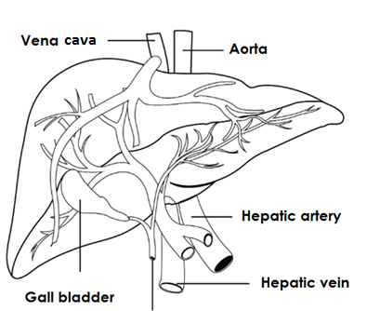

**Blood circulation in relation to the liver.**

1. **Hepatic artery**

* The hepatic artery transports oxygenated blood from the heart to the liver.

**ii) Hepatic vein**

* The hepatic vein transports de-oxygenated blood from the liver to the heart.

**iii) Hepatic portal vein**

* The hepatic portal vein transports blood rich in digested food from the ileum to the liver.

**Functions of the liver**

**Qn. State the various functions of the liver.**

* The liver produces bile that breaks down fats.
* The liver is a detoxicating agent.
* The liver produces heat in the body.
* The liver stores important vitamins e.g. vitamin A, vitamin B1, 2 and vitamin B1.
* The liver stores important mineral salts e.g. iron, potassium.
* The liver regulates blood sugar.
* The liver helps in deamination.

**Qn. Mention the diseases that affect the liver.**

* Hepatitis B
* Liver abcess
* Cirrhosis of the liver
* Liver cancer

**a) Hepatitis B**

* Hepatitis B is caused by a virus.

**Qn. How is hepatitis spread?**

* Hepatitis B is spread through contact with infected blood.
* Hepatitis B is spread through contact with infected semen.

**b) Liver abscess**

* Liver abscess causes boils on the liver.

**c) Cirrhosis of liver**

* Cirrhosis of the liver is the hardening of the liver caused by excessive drinking of alcohol.

**d) Live cancer**

**Qn. State the ways of maintaining the proper functioning of the liver.**

* Having regular physical exercises.
* Feeding on a balanced diet.
* Avoid excessive drinking of alcohol.

**THEME: MATTER AND ENERGY**

**TOPIC 6: LIGHT ENERGY**

**Qn. What is light?**

* Light is a form of energy that enables us to see.

**OR**

* Light is a form of energy that stimulates the sense of seeing / Sight.

**Qn. Why is light regarded as a form of energy?**

* Light has the ability to do work.
* Light is capable of doing work.

**Qn. Why are we able to see things around us?**

* Things around us reflect light into our eyes.

**Qn. Why are we unable to see in darkness?**

* There is no light to be reflected into our eyes.

**Qn. State the importance of light in the environment.**

* Light enables us to see.
* Light helps in photography.
* Light from the sun helps plants to make their own food.
* Light from the sun enables farmers to dry their harvested crops.
* Sunlight helps in drying washed clothes.
* Sunlight helps in the generation of solar energy.
* Sunlight enables eggs of amphibians, reptiles and fish to hatch.
* Traffic lights are used on streets to control road accidents.
* Light from the sun enables our skins to make vitamin D.

**Sources of Light**

**Qn. What is a source of light?**

* A source of light is an object / body / material that gives out light.

**Qn. Identify the types of sources of light.**

* Natural sources of light.
* Artificial sources of light.

1. **Natural sources of light.**

* Natural sources of light are objects that produce light by nature.

**Qn. Write down the examples of natural sources of light.**

* The sun
* Stars
* Fire flies
* Glow worms
* Volcanic eruption
* Lightning.

**Note:**

* The sun is the main source of light.

1. **Artificial sources of light.**

**Qn. What are artificial sources of light?**

* Artificial sources of light are objects that produce light and are made by people.

**Qn. Write down the different examples of artificial sources of light.**

* Electric bulbs
* Torches
* Candles
* Kerosene lamps
* Burning charcoal
* Fire
* Pressure lamps etc

**Note:**

* Sources of light are subdivided into two groups.

i) Luminous sources of light (Direct sources).

ii) Non luminous sources of light (Indirect sources)

**a) Luminous sources of light**

**Qn. What are luminous sources of light?**

* Luminous sources of light are objects that produce / emit their own light.

**OR**

* Luminoussources of light are objects that produce light directly.

**Qn. Mention the different examples of luminous sources of light.**

* Sun
* Stars
* Lightning
* Volcanic eruption
* Glow worms
* Fire
* Filament bulbs
* Burning charcoal
* Candles
* Lamps

**Qn. What name is given to living things that produce light?**

* Bio-luminescent objects.

**Qn. How do we call the production of light by living things?**

* Bio-luminescence

**Qn. Write down any examples of bio-luminescent objects.**

* Glow worms
* Fire flies
* Jelly fish
* Dragon fish
* Some squids

**Qn. What are incandescent sources of light?**

* Incandescent sources of light are objects that produce light when they are red hot.

**Qn. Write down the different examples of incandescent sources of light.**

* Sun
* Stars
* Burning charcoal
* Working filament of electric bulbs.

**b) Non – Luminous sources of light (Indirect sources)**

**Qn. What are non- luminous sources of light?**

* Non-luminous sources of light are objects that do not produce / emit their own light.

**OR**

* Non-luminous sources of light are objects that reflect light from other sources.

**Qn. Mention the different examples of non-luminous sources of light.**

* Moon
* Planets
* Mirrors

**Qn. Why is the moon not regarded as a source of light?**

* The moon reflects light from the sun.

**Speed of light**

* The speed of light in normal air is 300,000km / sec.

**Note:**

* Light travels fastest in objects with less density e.g. air.
* Light travels slowest in objects that have more density than air e.g. water, glass, etc.

**Properties of light**

Qn. **Identify the different properties of light.**

* Light can be reflected.
* Light travels in a straight line
* Light can be refracted.
* Light travels in all direction.
* Light does not require a medium of transmission / light does not require a medium to travel.

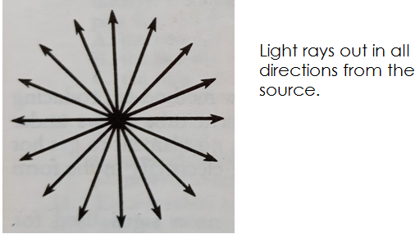**An illustration showing that light travels in all direction from the source.**

**Qn. Give any two similarities between light and sound.**

* Both can be reflected.
* Both are forms of energy.

**Qn. State any two differences between light and sound energy.**

* Light energy does not require a medium of transmission while sound energy requires a medium of transmission.
* Light can travel through a vacuum while sound can not travel through a vacuum.

**Qn. Write down the instances that shows that light travels faster than sound.**

* During a thunder storm, we see lightning before thunder is heard.
* During a race, we see a flash of light at the starter’s gun before hearing its sound.
* During a gunshot, we see a flash of light before hearing its sound.

**An experiment to show that light travels in a straight line.**

* Cardboards.
* Source of light.

**iii) Procedure**

* Get three cardboards and put a hole in each of them at the centre.
* Arrange them in a straight line and provide the source of light at exactly the same point.
* Look through and observe.

**Set up of experiment A**

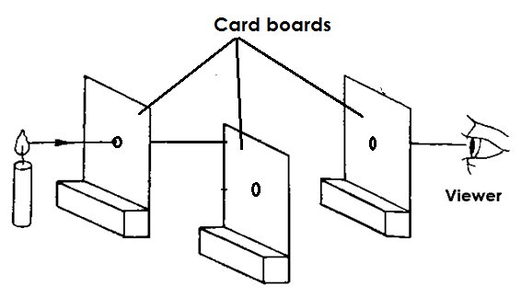**Arrangement 1**

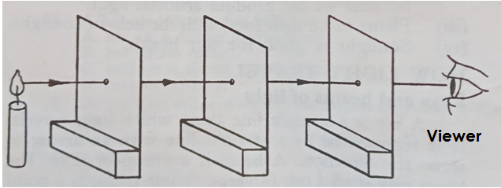**Arrangement 2**

**Note:**

* In arrangement 1, the cardboards are not in a straight line and light cannot pass through.
* In arrangement 2, the cardboards are in a straight line and light can pass through.

**Qn. Why is light unable to pass through in arrangement 1?**

* The cardboards are not in a straight line yet light travels in a straight line.

**Set up of experiment B**

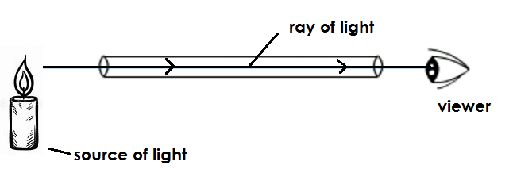**Arrangement 3**

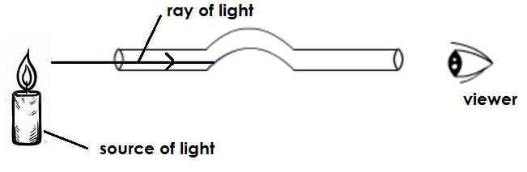**Arrangement 4**

**Observation**

* In arrangement 3, the tube is in a straight line and light can be seen through.
* In arrangement 4, the tube is bent and light cannot be seen through.

**Qn. Why is light unable to pass through arrangement 4?**

* The tube is bent and light cannot pass through yet light travels in a straight line.

**Qn. Write the two instances that show that light travels in a straight line.**

* We are unable to see around corners because light travels in a straight line.
* Shadows occur because light travels in a straight line.

**Qn. Why are we unable to see around corners?**

* Light travels in a straight line.

**Rays and beams of light**

**Qn. What is a ray of light?**

* A ray is a path taken by light.

**OR**

* A ray is a straight line through which light travels.

**Note:**

* A diagram showing a ray of light.

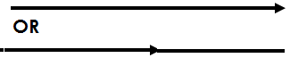

**b) BEAMS**

**Qn. What is a beam of light?**

* A beam of light is a collection of light rays.

**OR**

* A beam of light is a stream of light rays.

**Qn. Write down the three types of beams.**

* Parallel beam of light.
* Converging beam of light.
* Diverging beam of light.

1. **Parallel beam of light**

**Qn. What is a parallel beam of light?**

* A parallel beam of light is a type of beam where light rays move from the same source but do not meet.

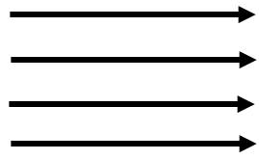**A diagram showing a parallel beam of light.**

**OR**

1. **Converging beam of light.**

**Qn. What is a converging beam of light?**

* A converging beam of light is a type of beam where light rays come from different sources / directions and meet at one point.

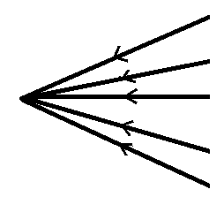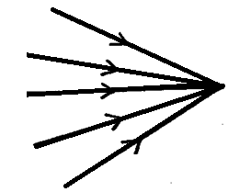**A diagram showing a converging beam of light.**

**OR**

1. **Diverging beam**

**Qn. What is a diverging beam of light?**

* A diverging beam of light is a type of beam where light rays move from one point and spread.

**Qn. Mention any two objects that produce a diverging beam of light.**

* Car headlights
* Torches

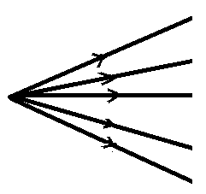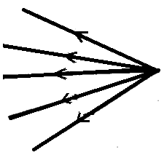**A diagram showing a diverging beam.**

**OR**

**Effects of light on different materials**

When light meets an object, one of the following happens:-

* Light is absorbed.
* Light is allowed to pass through
* Light is scattered or diffused.

**Note:**

* Materials / objects are divided into three groups depending on the effect of light on them.

The materials include:-

* Transparent objects.
* Translucent objects
* Opaque objects

1. **Transparent objects**

* Transparent objects are objects that allow all light to pass through them.

**Qn. Write down the examples of transparent objects.**

* Clear glass
* Clear polythene paper
* Clear air
* Clear water

**A diagram showing the effect of light on transparent objects.**

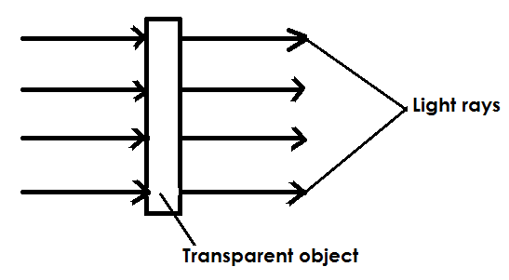

1. **Translucent objects**

**Qn. What are translucent objects?**

* Translucent objects are objects that allow little light to pass through them.

**Qn. Write down the different examples of translucent objects.**

* Tracing paper
* Coloured glass
* Smoky air
* Frosten glass
* Oiled paper
* Thin clothes

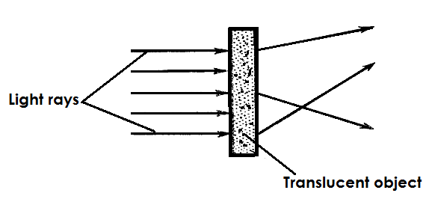**A diagram showing the effect of light on translucent objects**

1. **Opaque objects**

**Qn. What are opaque objects?**

* Opaque objects are objects that do not allow light to pass through them.

**Qn. Mention examples of opaque objects.**

* Walls
* Wood
* Human beings
* Metals
* Stones
* Sand paper
* Black cloth

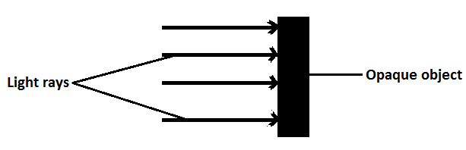**A diagram showing the effects of light on opaque objects.**

**Qn. What is the effect of opaque objects on light?**

* Opaque objects block light and a shadow is formed.

**OR**

* Opaque objects obstruct light and a shadow is formed.

**Shadows**

**Qn. What is a shadow?**

* A shadow is a region of darkness caused by obstruction of light by an opaque object.

**OR**

* A shadow is a region of darkness formed when light is blocked by an opaque object.

**Qn. State the characteristics of shadows**

* The shape of a shadow depends on the shape of opaque objects.
* The size of a shadow depends on the size of the object.
* The size of shadow depends on the size of the source of light.
* Shadow are made up of two parts i.e. umbra and penumbra.

**Qn. Write down the two parts of a shadow.**

* Umbra
* Penumbra

**Umbra**

* Umbra is the dark inner part of a shadow.

**Qn. How is an umbra formed?**

* An umbra is formed by total obstruction of light by an opaque object.

**OR**

* An umbra is formed by total obstruction of light by an opaque object.

**Penumbra**

**Qn. What is a penumbra?**

* A penumbra is the light outer part of a shadow.

**Qn. How is a penumbra formed?**

* A penumbra is formed by partial obstruction of light by an opaque object

**A diagram showing parts of a shadow.**

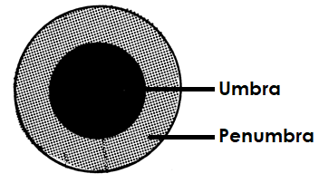

**Qn. What kind of shadow is formed when the source of light is small?**

* The umbra shadow is formed.

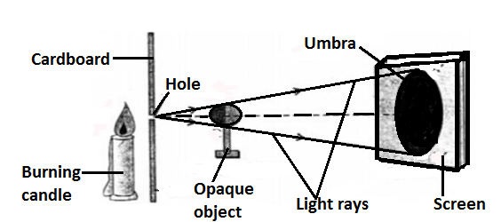**An illustration**

**Qn. What kind of shadow is formed when the source of light is big?**

* The penumbra shadow is formed.

**Illustration**

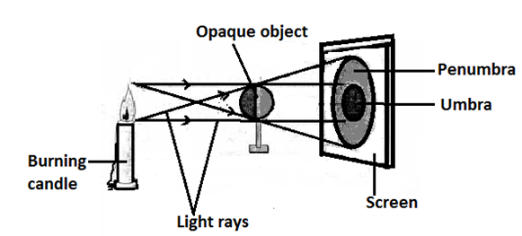

**Qn. How is the length of a shadow determined?**

* By the angle of the sun in relation to the earth

**Note:**

* Shadows appear longest in the morning and evening.
* Shadows appear shortest at noon / midday.

**Qn. State the importance of shadows.**

* Shadows help to tell time.
* Shadows help to determine direction.
* Shadows provide shade to animals / people.

**Eclipse**

**Qn. What is an eclipse?**

* An eclipse is a natural shadow formed when the sun’s light is blocked by either the moon or earth.

**Qn. Write down the types of eclipse.**

* Solar eclipse (Eclipse of the sun)
* Lunar eclipse (Eclipse of the moon

1. **Solar Eclipse.**

* Solar eclipse is the type of eclipse that occurs when the month comes in between the sun and earth.

**Qn. How is solar eclipse formed?**

* When the moon comes in between the sun and the earth. (SME)

**Qn. When happens when solar eclipse occurs?**

* The sun casts the moon’s shadow to the earth.

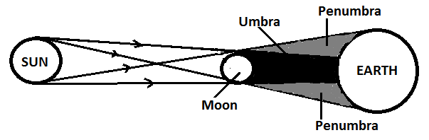**A diagram showing solar eclipse**

1. **Lunar eclipse**

* This is the type of eclipse that occurs when the earth comes in between the sun and the moon.

**Qn. How is lunar eclipse formed?**

* When the earth comes in between the sun and the moon (SEM).

**Qn. What happens when lunar eclipse occurs?**

* The sun casts the shadow of the earth to the moon.

**Diagram showing lunar eclipse**

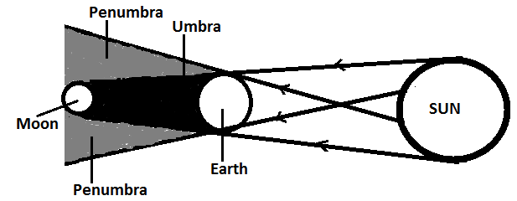

**Reflection of light**

**Qn. What is reflection?**

* This is the bouncing back of light rays.

**Qn. Write down the types of reflection.**

* Regular reflection.
* Irregular /diffuse reflection.

1. **Regular reflection**

**Qn. What is regular reflection?**

* This is the type of reflection where light rays are sent back in a definite direction.

**Qn. How does regular reflection occur?**

* When light rays fall on smooth shiny polished surface.
* 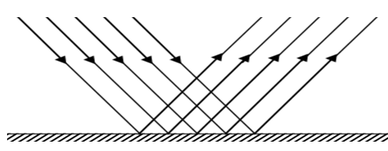**Illustration showing regular reflection.**

**Qn. Write down any one example of a material that produces regular reflection.**

* Plane mirrors

**Qn. Give a reason why we are able to see clear images in plane mirrors.**

* Plane mirrors have smooth shinny polished surfaces that give rise to regular reflection.

**b) Irregular reflection / diffuse reflection**

* Thisis the type of reflection where light rays are thrown back and scattered in different direction.

**Qn. How does irregular reflection occur?**

* When light rays fall on a rough unpolished surfaces.

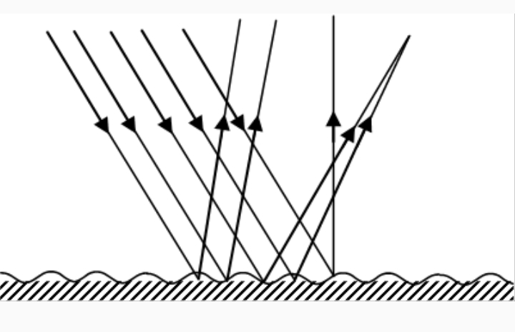**A diagram showing irregular reflection.**

**Qn. Write down different examples of materials that produce irregular reflection.**

* Cracked plane mirror
* Disturbed water

**Qn. Give a reason why we are unable to see clear image on a rough unpolished surface.**

* Rough unpolished surfaces scatter light rays and give rise to irregular reflection.

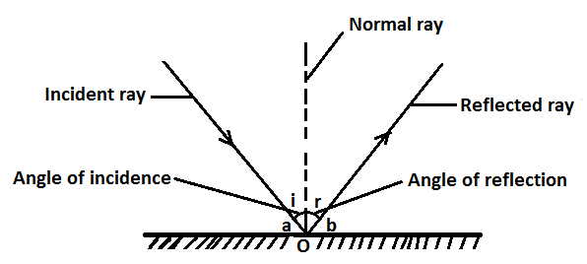**A diagram showing reflection of light on a plane mirror.**

**Note:**

* **O**is the point of incidence.
* **a** and **b** are glancing angles.

**Qn. Give the meaning of the following terms:-**

**i) Incident ray**

* An incident ray is a ray that strikes the reflecting surface.

**ii) Reflected ray**

* A reflected ray is a ray that bounces off the reflecting surface.

**iii) Normal ray**

* A normal ray is a ray that is perpendicular to the reflecting surface.

**iv) Angle of incidence**

* The angle of incidence is the angle between the normal ray and the incident ray.

**v) Angle of reflection.**

* The angle of reflection is the angle between the normal ray and reflected ray.

**vi) Point of incidence**

* A point of incidence is where the incident ray strikes / hits the reflecting surface and the reflected ray leaves the reflecting surface.

**vii) Glancing angles**

* These are angles between the incident ray or the reflected ray lying on the reflecting surface.

**Laws of reflection**

**Qn. State the laws of reflection.**

* The angle of incidence is equal to the angle of reflection.
* The incident ray, the normal and the reflected ray at the point of incidence all lie on the same plane.

**Calculations on reflection of light.**

**Examples**

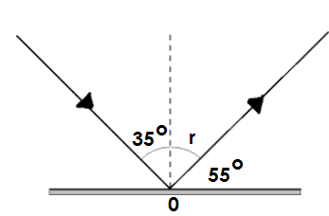**1. Calculate the size of angle r on the diagram.**

**Solution:**

**Since $<i = <r$**

**Therefore $<r=35°$**

**2. Find the size < P in the diagram below.**

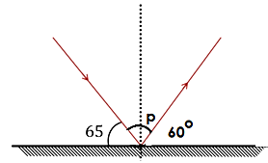

**Solution:**

P + 60**o** = 90**o**

P + 60**o** – 60o = 90 – 60o.

P = 30o.

**∴ The size of P is 30o.**

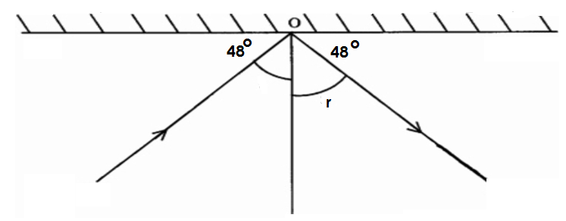**3. Find the angle of incidence.**

**Solution:**

i + 48**o** = 90**o**.

i+ 48o – 40o = 90o – 48o.

i = 42

**∴The angle of incidence = 42o.**

**Activity:**

**1. Find the size of angle y**

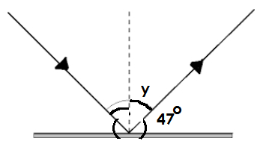

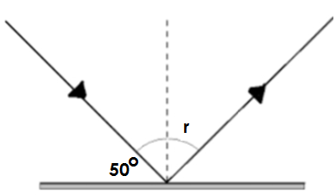**2. Find the size of the angle of reflection.**

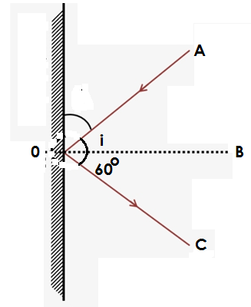**3. Use the diagram below to answer the questions that follow.**

**a) Name the rays marked;**

i) A ii) B

1. **Find the size of the size of the angle of incidence.**
2. **Name Point O.**

**Reflection of light on different materials**

i) Dark and dull materials are good absorbers of light and heat.

ii) Light and smooth materials are good reflectors of light and heat.

**Qn. Mary washed a black and a white shirt at the same time and put them under sunshine.**

**a) Which shirt dried first?**

* The black shirt

**b) Give a reason to support the answer above.**

* The black shirt absorbs heat.

**c) Which shirt dried last?**

* The white shirt.

**d) Give a reason to support the answer above.**

* The white shirt reflects heat.

**Qn. Why do objects appear by their colours?**

* Objects appear by their colours because they absorb all other colours and reflected itscolour.

**Qn. Why does a blue shirt appear blue?**

* A blue shirt appears blue because it absorbs all other colours and reflects blue.

**Qn. Why does a red dress appear red?**

* A red dress appears red because it absorbs all other colours and reflects red.

**Qn. Why does a white shirt appear white?**

* A white shirt appears white because it reflects all other colours and absorbs none.

**Qn. Why does a black trouser appear black?**

* A black trouser appears black because it absorbs all other colours and reflects none.

**Images and plane mirrors**

**Qn. What is an image?**

* An image is a light pictureformed by light rays.

**Qn. Write down the two types of images.**

* Real images
* Virtual images

**Real Images**

**Qn. What are real images?**

* Real images are images that are formed on the screen.

**Virtual Images**

**Qn. What are virtual images?**

* Virtual images are types of images that are formed behind the screen.

**Plane mirrors**

**Qn. What are plane mirrors?**

* Plane mirrors are mirrors with flat surfaces.

**Qn. State the characteristics of images formed on a plane mirror.**

* The image formed is virtual.
* The image formed is upright.
* The image formed is laterally inverted.
* The image size is equal to the object size.
* The image distance is equal to the object distance from the mirror.

**Illustration showing the images formed on a plane mirror.**

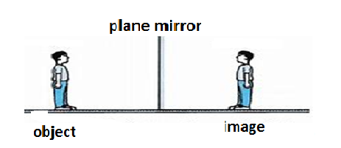

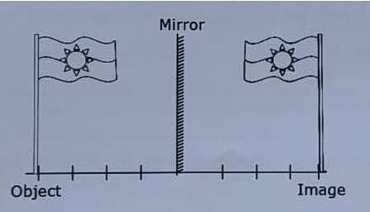**b)**

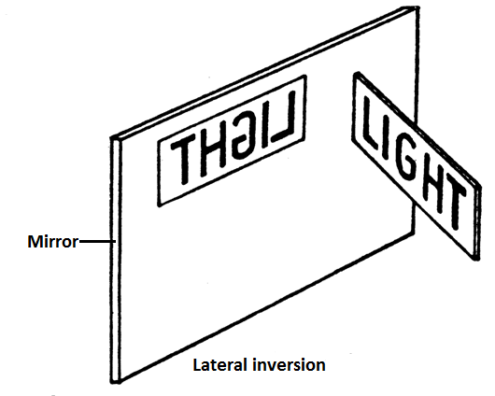

**Uses of plane mirrors**

**Qn. State the uses of plane mirrors in daily life.**

* Plane mirrors are used as dressing mirrors.
* Plane mirrors are used in salons.
* Plane mirrors are used in periscopes.

**A periscope**

**Qn. What is a periscope?**

* A periscope is an instrument or device used to see overhead.

**Qn. Under what principle does a periscope work?**

* A periscope works on a principle that light can be reflected.

**OR**

* A periscope works on a principle of reflection of light.

**A diagram showing a periscope**

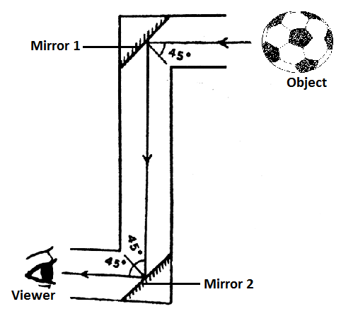

**Qn. How is the observer able to see objects?**

* By the help of reflection of light.

**Uses of periscopes**

**Qn. State the uses / application of a periscope in our daily life.**

* Periscopes are used by submariners to see over the surface of the sea.
* Periscopes are used by soldiers in trenches to see their enemies without exposing themselves.
* Periscopes are used to see around corners.
* Periscopes are used by spectators to watch a football match over heads of crowds.

**Uses of reflection in daily life**

**Qn. How is reflection useful / important in our daily life?**

* Reflection enables us to see our images in plane mirrors.
* Reflection enables submariners to see over the surface of the sea using a periscope.
* Reflection enables soldiers in trenches to see their enemies without exposing themselves using a periscope.
* Reflection helps spectators to watch football matches over the head of crowds using a periscope.

**Spherical or curved mirrors**

**Qn. What are spherical mirrors?**

* Spherical mirrors are mirrors that are sphere-like in shape.

**Note:**

* Spherical mirrors are made by silvering inside or outside the sphere.

**Types of curved / spherical mirrors**

**Qn. Write down the two types of curved / spherical mirrors.**

* Convex mirrors
* Concave mirror

**i) Convex mirrors**

**Qn. What are convex mirrors?**

* Convex mirrors are mirrors made by silvering inside the sphere.

**An illustration showing a convex mirror.**

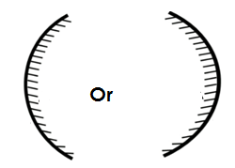

**Qn. State the characteristics of images formed by convex mirrors.**

* The image formed is diminished (smaller than the object).
* The image formed is virtual.
* The image formed is upright.

**Qn. Give the uses / application of convex mirrors in our daily life.**

* Convex mirrors are used as driving mirrors on vehicles.
* Convex mirrors are used in super markets.

**Qn. Why are convex mirrors used as driving mirrors?**

* Convex mirrors give a wider view of the object behind the vehicle.

**ii) Concave mirrors**

**Qn. What are concave mirrors?**

* Concave mirrors are mirrors made by silvering outside the sphere.

**An illustration showing a concave mirror**

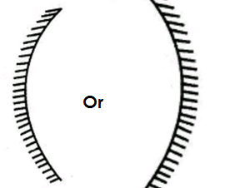

**Qn. State the characteristics of images formed by concave mirrors.**

* The image formed is upright / erect.
* The image formed is virtual.
* The image formed is larger than the object.

**Qn. State the uses / applications of concave mirrors in our daily life.**

* Concave mirrors are used as shaving mirrors.
* Concave mirrors are used by dentists to examine teeth.
* Concave mirrors are used in torches.

**Refraction of light**

**Qn. What is refraction?**

* Refraction is the bending of a light ray as it moves from one transparent medium to another.

**Qn. What causes refraction?**

* Refraction is caused due to the change in the speed of a light ray as it moves from one transparent medium to another.

**Law of refraction**

**Qn. State the law of refraction.**

* The law of refraction states that the incident ray and the refracted ray are on the opposite side of the normal ray at the point of incidence and all lie on the same plane.

**An illustration**

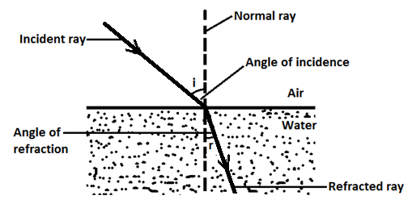

**Note: 1**

**a) Incident ray**

* The incident ray is a ray of light before refraction.

**b) Refracted ray**

* The refracted ray is a ray of light after refraction.

**c) Angle of incidence**

* The angle of incidence is the angle between the incident ray and the normal ray.

**d)** **Angle of refraction**

* The angle of refraction is the angle between the refracted ray and the normal ray,

**Note 2:**

When the light ray moves from a medium of less density to the medium of more density, the following happens:-

* The speed of the ray reduces.
* The refracted ray bends towards the normal ray.

**Qn. Why does the refracted ray bend towards the normal ray?**

* Due to the change of speed as the light ray moves from a medium of less density to a medium of more density.

**Refraction of light from air to glass.**

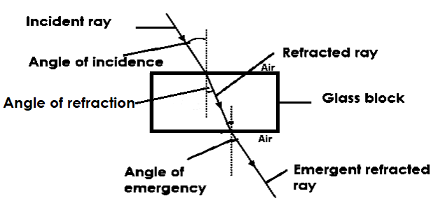**An illustration**

**Note:**

When a light ray moves from a medium of more density to a medium of less density, the following happen:-

* The speed of light increases
* The emergent refracted ray bends away from the normal ray.

**Qn. Give a reason why the emergent refracted ray bends away from the normal ray.**

* Due to change of speed as the light ray moves from a medium of more density to a medium of less density.

**Effects of refraction**

State the effects of refraction

* Refraction makes a stick / straight object partially dipped into water to appear bent or broken.
* **An illustration**

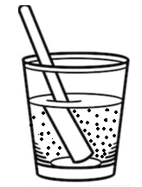

ii) Refraction makes an object dipped in water appear nearer to the surface than it is.

**Illustration**

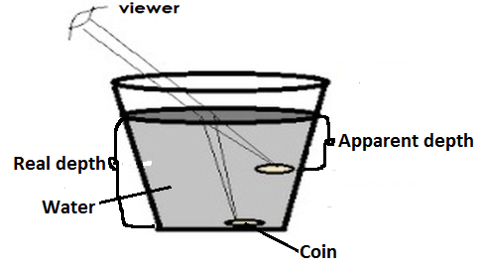

iii) Refraction makes a swimming pool to appear shallower than its real depth.

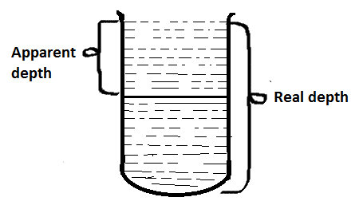**An illustration**

iv) Refraction produces different colours of the spectrum.

v) Refraction causes mirage.

**Qn. What is a mirage?**

* A mirage is when the surface of a tarmac road appears like a pool of water during hot weather.

**Qn. Write down any two places where mirages are commonly found.**

* Tarmac roads.
* Iron sheets

**Qn. State the disadvantages of refraction.**

* Refraction causes drowning and near drowning in swimming pools.
* Refraction may lead to accidents on the road.

**Lenses**

**Qn. What is a lens?**

* A lens is a transparent material with curved surfaces capable of refracting light?

**Types of lenses**

**Qn. Write down the types of lenses**

* Convex lens (converging lens)
* Concave lens (Diverging lens)

**Convex lens**

**Qn. What is a convex lens?**

* A convex lens is a lens which is thick in the middle and thin at the edges.
* A convex lens is a lens whose surface is curved outwards.

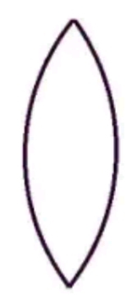**A diagram showing a convex lens**

**Qn. How does a convex lens affect light rays?**

* A convex lens converges light rays to meet at one point in front of it.

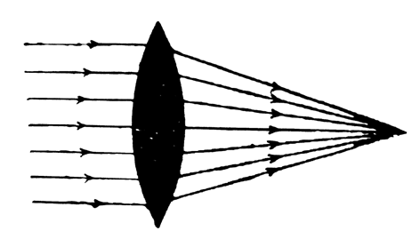**An illustration**

**b) Concave lens**

**Qn. What is a concave lens?**

* A concave lens is a lens which is thin in the middle and thick at the edge.

**OR**

* A concave lens is a lens whose surface is curved inwards.

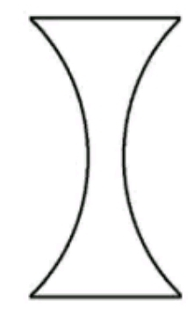**A diagram showing a concave lens**

**Qn. How does a concave lens affect light rays?**

* A concave lens diverges light rays.

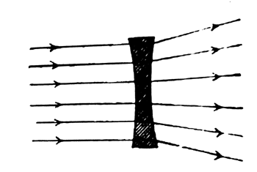**Illustration**

**Uses of lenses**

**Qn. State the uses / application of lenses**

* Lenses are used in magnifying glasses to enlarge objects.
* Lenses are used in optical instruments.

**Optical instruments**

**Qn. What are optical instruments?**

* Optical instruments are instruments that use light to function.

**Qn. Write down the different examples of optical instruments.**

* Human eye
* Spectacles
* Projectors
* Microscope
* Magnifying glasses
* Telescopes
* Binocular
* Lens camera

**Uses of each optical instrument**

**i) Magnifying glass**

* A magnifying glass is an optical instrument used to enlarge objects.

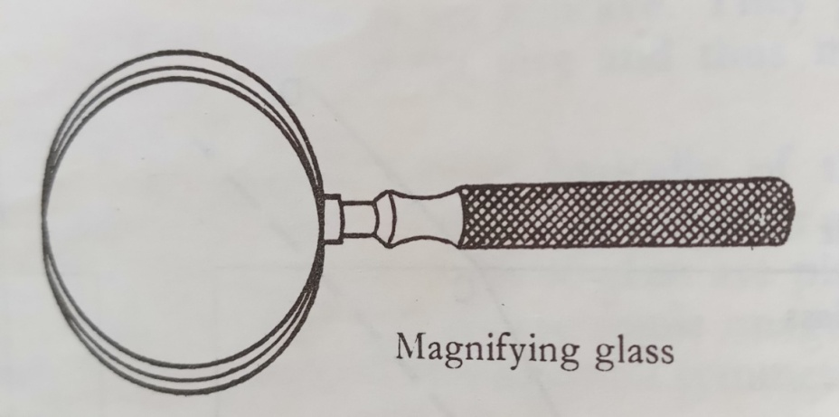**A diagram showing a magnifying glass.**

**Microscope**

* A microscope is used to see very tiny objects e.g. germs.

**Projectors**

* Projectors are used to form / cast images on the screen.

**Lens camera**

* A lens camera is used to take photos.

**Telescope**

* A telescope is used to see distant objects clearly.

**Binoculars**

* A binocular is used to see distant objects clearly.

**A pinhole camera**

**Qn. What is a pinhole camera?**

* A pinhole camera is a camera made up of a light proof container and a translucent screen at the end.

**Qn. How does a pinhole work?**

* Light from an object is reflected towards the pinhole camera.
* The light rays pass through the pinhole moving in a straight line.
* The rays then fall on the screen and form an image.

**Qn. Under what principle does a pinhole camera work?**

* A pinhole camera works on a principle that light travels in a straight line.

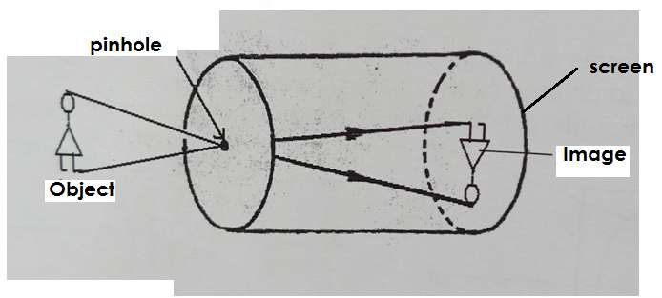**A diagram showing a pinhole camera.**

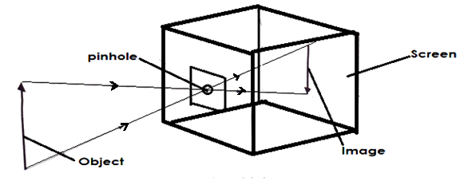b.

**Note:**

* When the pinhole is big, the image formed is blurred or unclear.
* When the pinhole is small, the image formed is sharp.
* When the distance between the pinhole camera and the object is short or reduced, the image formed is larger and sharper.

**Qn. State the characteristics of images formed in a pinhole camera.**

* The image is real.
* The image formed is inverted (upside down).
* The image former is diminished (smaller) than the object.

**Qn. Why does a pinhole camera form a real object?**

* The images are formed from real light rays.

**Qn. Why does the image formed in a pinhole camera appear inverted?**

* Light travel in a straight line.

**Qn. Why does the image formed in a pin hole camera diminished / smaller than the object.**

* Light travels in a narrow passage.

**The lens camera**

The lens camera is a camera used for taking photograph.

**Diagram showing the lens camera/photographic camera.**

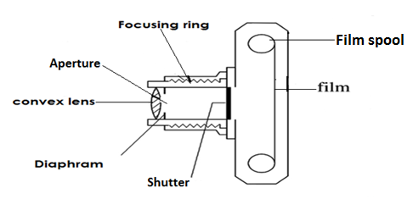

**Qn.State different functions of each part of a lens camera.**

**A convex lens**

* To focus the real image to the film.

**Diaphragm**

* To control the amount of light entering camera.

**Focusing ring**

* To adjust the distance between the lens and the film.

**Shutter**

* To expose the film to light.

**Film**

* It is where the inverted image is formed.

**Qn. State the characteristics of image formed in a lens camera.**

* The image formed is real.
* The image is diminished (smaller than the object).
* The image formed is inverted upside down.

**The human eye**

* The human eye is the sense organ for sight.
* The human eye is protected by part of the skull called eye socket.

**Structure of the human eye**

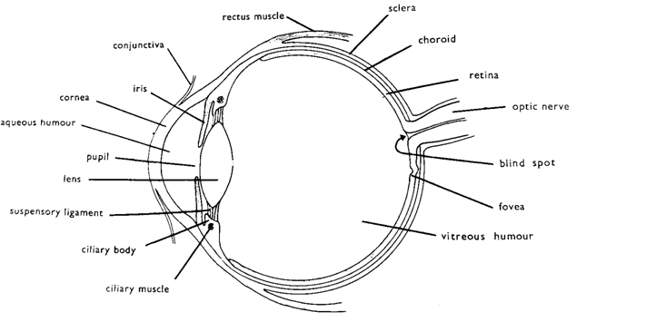

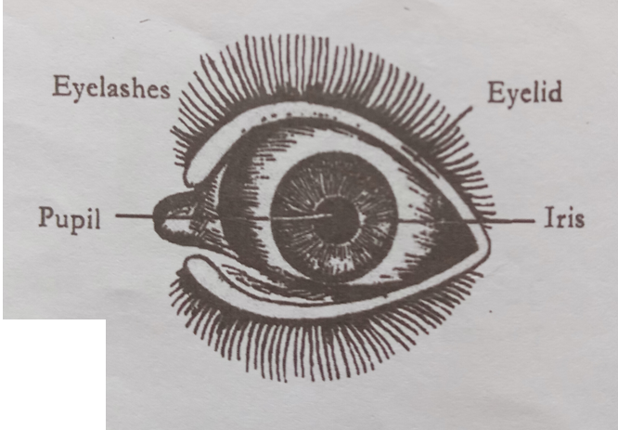**A diagram showing front view of the human eye.**

**Functions of the parts of the eye.**

**Qn. State the function of each of the following parts of an eye.**

**Eyelid**

* The eyelid protects the eye by covering it.
* The eyelid uncovers the pupil to allow light into the eye.

**Eye lashes**

* The eye lashes prevent foreign bodies from entering into the eye.

**Eye brows**

* The eye brows prevent sweat from flowing into the eye.

**Conjunctiva**

* The conjunctiva is a thin membrane that covers and protects the cornea.

**Cornea**

* The cornea helps in refracting and converging light rays.

**Pupil**

* The pupil allows light into the eye.

**Iris**

The iris controls the amount of light entering into the eye.

**Convex lens**

* The convex lens refracts light rays to the retina so that the images are formed.

**Suspensory ligament**

The suspensory ligament holds the lens in position.

**Ciliary muscle**

* The ciliary muscle adjusts the shape of the lens to allow the images of both far and near objects to be focused on the retina.

**Ciliary body**

* The ciliary body contains blood vessels that supply blood to the eye.

**Vitreous and Aqueous humour.**

* The vitreous and aqueous humours keep and maintain the shape of the eye.
* The vitreous and aqueous humours refract light rays onto the retina.

**Retina**

* The retina is where images are formed.

**Note:**

* The retina is the light sensitive part of the eye.
* The retina contains light sensitive cells called **rods**and **cones**.
* The rods are sensitive to dim light and night vision.
* The cones are sensitive to bright light and day light vision.

**Choroid**

* The choroid prevents internal reflection with in the eye.
* The choroid also supplies the eye with oxygen and digested food.

**Fovea (Yellow spot)**

* The fovea is where the images appear sharper.

**Blind spot**

* The blind spot is where the optic nerve leaves the eye.

**Optic nerve**

* The optic nerve transmits or carries nerve impulses to the brain for interpretation.

**Tear glands**

* The tear glands produce tears.

**Qn. What is the importance of tears in the human eye?**

* Tears lubricate the eye ball.
* Tears wash off foreign bodies from the eye.
* Tears kill some bacteria that go to the eye.

**Qn. How does the iris control amount of light entering the eye?**

* By regulating the size of the pupil.

**Note:**

* During dim light, the iris contracts to enlarge the size of the pupil and relaxes to reduce the size of the pupil during bright light.

**A diagram showing regulation of light by the iris during dim light.**

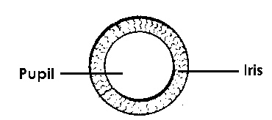

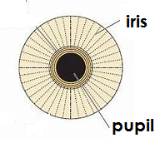**A diagram showing regulation of light by the bright light.**

**Characteristics of images formed in the human eye.**

**Qn. State the characteristics of images formed in the human eye.**

* The image formed is real.
* The image formed is inverted (upside down),
* The image formed is diminished (smaller than the object).

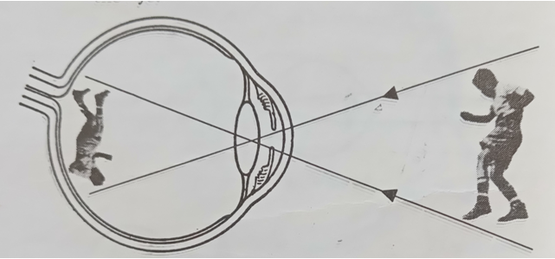**A diagram showing how images are formed in the human eye**

**Qn. State the similarities between the eye and the lens camera**

|  |  |
| --- | --- |
| **Human eye** | **Lens camera** |
| * The iris controls the amount of light entering the eye. | * The diaphragm controls the amount of light entering the camera. |
| * The image formed on the retina is inverted, real and diminished. | * The image formed on the film is inverted, real and diminished. |
| * The eyelid keeps out light | * The shutter keeps out light. |
| * It has a convex lens | * It has a convex lens. |

**Qn. State the differences between the eye and the lens camera.**

|  |  |
| --- | --- |
| **Human eye** | **Lens camera** |
| * The distance between the lens and retina is fixed. | * The distance between the lens and film changes. |
| * The shape of the lens easily changes to focus different distances. | * The shape of the lens does not change and only focuses certain distances. |
| * The lens is soft and elastic | * The lens is made of a hard glass. |
| * Thickness of the lens changes | * Thickness of the lens does not change. |
| * The iris adjusts itself. | * The diaphragm can be adjusted. |
| * The image is focused by making the lens thicker. | * The image is focused by moving the lens. |

**Qn. Identify the parts of the human eye and lens camera with similar functions.**

|  |  |
| --- | --- |
| **Human eye** | **Lens camera** |
| * Retina | * Film |
| * Iris | * Diaphragm |
| * Pupil | * Aperture |
| * Eyelid | * Shutter |
| * Convex lens | * Convex lens |

**Note:**

* The ability of the eye to focus near and distant objects is calledaccommodation.

**Qn. What is accommodation?**

* Accommodation is the ability of the eye to focus near and distant objects on the retina.

**Eye defect / disorders**

**Qn. What is an eye defect?**

* An eye defect is the inability of the eye to see normally.

**OR**

* An eye defect is the inability of the eye to focus images on the retina normally.

**Qn. Write down the different causes of eye defects.**

* Abnormal shape of the eye ball.
* Abnormal shape of the eye lens.
* Irregular shape of the cornea
* Old age
* Eye strain

**Qn. Mention the different examples of eye defects**

* Short sightedness (myopia)
* Long sightedness (hypermetropia)
* Astigmatism
* Colour blindness
* Old age sight (presbyopia)

**Short sightedness (Myopia)**

**Qn. What is short sightedness?**

* Short sightedness is a condition where a person is able to see nearby objects but cannot see distant objects.

**Qn. Write down the causes of short sightedness.**

* Having too long eyeballs.
* Having a thick lens

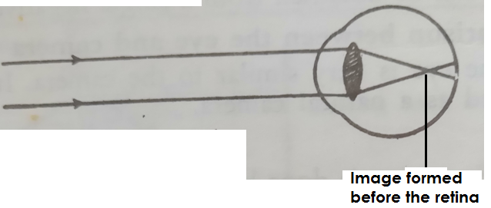**An illustration showing shortsightedness.**

**Qn. How can short sightedness be corrected?**

* By wearing spectacles with concave lenses.

**Qn. How does a concave less correct short sightedness?**

* The concave lens diverges light rays before they reach the lens inside the eye.

**A diagram showing short sightedness after correction**

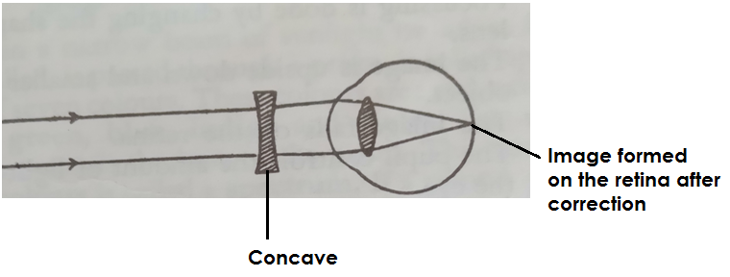

**ii) Long sightedness (Hypermetropia)**

**Qn. What is long sightedness?**

* Long sightedness is a condition where a person is able to see distant objects but cannot see nearby objects.

**Qn. Give any two causes of long sightedness.**

* Having too short eye balls.
* Having too thin eye lens.

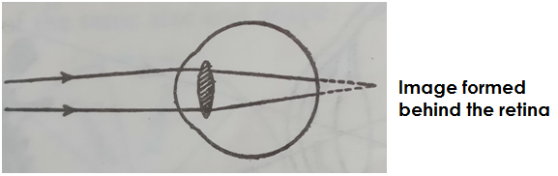**An illustration**

**Qn. How can long sightedness be corrected?**

* By wearing spectacles with convex lenses.

**Qn. How do convex lenses correct long sightedness?**

* Convex lenses converge light rays before they reach the lens inside the eye.

**A diagram showing long sightedness after correction**

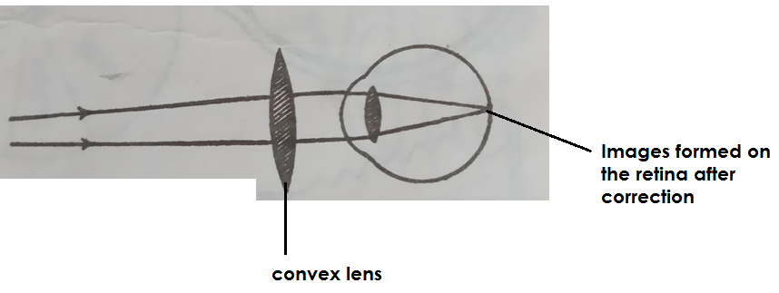

**iii Astigmatism**

**Qn. What is astigmatism?**

* Astigmatism is a condition where a person is not able to see both vertical and horizontal objects clearly at the same time.

**Qn. What causes astigmatism?**

* Astigmatism is caused by having an irregular or rough cornea.

**OR**

* Astigmatism is caused by having a cornea that is not evenly curved.

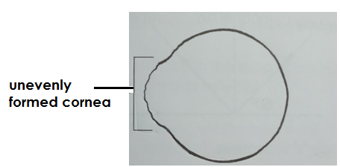**An illustration**

**Qn. How is a stigmatism corrected?**

* By wearing spectacles with cylindrical lenses.

**Colour blindness**

**Qn. What is colour blindness?**

* Colour blindness is a condition in which one is unable to differentiate one or more colours.

**v) Old age sight (Presbyopia)**

* Old age sight is a condition of the eyes that happens in the old age above 60 years.

**Qn. How is old age sight caused?**

* By loss of elasticity by the eye lens.

**Qn. How can old sight be corrected?**

* By wearing spectacles with converging lenses.

**Note:**

**Qn. What is eye squint?**

* Eye squints is a condition in which a person looks side ways.

**Eye diseases**

**Qn. Write down the different examples of diseases that affect the eye.**

* Trachoma
* Conjunctivitis
* Night blindness
* Glaucoma
* Iritis
* Sty
* Cataracts

**Trachoma**

* Trachoma is an infectious disease of the eye caused by Chlamydia.

**Qn. Name the vector that spreads germs that cause trachoma.**

* House fly

**Qn. How does trachoma spread?**

* By houseflies landing on the eyes.
* Through sharing face towels with an infected person.
* Through sharing handkerchiefs with an infected person.
* Through body contact with an infected person.
* Through sharing basins with an infected person.

**Qn. Mention the different signs shown by a person suffering from trachoma.**

* The eyes turn red (redness of the eyes)
* Swelling of the eyelids
* Watery discharge from the eyelids.

**Qn. Write down the symptoms of trachoma.**

* Severe itching of the eyes.
* Pain while looking at light.

**Qn. State the ways of preventing and controlling the spread of trachoma.**

* Wash hands with clean water and soap regularly.
* Avoid sharing basins with an infected person.
* Avoid sharing face towels with an infected person.
* Avoid sharing handkerchief with an infected person.
* Use clean handkerchiefs while cleaning the eyes.
* Avoid shaking hands with infected people.

**Qn. How can trachoma be treated?**

* By treating the eyes with tetracycline ointment.

**Note:**

* Trachoma can lead to total blindness if not treated.

**River blindness**

* River blindness is an eye disease caused by a worm calledonchocerca volvulus.

**Qn. Name the vector that spreads germs that cause river blindness.**

* Black fly / simulium fly / Jinja fly

**Qn. Where does a black fly breed from?**

* In fast flowing water.

**Qn. Write down the signs of river blindness.**

* Red watery eyes.
* Tears flow from the eyes.

**Qn. Mention the symptoms of river blindness.**

* Severe itching of the eyes.
* Severe body itching.

**Qn. How can river blindness be prevented / controlled?**

* By spraying bushes near river banks using insecticides.
* By clearing bushes around river banks to destroy hiding places for black flies.

**Night blindness**

* Night blindness is a food deficiency disease of the eyes.

**Qn. What causes night blindness?**

* Lack of vitamin A in one’s body.

**Qn. Mention any one sign of night blindness.**

* Poor night vision.

**Qn. Write down the different symptoms of night blindness.**

* Sore eyes
* Colds

**Qn. How can night blindness be prevented?**

* By eating food rich in vitamin A.

**Conjunctivitis**

* Conjunctivitis is an eye disease that affects the conjunctiva.

**Qn. How does conjunctivitis spread?**

* Through shaking hands with an infected person.
* Through sharing handkerchiefs with an infected person.
* Through sharing face towels with an infected person.
* Through sharing basins with an infected person.

**Qn. Write down any four signs shown by a person suffering from conjunctivitis.**

* The eyes turn pink
* Mucus discharge from the eyes.
* Pus from the eyes
* Inflammation of the eyes.

**Qn. Write down any one symptom of conjunctivitis in humans.**

* Severe itching of the eyelids.

**Qn. How can conjunctivitis be prevented / controlled?**

* Isolate infected people from healthy ones.
* Avoid sharing handkerchiefs with an infected person.
* Avoid shaking hands with an infected person.
* Avoid sharing face towels with an infected person.
* Avoid sharing basins with an infected person.
* Get early treatment of the infected eyes.

**Iritis**

* Iritis is an inflammation of the iris muscles.

**Qn. Mention any two causes of iritis?**

* By an injury on the eyes.
* By other eye diseases.

**Qn. Write down the common sign of iritis**

* Swelling of the iris

**Glaucoma**

* Glaucoma is the eye disease that affects the optic nerves.

**Note**

* Glaucoma is mainly caused due to too much pressure on the eyes.

**Sty**

* Sty is a small inflammation on the eyes.

**Cataracts**

* Cataracts is a condition in which the eye lens becomes grey and opaque.

**Qn. How is cataracts caused?**

* An injury on the eyes.
* Continued exposure of the eye to high temperature.

**Care for the eyes**

**Qn. Write down the different ways of caring for the human eyes.**

* Wash the eyes with clean water and soap regularly.
* Eat food that makes up a balanced diet.
* Avoid looking directly at the sun.
* Eat foods rich in vitamin A.
* Avoid sharing handkerchiefs, face towels with infected persons.
* Do not strain eyes reading very small prints.
* Avoid reading in dim light.
* Do not expose eyes to very bright light.
* Treat eye infections immediately.
* Avoid reading when holding the book too close or too far.

**Dispersion of light**

**Qn. What is dispersion of light?**

* Dispersion of light is the splitting /scattering of light rays into seven different colours.

**Note:**

* A band / collection of the seven colours is called a **spectrum**.

**Qn. What is a spectrum?**

* A spectrum is a band or collection of seven different colours.

**Qn. How is dispersion of light caused?**

* Dispersion is caused by refraction of light as it passes through a glass prism.

**Qn. What is a prism?**

* A prism is a device that splits light into seven different colours.

**Qn. Mention the example of a spectrum in nature.**

* Rainbow

**Qn. How is a rainbow formed?**

* When the light rays from the sun pass through rain drops.

**Note:**

* The inner colour of a rainbow is violet.
* The outer colour of a rainbow is red

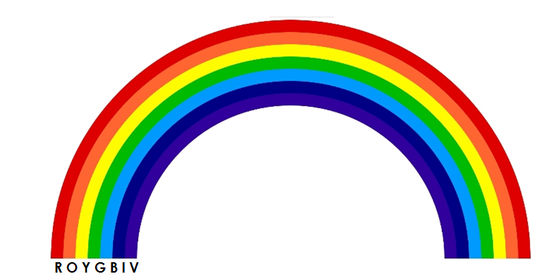**A diagram showing a rainbow**

**Note:**

The order of the colours of the spectrum is as follows:-

* Red, Orange, Yellow, Green , Blue, Indigo and Violet (ROYGBIV)

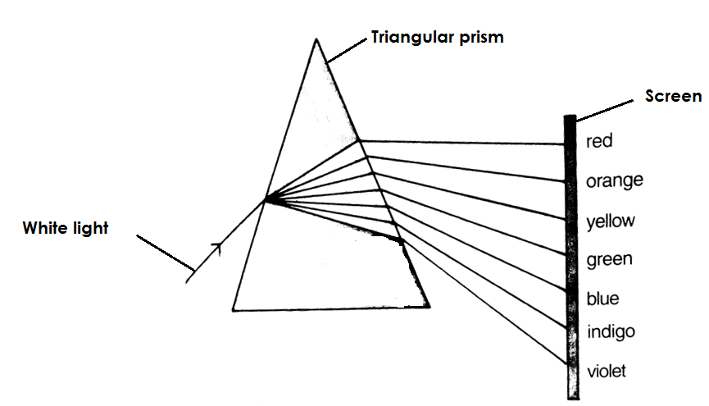**A diagram showing dispersion of light on a triangular prism.**

**Note:**

* The red colour bends least and violet bends most.

**Qn. Why does the red colour appear on top of the spectrum?**

* Red is refracted least.

**Qn. Why does violet appear at the bottom of the spectrum?**

* Violet is refracted most.

**Qn. What happens to light rays when they pass through an inverted glass prism?**

* Violet is bent least and red is bent most.

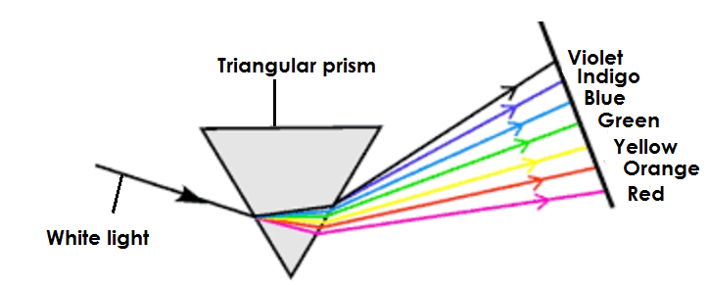**A diagram showing dispersion of light on an inverted triangular prism.**

**Colours of light**

**Qn. Write down the three types of colours of light.**

* Primary colours
* Secondary colours
* Complementary colours

**Primary colours**

**Qn. What are primary colours?**

* Primary colours are colours got without mixing any other colour.

**Qn. Write down the examples of primary colours.**

* Blue
* Green
* Red

**Secondary colours**

**Qn. What are secondary colours?**

* Secondary colours are colours got after mixing two primary colours in equal amount.

**Qn. Mention the examples of secondary colours**

* Yellow
* Magenta
* Cyan

**Qn. How to obtain secondary colours**

* Red + Green = Yellow
* Red + Blue = Magenta
* Blue + Green + Cyan

**c) Complementary colours**

**Qn. What are complementary colours?**

* Complementary colours are colours of light when mixed we get a universal colour called **white**.

**OR**

* Complementary colours are colours got after mixing a primary colour and a secondary colour in equal amounts.

**Note:**

* White is a universal colour.

**Qn. How is white obtained?**

* Red + Cyan = White
* Blue + Yellow = white
* Green _ Magenta = white

**A venn diagram showing colours of light.**

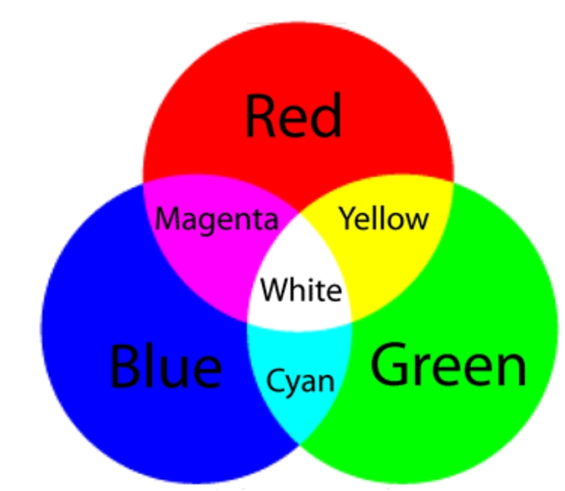

**THEME:**

**TOPIC 7: INTERDEPENDENCE OF THINGS IN THE ENVIRONMENT**

**Qn. What is environment?**

* Environment refers to things surrounding people.

**2. Write down the two types of environment.**

* Biotic (Biological environment)
* A biotic (Physical environment)

**Qn. What is biotic environment?**

* This is the type of environment made up of living things.

**Qn. What is abiotic environment?**

* This is the type of environment made up of non living things.

**Qn. Mention different components of the environment.**

* Plants
* Animals
* Soil
* Water
* The sun
* Air
* Animal structure

**Qn. Write down the two examples of biotic environment.**

* Plants
* Animals

**Qn. Mentionat least two examples of abiotic environment .**

* The sun
* Water
* Air
* Animal structures
* Soil

**Qn. What is interdepence?**

* This is the way things is the environment depend on each other.

**Interdependence of living things**

**Qn. Write down different ways animals depend on plants.**

* Animals get food from plants.
* Animals get oxygen from plants
* Some animals use plants as their habitat.
* Some animals get wood fuel from plants.
* Some animals get herbal medicine from plants.
* Some animals get building materials from plants.

**Qn. State at least four ways plants depend on animals.**

* Plants get carbon dioxide from animals.
* Plants get manure from animals
* Plants are pollinated by some animals
* Plants are dispersed by some animals.
* Plants get special care from animals.

**Qn. How do animals depend on other animals?**

* Some animals use other animal as food.
* Some animals get protection from other animals.
* Some animals get transport from other animals.
* Some animals help other animals in ploughing.

**Qn. Give different ways how plants depend on other plants,**

* Plants get manure from other plants.
* Some plants with weak stems get support from other plants.
* Plants are protected from strong wind by other plants.
* Some parasitic plants get food from other plants.

**Qn. Write down different ways how living things depend on other living things.**

* Some living things get food from other living things.
* Some living things get protection from other living things.
* Some living things get labour from other living things.
* Some living things get transport from other ling things.

**Qn. How do living things depend on non-living things?**

* Some living things use soil as their habitat.
* Some living things use water as their habitat.
* Plants use water to make food.
* Animals drink water.
* Plants get heat and light from the sun.
* Animals use soil to build houses.

**Qn. Give different ways how non ling things depend on living things.**

* Plants purify air.
* Animals add manure to the soil
* Plants control silting.

**Qn. What is silting?**

This is the deposition of silt into a water body.

**Qn. State the three causes of silting.**

* Soil erosion
* Bush burning
* Deforesting

**Qn. Write down different dangers of silting.**

* Silting reduces the depth of the water body.
* Silting leads to water pollution.
* Silting leads to death of aquatic animals.

**Qn. Identify different ways of controlling silting.**

* By afforestation
* By re-afforastation
* By agro-forestry
* By bush fallowing

**Food chain**

**Qn. What is food chain?**

* This is the way organisms in the environment obtain their food.

**Note:**

* Plants are the producers in any given food chain.

**Qn. What are producers?**

* Producers are organisms that make their own food.

**Qn. Why are plants regarded as producers in a food chain?**

* Plants make their own food.

**Qn. What are consumers?**

* These are organisms that depend on already made food.

**Qn. Mention the three groups of consumers.**

* Primary consumers.
* Secondary consumers
* Tertiary consumers

**Qn. What are primary consumers?**

These are organisms that feed directly on producers.

**Qn. Give different examples of primary consumers.**

* Monkeys
* Grass hoppers
* Rabbits
* Goats
* Cows
* Sheep
* Man
* Locusts’

**Qn. What are secondary consumers?**

* These are organisms that feed on primary consumers.

**Qn. List down different examples of secondary consumers.**

* Lion
* Tiger
* Leopard
* Snakes
* Frogs
* Toads
* Man

**Qn. Mention different examples of tertiary consumers.**

* Man
* Eagles
* Kites
* Owl
* Vultures
* Hawk
* Crows

**Note:**

* Fungi and bacteria are regarded as decomposers and the sun is the main source of energy in a food chain.

**Qn. Why are bacteria and fungi regarded as decomposers?**

* They break down organic matter.

**Qn why is the sun regarded as the main source of energy?**

* The sun provides energy to other energy sources in the environment.

**Examples of food chain.**

**Qn. Use the list below to form a food chain.**

1. **Lizard, fungi,sun,hawk,leaves, grass hoppers.**

* Sun—leaves—grasshopper—lizard—hawk—fungi

**b) Lion, sun,cabbage,crow,bacteria, rabbits.**

* Sun—cabbages—rabbits—lions—crows—bacteria.

**c) Goats, bacteria,leopard,Nakati.**

* Nakati—goats—leopard—bacteria.

**Qn. What will happen to cabbages if the rabbits die in the list (b) above?**

* The cabbages will increase in number.

**Qn. What will happen to the leopards if Nakati dries up in list (c) above?**

* The leopards will reduce in number.

**Eco-system**

**Qn. What is eco-system?**

* This is the community of organisms in a habitat plus the non – living part of the environment.

**Qn. What is a food web?**

* A food web is the interrelationship on how organisms in the environment obtain their food.

**A diagram showing a food web.**

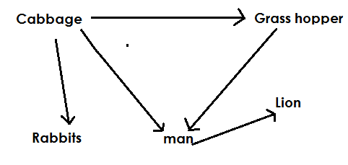

**Agro – forestry**

**Qn. What is agro- forestry?**

* This is the growing of crops, trees and rearing of animals on the same piece of land.

**Qn. State different importance of agro-forestry.**

* The farmer gets double income.
* Animals get oxygen from crops and trees.
* Crops and trees get carbon dioxide from animals.
* Trees and crops get manure from animals.
* Crops with weak stems get support from trees.
* Trees protect some crops from strong wind.
* Trees help in formation of rainfall.
* Leguminous trees and crops help to improve on soil fertility.
* Trees help to purify air.
* Trees help to control soil erosion.
* Trees help to control global warming.

**Qn. How do trees purify air?**

* Trees use carbon gases in the atmosphere.

**Qn. State ways in which trees control soil erosion.**

* Tree roots bind soil particles together.
* Trees act as wind breaks.
* Tree leaves prevent direct rain drops on the soil.

**Crops and tree growing**

**Qn. What is a crop?**

* A crop is any plant grown and cared for.

**Qn. Write at least three factors considered when selecting seeds for crops and tree growing.**

* The seed embryo should not be broken.
* The seed embryo should be free from pest damage.
* The seed embryo should be mature.
* The seeds should be of a right variety.
* The seeds should be disease free.
* The seeds should be a whole without holes.

**Qn. Give at least three factors to consider when selecting a garden for crops and tree growing.**

* The soil should be well drained.
* The garden should be near the main road.
* The garden should be near the home.
* The garden should be near the water source.

**Qn. Identify at least three factors to consider when selecting a good tree for planting.**

* Maturity of the trees.
* High harvest or yields of the trees.
* The trees should be resistant to diseases.
* The tree should be multipurpose.
* **Types or pieces of trees**
* Indigenous trees.
* Exotic trees

**Indigenous trees**

**Qn. What are indigenous trees?**

* These are trees that are commonly found in natural forests.

**Qn. Give different characteristics of indigenous trees.**

* They produce hard wood.
* They grow wildly.
* They take long to mature.
* They can withstand harsh weather.

**Qn. State five examples of indigenous trees.**

* Mvule
* Mahogany
* Musizi
* Acacia
* Mutuba or ficus trees
* Jack fruit
* Mango trees

**Exotic trees**

**Qn. What are exotic trees?**

* These are trees that have been introduced to Uganda of recent.

**Qn. List down three characteristic of exotic trees.**

* They mature faster
* They need proper care.
* They produce soft wood.
* Some of them cannot withstand harsh weather.

**Qn. Identify four examples of exotic trees.**

* Cypress
* Pine
* Cedar
* Black wattle
* Ginkgo

**A nursery bed**

**Qn. What is a nursery bed?**

* A nursery bed is a small garden prepared for raising seedlings.

**Qn. Give examples of crops that are planted in a nursery bed.**

* Tomatoes
* Egg plants
* Cabbage
* Passion fruits
* Carrots
* Rice
* Onion

**Qn. State the advantages of a nursery bed.**

* A nursery bed protects seedlings from direct rain drops.
* A nursery bed protects seedlings from direct sunlight.
* A nursery bed promotes proper selection of seedlings.
* A nursery bed enables water to sink deep into the soil.

**Qn. State the steps followed when preparing a nursery bed.**

* Clear the land and dig the soil deeply.
* Break the soil lumps and make it fine.
* Apply manure to the soil.
* Make furrows in thesoil.
* Plant the seeds.
* Cover the seeds with light soil
* Construct a shade of one metre high.

**Qn. What is a seedling?**

* A seedling is a young plant in a nursery bed or garden.

**Qn. State the different ways of caring for seedlings in a nursery bed.**

* By watering
* By manuring
* By thinning
* By hardening off

**Qn. What is hardening off?**

* This is the removal of shades from a nursery bed to enable seedlings get used to garden conditions when transplanted.

**Note:**

* During hardening off, watering is reduced.
* After hardening off and the seedlings are ready, transplanting is done.

**Qn. What is transplanting?**

* Transplanting is the transfer of seedlings from a nursery bed to the well prepared garden.

**Qn. Name the garden tool used for transplanting seedlings.**

* Trowel

**Qn. Why is transplanting done using a trowel?**

* A trowel prevents damage on roots of seedlings.

**Qn. Why is transplanting done in the evening?**

* To prevent wilting of seedlings.

**Qn. What is wilting?**

* This is the process by which a plant loses more water than it gains from the soil.

**Qn. State the different ways of caring for crops and trees grown.**

* Mulching
* Pruning
* Row planting
* Crop spacing
* Weeding
* Plant training
* Gap filling
* Manuring

1. **Row planting**

**Qn. What is row planting?**

* Row planting is the planting of crops in lines.

**Qn. Identify the advantages of row planting.**

* Row planting makes weeding easy.
* Row planting makes weeding easy.
* Row planting makes spraying easy.
* Row planting makes pruning easy.
* Row planting leads to high yields.
* Row planting controls overcrowding of plants in the garden.
* Row planting reduces hiding places for pests.

**Qn. State the advantages of row planting.**

* Row planting is tiring.
* Row planting requires a large piece of land.
* Row planting needs a lot of time.
* Row planting requires much labour.

**Qn. Give examples of crops planted using he row planting method.**

* Onions
* Cabbages
* Beans
* Maize
* Egg plants
* Ground nuts.

**Qn. A part from row planting, mention the other method used to plant crops.**

* Broadcasting is a method of planting where seeds are just scattered in a well prepared garden.

**Qn. State the advantages of broadcasting method.**

* Broad casting method saves time.
* Broad casting is less tiring.
* Broad casting does not require a lot of labour.

**Qn. State the disadvantages of broadcasting method.**

* Broadcasting makes harvesting difficult.
* Broadcasting makes weeding difficult.
* Broadcasting makes spraying difficult.
* Broadcasting leads to overcrowding of crops in the garden.
* Broadcasting leads to easy spread of pests and diseases among crops.
* Broadcasting leads to competition for sunlight.

**Qn. Identify examples of crops planted by the broadcasting method.**

* Sorghum
* Millet
* Cowpeas
* Rice
* Simsim

1. **Mulching**

**Qn. What is mulching?**

* Mulching is the covering of top soil with dry plant materials.

**Note:**

* The dry plant material used for mulching are called mulches.

**Qn. What are mulches?**

* Mulches are dry plant material used to cover top soil in the garden.

**Qn. Mention the different examples of mulches.**

* Dry grass
* Dry banana leaves
* Saw dust
* Wood shavings
* Rice husks

**Qn. Give the advantages of mulching.**

* Mulching keeps moisture in the soil.
* Mulching controls soil erosion.
* Mulching improves soil fertility.
* Mulching controls the growth of weeds.

**Qn. Write down the disadvantages of mulching.**

* Some mulches can grow into weeds.
* Mulches act as fire hazards.
* Mulches hide crop pests.
* Some mulches are expensive to get.
* Mulching is tiring.

**Qn. How does mulching improve on soil fertility?**

* Mulches rot / decay and form humus.

**Qn. How does mulching maintain moisture in the soil?**

* Mulches control the rate of evaporation of water from the soil.

**Qn. How does mulching control the growth of weeds in the garden?**

* Mulches prevent sunlight from reaching weeds.

**Qn. How does mulching control soil erosion?**

* Mulches reduce the speed of running water.

1. **Gap filling**

**Qn. What is gap filling?**

* Gap filling is a practice done to fill gaps or spaces in a crop garden.

**Qn. Why is gap filling done?**

* To fill the spaces where seeds failed to germinate.
* To fill spaces where seedlings died after transplanting.

**Qn. State the advantages of gap filling.**

* Gap filling increases crop yields.
* Gap filling enables a farmer to keep the right number of crops in the garden.

1. **Pruning**

**Qn. What is pruning?**

* Pruning is the removal of excess branches from a plant.

**Qn. Mention the garden tools used for pruning.**

* Secateurs
* Pruning saw
* Shears

**Illustrations of garden tools used for pruning.**

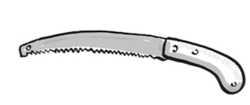**Pruning saw**

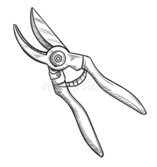**Secateurs**

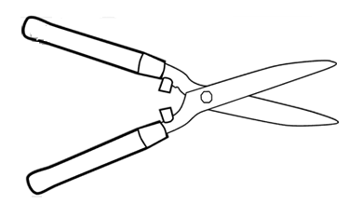**Shears**

**Qn. Give examples of crops that can be pruned.**

* Bananas
* Avocado
* Jackfruit
* Oranges
* Coffee
* Mangoes

**Qn. Identify the advantages of pruning.**

* Pruning reduces the weight of a plant.
* Pruning reduces the rate of transpiration.
* Pruning makes harvesting easy.
* Pruning makes spraying easy.
* Pruning reduces hiding places for pests.
* Pruning controls easy spread of pests and diseases among crops.
* Pruning leads to high yields.
* Pruning prevents overcrowding of crops in the garden.

**Note:**

* Pruning is mainly done in the dry season.

**Qn. Why is pruning always done in the dry season?**

* To allow easy recovery of plant at the beginning of the rainy season.

1. **Thinning**

* Thinning is the removal of excess or poorly growing seedlings from the nursery bed or garden.

**Qn. Give the advantages of thinning**

* Thinning makes harvesting easy.
* Thinning makes spraying easy.
* Thinning makes weeding easy.
* Thinning reduces the hiding places for pests.
* Thinning leads to high yields.
* Thinning reduces competition for sunlight among plants.
* Thinning reduces competition for soil nutrients among plants.
* Thinning regulates crop population in the garden.

1. **Crop spacing**

**Qn. What is crop spacing?**

* Crop spacing is the planting of crops leaving space among individual crops.

**Qn. State the advantages of crops spacing**

* Crop spacing makes weeding easy.
* Crop spacing makes spraying easy.
* Crop spacing reduces the hiding places for pests.
* Crop spacing reduces competition for sunlight among crops.

1. **Weeding**

* Weeding is the removal of unwanted plants from the garden.

**What are weeds?**

* Weeds are unwanted plants in the garden.

**Qn. Mention the common examples of weeds.**

* Black jack
* Spear grass
* Couch grass
* Elephant grass
* Wandering jew

**Qn. Give the advantages / uses of weeds.**

* Some weeds are used as mulches in the garden.
* Some weeds are used to thatch houses.
* Some weeds are used as herbal medicine.
* Some weeds are used as pasture for animals.

**Qn. State the dangers / disadvantages of weeds in the garden.**

* Weeds hide pests.
* Weeds compete with plants for sunlight.
* Weeds make harvesting difficult.
* Weeds compete with plants for soil nutrients.
* Weeds make spraying difficult.
* Weeds lead to poor yields.

**Qn. State the advantages of weeding.**

* Weeding reduces hiding places for pests.
* Weeding reduces competition for soil nutrients.
* Weeding makes spraying easy.
* Weeding leads to high yields.
* Weeding makes harvesting easy.
* Weeding reduces competition for sunlight.

**Qn. Give the different ways of controlling weeds.**

* By spraying using herbicides.
* By uprooting using hands.
* By digging using a hoe.
* By mulching the garden.

1. **Plant training**

**Qn. What is plant training?**

* Plant training is a way a plant is made to grow in a certain direction and shape.

**Qn. Write down three methods / ways of plants training.**

* Staking
* Trellising
* Propping

1. **Staking**

**Qn. What is staking?**

* Staking is the giving of support to a plant with a weak stem using a strong stick, stake or peg.

**Qn. Mention the common examples of plants that can be staked.**

* Vanilla
* Tomatoes
* Peas
* Some beans
* White yams

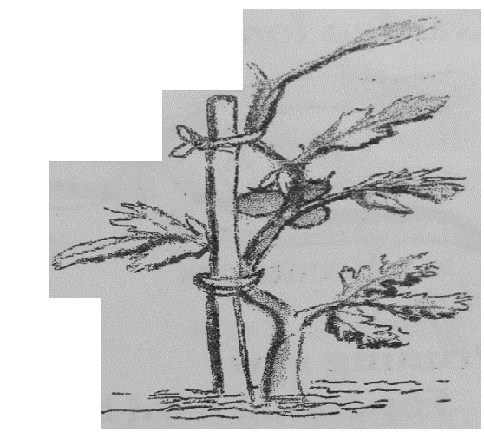**A diagram showing staking in tomatoes.**

**ii) Trellising**

**Qn. What is trellising?**

* Trellising is the providing of support to plants with weak stems using sisal strings or wires held between poles.

**Qn. Name any one crop that can be trellised.**

* Passion fruits.

**A diagram showing trellising in a passion fruit.**

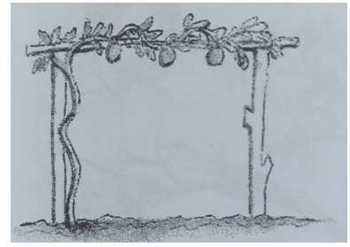

**iii) Propping**

**Qn. What is propping?**

* Propping is the providing of support to plants with heavy bunches or branches using forked stake or pole.

**Qn. Mention the examples of plants that can be propped.**

* Bananas
* Coffee
* Guavas
* Avocado

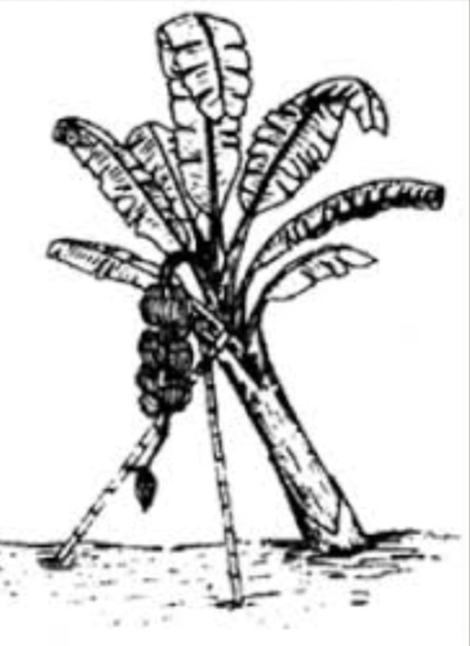**A diagram showing propping in bananas**

**Qn. State the advantages of plants training.**

* Plant training makes harvesting easy.
* Plant training makes spraying easy.
* Plant training makes pruning easy.
* Plant training improves crop yields.
* Plant training prevents fruits of weak plants from rotting.
* Plant training enables all parts of a plant to receive sunlight.
* Plant training prevents plants with heavy bunches from breaking or falling.

**Crop pests and diseases**

1. **Crop pests**

**Qn. What are crop pests?**

* Crop pests are organisms that destroy farmers’ crops.

**Qn. What are vermins?**

* Vermins are animals that destroy farmers’ crops.

**Qn. Give examples of vermins.**

* Monkeys
* Rats
* Squirrels

**Example of common crop pests and the crops they attack.**

|  |  |  |  |
| --- | --- | --- | --- |
| **No** | **Crops** | **Pests** | **Effects of pest damage** |
| 1 | Cassava | White fly | * Leaves becomes yellow * Leaves curl and lose shape. |
| 2 | Maize | * Maize stalk borers * Army worms * Monkeys * Squirrels * Maize weevils * Rats * Termites * Weaver birbs | * Holes in leaves * Holes in the stalks * Holes in the fruits * Rotting of some parts |
| 3 | Bananas | * Monkeys * Banana thrips * Termites * Banana weevils | * Rotting of the fruits * Holes in the leaves * Holes in the stem and fruit. * Thrips cause prematurity of the fruit. |
| 4 | Mangoes | * Monkeys * Caterpillars * False codling * Month. | * Rotting of the fruit * Holes in the fruits * Black spots develop on the fruit. |
| 5. | Tomatoes | * Caterpillars * Eel worms * Monkeys | * Rotting of the fruits * Holes in the fruits * Dark spots develop on their fruits and leaves. |
| **No** | **Crops** | **Pests** | **Effects of pest damage** |
| 6 | Sugarcane | * Termites * Monkey * White grub * White scale | * Holes in the stem * Drying of the stem * Holes in the plant * Falling of the plant |
| 7 | Sweet potatoes | * Rats * Sweet potato weevils * Squirrels * Millipedes * Mole rats * Monkeys * Caterpillars * Nematodes | * Holes in the roots * Rotting of the roots * Holes in the leaves * Yellowing of leaves |
| 8 | Coffee | * Leaf miner * Mealy burgs * Coffee berry borers * Aphids | * Holes in the berry * Premature drying of the berry. * Rotting of the berry * Yellowing of leaves. |
| 9 | Oranges | * Monkeys * Aphids * False codling * Caterpillars * Black fly | * Rotting of the fruits * Dark spots develop in the fruit. * Dark spots develop in the leaves. * Holes in the leaves * Holes in the fruits. |
| 10 | Pineapples | * Leaf miner * Mealy burgs | * Hole in the leaves * Yellowing of leaves * Rotting of the fruit. * The leaf miner reduces * The ability of the pineapple to make sugar. |
| 11 | Cotton | * Cotton stainer * American ball worm * False codling month. * Aphids | * Black spots on the cotton seeds. * Yellowing of leaves * Holes in the cottons seeds. |
| 12 | Beans | * Thrips * Bean weevils * Cut worms * Aphids * Bean fly * American ball worm | * Yellowing of leaves * Holes in the seeds * Holes in the leaves |

**Examples of crop diseases and the crops attacked.**

|  |  |  |  |  |
| --- | --- | --- | --- | --- |
| **No.** | **Crop** | **Diseases and cause** | **Sign of disease damage** | **Prevention and control** |
| 1 | Banana | * Panama (fungus) | * Wilting of the crop | * Spraying using fungicides. * Planting using health suckers * Burn all affected plants. |
|  | * Cigar end rot (Bacteria) | * Dark spots on leaves * Rotting of the fruits. * Tips of the affected plant look like a garish. | * Burn all infected crops. |
|  |  | * Banana bacterial wilt   (Bacteria) | * The banana stem rots and falls down. * Rotting of the banana plant. | * Planting healthy suckers. |
| 2 | Mangoes | * Powdery mildew (Fungi) | * Powdery patches appear on leaves. | * Spray using fungicides. |
| 3 | Tomatoes | * Tomato mosaic (virus) | * Leaves develop yellow and white patches. | * Spray using pesticides to kill white flies. |
|  |  | * Tomato blight (Bacteria) | * Leaves turn yellow | * Spray with pesticides |
| 4 | Cassava | * Cassava mosaic (virus) | * Leaves turn yellow * Leaves develop white spots | * Spraying with pesticides to kill white flies. |
|  | Cassava | * Brown streak (virus) | * Leaves turn yellow | * Spray using pesticides * Practice crop rotation |
| 5 | Potatoes | * Potato blight (Bacteria) | * Leaves turn yellow | * Spraying with pesticides. |
|  |  | * Potato wilt (Bacteria) | * Leaves are eaten up. | * Spraying using pesticides |
|  |  | * Potato mosaic (Virus) | * Leaves develop white spots |  |
| **No.** | **Crop** | **Diseases and cause** | **Sign of disease damage** | **Prevention and control** |
| 6 | Sugarcanes | * Sugar cane smut (virus) | * Holes on the sugarcane stem. | * Spraying using pesticides. |
|  |  | * Yellow wilt (Bacteria) | * Rotting of the stems | * Spraying using pesticides |
| 7 | Maize | * Maize streak (virus) | * Leaves turn yellow | * Spray using pesticides. |
|  |  | * White leaf blight (bacteria) | * Wilting of the plants. | * Spray using pesticides. |
|  |  | * Leaf rust (Fungus) | * Rotting of the fruit | * Spray using fungicides. |
| 8 | Coffee | * Coffee berry disease (Fungus) | * Yellowing of leaves |  |
|  |  | * Leaf rust (Fungus) | * Holes on the berry. * Rotting of the berry |  |
| 9. | Oranges | * Stem pitting (Fungus) | * The stem dries up with green powder on it. | * Spray using fungicides |
|  |  | * Green moulds (Fungus) | * Rotting of the fruits. | * Spray using fungicides. |

**Qn. State the general signs of pest and disease damage in plants.**

* Yellowing of the leaves.
* Wilting of the plant
* Black spots on the leaves
* Rotting of the plant parts e.g. roots, stems, leaves, fruits.
* Curling of leaves.
* Dark spots on leaves
* Dry patches on the plant
* Holes in seeds

**Qn. Write down the characteristic of root crop pests.**

* Root crop pests have sharp claws.
* Root crop pests have sharp incisor teeth.
* Root crop pests have strong mouth part.
* Root crops have fingers for uprooting root crops.

**Qn. Identify the effects of pests and diseases on crops**

* Pests and diseases lead to poor yields.
* Pests and diseases lead to poor growth of crops.
* Pests and diseases lead to wilting of crops.
* Pests and diseases lower the quality of crops.
* Pests spread diseases to crops.
* Pests and diseases lower the quality ofcrops.

**Qn. State the different ways of controlling crop pests and diseases.**

* Practicing crop rotation
* Spraying using pesticides
* Regular weeding
* Fencing the garden
* Spraying using pesticides
* Using traps
* Planting healthy suckers
* Using scare crows
* Keeping cats to eat rats
* Burning infected crops.
* Early planting
* Plant disease resistant crops.
* Dusting crop stores with pesticides.
* Using lady birds to feed on some insect pests
* Cutting diseased crops
* Planting healthy stem cuttings.

**Qn. Give the mechanical methods of controlling pests.**

* Setting traps
* Fencing gardens
* Regular weeding
* Uprooting diseased crops

**Qn. Identify the biological methods of controlling pests.**

* Rearing cats to feed on rats.
* Rearing lay birds to feed on insect pests.

**Qn. State the cultural methods of controlling pests in the garden.**

* Crop rotation
* Planting disease free stem cuttings
* Planting disease free suckers
* Planting resistant crops.

**Qn. Write down the chemical methods of controlling pests.**

* Spraying with pesticides.

**Qn. Give the factors that affect better yields of crops and trees.**

* Pests and diseases
* Poor farming methods.
* Prolonged drought
* Floods
* Infertile soils
* Poor seed selection
* Early harvesting
* Irregular weeding

**Proper methods of harvesting trees / wood**

Qn. Write down the three methods of harvesting wood.

* Coppicing
* Lopping
* Pollarding

**a) Coppicing**

**Qn. What is coppicing?**

* Coppicing is the method of harvesting wood where a tree is cut and a trunk is left some few centimetres from the ground.

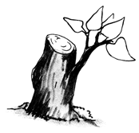**An illustration showing coppicing meet.**

1. **Lopping**

**Qn. What is lopping?**

* Lopping is a method of harvesting wood where the side branches of a tree are cut off leaving the terminal bud to grow.

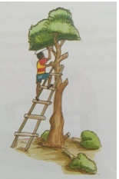**An illustration**

1. **Pollarding**

**Qn. What is pollarding?**

* Pollarding is a method of harvesting wood where the top part of a tree is cut off leaving the lower side branches to grow.

**An illustration**

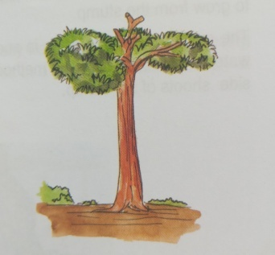

**Qn. Write down ways of preparing wood for different purposes.**

* Wood for firewood is prepared by splitting, drying and keeping it in a shade.
* Wood for electric poles should be treated using chemicals called wood preservatives.
* Wood for timber should be cut into different pieces and kept in a shade.

**Qn. State the importance of splitting wood for firewood.**

* To make it easy for water in the wood to evaporate.

**Qn. Give a reason why wood for electric poles should be treated using wood preservatives.**

* To prevent the poles from being destroyed by termites.

**Qn. Give two examples of substances that can be used as wood preservatives.**

* Used engine oil
* Strong salt solution

**Qn. What term refers to the keeping of timber in a shade to allow it dry at a slow rate?**

* Seasoning

**Qn. State the advantage of seasoning.**

* Seasoning prevents warping / twisting of wood.
* Seasoning prevents wood from splitting.

**Wood for charcoal**

**Qn. State the steps followed when preparing charcoal.**

* Cutting down trees.
* Cutting the wood into short pieces.
* Stacking the pieces of wood into a heap.
* Covering the heap of wood with soil and lit it to burn in limited supply of oxygen.

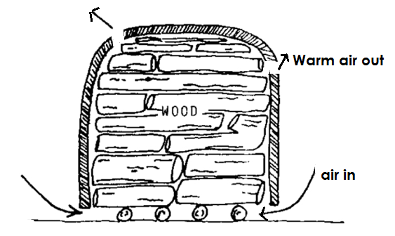**Illustration**

**Qn. Why is the heap of wood covered with soil?**

* To limit the supply of oxygen.

**Qn. How is charcoal obtained?**

* By burning wood in limited supply of oxygen.

**Qn. What happens if wood is burnt in plenty supply of oxygen?**

* Wood burns into ash.

**Qn. How does the cutting of wood for charcoal affect the environment?**

* It leads to environmental degradation.
* It leads to global warming.
* It leads to low rain formation.

**A woodlot project**

**Qn. What is a woodlot?**

* A woodlot is a small garden where trees are planted for a small scale production.

**Qn. State the factors to consider when setting up a woodlot.**

* The place should be near a school or home.
* The place should be well drained.
* The place should have fertile soils.

**Qn. Identify the importance of a woodlot.**

* Trees in a woodlot provide firewood.
* Trees in a woodlot provide shade.
* Trees in a woodlot provide fruits to people.
* Trees in a woodlot help to control soil erosion.
* Trees in a woodlot are a source of income to people.

**Science clubs in school**

**Qn. What are science clubs?**

* Science clubs are clubs t hat teach learners production skills.

**Qn. Give the examples of science club in a school.**

* Red cross club
* Wildlife club
* Young farmer’s club
* Exhibition club

**Young farmers club**

**Qn. What is a young farmer’s club?**

* A young farmer’s club is a club that teaches its members practical skills of rearing animals and growing crops.

**Qn. Write down the different activities done by the young farmers club.**

* The young farmer’s club teaches children how to plant and care for crops.
* The young farmer’s club teaches children modern methods of farming.
* The young farmer’s club teaches children how to care for animals.
* The young farmer’s club organizes field trips to agricultural centres.
* The young farmer’s club organizes science exhibition at school.
* The young farmer’s club encourages conservation of the environment.

**Record keeping on a farm**

**Qn. What are farm records?**

* Farm records are written information on various activities that take place on a farm.

**Qn. Give the different example of farm records**

* Health records
* Production records
* Feeding records
* Breeding records
* Field records
* Marketing records
* Income and expenditure records
* Inventory records

**Qn. State the importance of keeping farm records.**

* Farm records enable farmers to be taxed fairly.
* Farm records enable farmers to plan for the farm.
* Farm records help farmers to know the progress of the farm.
* Farm records help farmers to know the birth and death rates on a farm.
* Farm records help farmers to know the profit or loss on the farm.
* Farm records help farmers to know when important activities should take place on a farm.
* Farm records help farmers to get loans.

**TOPIC 8: POPULATION AND HEALTH**

**Qn. What is population?**

* Population is the total number of organisms living in an area.

**Qn. What is health?**

* Health is the state of being physically, mentally, socially and spiritually well.

**Qn. What is a community?**

* A community is a group of people living or working together.

**Qn. Write down the examples / types of communities.**

* School community
* Church community
* Market community
* Prison community
* Home community
* Hospital community
* Convent community

**Social problems**

* Social problems are challenges that affect the social life of people in an area.

**Qn. Write down the common examples of health and social problems in our communities.**

* Diseases (common sicknesses)
* Smoking
* Alcoholism
* Drug abuse
* Poor sanitation standards
* Malnutrition
* Living in poorly ventilated houses
* Anti socialbehaviours

**Diseases or common sicknesses**

**Qn. Write down the types of diseases.**

* Communicable diseases / infectious diseases.
* Non communicable diseases / non-infectious diseases.

**Communicable diseases**

**Qn. What are communicable diseases?**

* Communicable diseases are diseases caused by germs and can be spread from an infected person to a healthy one.

**Qn. Give some examples of communicable diseases.**

* AIDS
* Gonorrhea
* Tuberculosis
* Diphtheria
* Whooping cough
* Syphilis

**Non communicable diseases**

**Qn. What are non communicable diseases?**

* Non communicable diseases are diseases that are not caused by germs and cannot spread from one infected person to a healthy one.

**Qn. Write down some examples of non communicable diseases.**

* Kwashiorkor
* Beriberi
* Pellagra
* Lung cancer
* Emphysema
* Scurvy

**Qn. Write down the different causes of sickness in our homes and communities.**

* Poor feeding
* Poor sanitation
* Poor personal hygiene
* Poor water supply
* Alcoholism
* Smoking
* Lack of body / physical exercises
* Lack of enough rest and sleep.
* Living in poorly ventilated houses
* Poor healthy life styles.

**Qn. Give the different ways of controlling sickness in homes and communities.**

* Feeding on a balanced diet.
* Having regular physical exercises
* Living in well ventilated houses.
* Promoting proper personal hygiene.
* Promoting proper sanitation
* Having enough rest and sleep.
* Covering left over food.
* Having latrines for proper disposal of faeces and urine.

**Population and heath concerns**

**Qn. What are health concerns?**

* Health concerns are health problems affecting people in the community and need immediate solution.

**OR**

* Health concerns are things in which individuals, families and communities should be concerned with in order to live healthy.

**Qn. Write down the examples of population and health concerns.**

* Poor sanitation
* Poor water supply / inadequate water supply.
* Anti-social behaviours
* Inadequate food supply.

**Poor sanitation**

**Qn. What is poor sanitation?**

* Poor sanitation is the dirtiness of a place where we live or stay.

**Qn. State the different causes of poor sanitation.**

* Poor disposal or rubbish.
* Poor disposal of faeces
* Poor ventilation of houses
* Overcrowding in an area.
* Blockage of sewerage systems.
* Sharing houses with animals
* Failure to slash bushes around a home.

**Qn. Write the ways of addressing poor sanitation / how to maintain sanitation.**

* Sweeping the compound.
* Draining away stagnant water.
* Slashing tall grass around the compound.
* Burning rubbish in rubbish pits.
* Proper disposal of feaces and urine.
* Living in well ventilated houses.
* Avoid sharing houses with animals.
* Repairing the damaged sewerage systems.

**Anti – social behaviours**

* Anti – social behaviours are habits that are not allowed in society.

**OR**

* Anti-social behaviours are habits that are not accepted in society.

**Qn. Write down the examples of anti-social behaviours.**

* Truancy
* Arson
* Violence
* Wandering
* Alcoholism
* Bullying
* Teasing
* Fighting
* Abortion
* Prostitution
* Defilement
* Murder
* Pape
* Smoking
* Drug abuse
* Stealing
* Sexual deviations

**Qn. State the causes of anti- behaviours.**

* Poor home atmosphere.
* Influence from bad peer groups.
* Living in broken homes / unstable families.
* Pampering of children.
* Unfulfilled expectations.
* Over strictness by teachers or parents.
* Poor family background.
* Failure to enforce rules in a family or community.
* Uncensored exposure to music, videos, films and dances.

**Qn. Identify the effects of anti-social behanviours.**

* Anti-social behaviours may lead to imprisonment.
* Anti-social behaviours may lead to shame to the family e.g. stealing, defilement.
* Anti-social behaviours may lead to school drop out.
* Anti-social behaviours may lead to death e.g. abortion.
* Anti-social behavioursmay lead to destruction of property e.g. arson.
* Anti-social behaviours may lead to unwanted pregnancies e.g rape, defilement.
* Anti-social behaviours may lead to lung cancer e.g. smoking.
* Anti-social behaviours may become criminals.
* Many individuals may be hurt and feel a lot of pain.

**Qn. State the different ways of controlling / avoiding anti-social behaviours.**

* Joining good social groups during free time.
* Avoid bad peer groups.
* All parents should create stable families.
* Providing counseling services to children.
* All children should be given equal treatment.
* Avoid setting high standards of behaviours.
* Giving appropriate punishments to wrong doers.
* Keeping delinquents in reformatory schools.

**Qn. Define the following terms:-**

* Arson is intended act / crime of setting fire on buildings and people’s property.

**Truancy (school refusal)**

* Truancy is the practice of staying away from school without permission.

**Causes of truancy**

* Learning difficulties in subjects.
* Overcrowding in classes.
* Boredom in classes.
* Bullying at school.
* Unfair treatment at school

**Violence**

* Violence is a state in which a person is aggressive and has destructive behaviours.

**Types of violence**

* Sadism
* Masochism

**Qn. What is sadism?**

* Sadism is an extreme aggressive motive to harm others.

**Qn. What is masochism?**

* Masochism is an extreme aggressive motive to harm oneself.

**A juvenile**

* A juvenile is a young person below 18 years of age.

**Juvenile delinquency**

**Qn. What is juvenile delinquency?**

* Juvenile delinquency is an anti-social act done by a young person and is punished by law.

**Delinquent / Juvenile delinquent**

**Qn. Who is a delinquent / juvenile delinquent?**

* A delinquent is a young person who commits a crime that is against the law.

**Criminal**

* A criminal is an adult person who commits any anti-social behavior / act against the law of the country.

**Sexual deviations**

**Qn. What are sexual deviations?**

* Sexual deviations are abnormal sexual practices done by people in the community.

**Qn. Write down the examples of sexual deviations.**

* Homosexuality
* Oral sex
* Bestiality
* Masturbation
* Lesbianism
* Necrophilia
* Incest
* Fellatio

**Qn. Give the meaning of the following terms:-**

**Homosexuality**

* Homosexuality is the sexual activity between two males i.e a man and a man.

**Lesbianism**

* Lesbianism is the sexual activity between two females.

**Oral sex**

* Oral sex is stimulation of one’s sexual organism using the mouth.

**Necrophilia**

* Necrophilia is the sexual attraction to a dead body.

**Bestiality**

* Bestiality is the sexual activity between a human being and an animal.

**Masturbation**

* Masturbation is the stimulation of one’s sexual organs by oneself.

**Incest**

* Incest is the sexual activity between two close relatives e.g brother and sister, father and daughter etc.

**Qn. State the different causes of sexual deviations**

* Bad peer groups
* Exposure to pornography
* Drug abuse
* Foreign influence
* Living in broken homes
* Too much desire for money
* Lack of satisfaction during sexual intercourse.
* Poor family background.

**Qn. Give the different ways of preventing sexual deviation**

* Avoid bad peer groups
* Avoid drug abuse
* Avoid watching pornography
* Join good social groups like sports clubs.
* Get activities to occupy you during your free time.

**Poor water supply**

**Qn. What is poor water supply?**

* Poor water supply is a situation in which a family / community uses little or dirty water.

OR

* Poor water supply is a situation in which a community does not have enough water to use.

**Note:**

* Dirty / contaminated water results into water associated diseases.

**Qn. Write down the groups of water associated diseases.**

* Water borne diseases
* Water cleaned diseases
* Water contact diseases
* Water habitat vector diseases

**Qn. What are water borne diseases?**

* Water borne diseases are diseases we get through drinking contaminated water.

**Qn. Mention the examples of water borne diseases.**

* Polio
* Cholera
* Diarrhoea
* Dysentery
* Typhoid
* Hepatitis B
* Bilharziasis

**Qn. State the different ways of controlling water borne diseases.**

* By boiling drinking water.
* By chlorination.

**Qn. What are water cleaned diseases?**

* Water cleaned diseases are diseases we get when we do not have enough water to use for cleaning the body.

**Qn. Mention the examples of water cleaned diseases**

* Scabies
* Trachoma
* Impetigo
* Conjunctivitis

**Qn. What are water contact diseases?**

* Water contact diseases are diseases we get when our bodies get into contact with contaminated water.

**Qn. Mention any two examples of water contact diseases.**

* Bilharziasis
* Swimmer’s itch

**Qn. What are water habitat vector diseases?**

* Water habitat vector diseases are diseases that are spread by vectors that spend part of their life cycle in water.

**Qn. Write the common examples of water habitat vector diseases.**

* Malaria
* Elephantiasis
* Yellow fever
* Bilharziasis
* Dengue fever
* River blindness

**Qn. Mention the ways of making water safe for drinking.**

* Boiling water
* Treating water using chemicals e.g chlorine, calcium, chloride, potassium, permanganate.

**Qn. Mention the process of making water safe by National Water Sewerage Co-operation (NWSC)**

* Sedimentation
* Filtration
* Coagulation
* Chlorination

**Qn. Identify the different ways how water can get contaminated / polluted.**

* Dumping garbage into water sources
* Bathing in water sources
* Defecating in the water sources.
* Washing clothes in water sources.
* Urinating in water sources
* Discharging industrial wastes into water sources.

**Qn. State the different ways of addressing / solving poor water supply.**

* By constructing boreholes.
* By constructing valley dams.
* By treating water with chemicals e.g. chlorine
* By fencing and protecting water sources.
* By cleaning bushes around water sources.

**Inadequate food supply**

**Qn. What is inadequate food supply?**

* Inadequate food supply is a situation in which a family or community does not have enough food.

**Qn. Give the different causes of inadequate food supply.**

* Drought
* Pests and diseases
* Floods
* Poor faming methods
* Landslides
* Laziness
* Volcanic eruption
* Low levels of technology.
* Poor attitude towards farming.
* Wars
* High population increase
* Poor storage of harvested crops
* Poverty
* Shortage of land

**Food security**

**Qn. What is food security?**

* Food security is a situation when a family or community has enough food for future use.

**Qn. State the ways of addressing inadequate food supply (maintaining food security).**

* Teaching people good farming methods.
* Storing harvested crops in granaries, silos etc
* Providing good quality seeds to farmers.
* Applying fertilizers to improve soil fertility.
* Spraying crops using pesticides.
* Constructing valley dams to trap water for irrigation during drought.
* Planting drought resistant crops.
* Terracing hilly areas to control soil erosion.
* Teaching people the importance of storing food.

**Note:**

* Inadequate food supply may result into malnutrition.

**Qn. What is malnutrition?**

* Malnutrition is the condition when the body does not receive enough essential food values.

**Qn. State the effects or signs of malnutrition.**

* Poor spirit of doing work.
* Constant tiredness.
* Low concentration at work.
* Low interest in work.
* Malnutrition leads to deficiency diseases.

**Activities to address health concerns**

* Caring for our homes
* Carrying out health surveys
* Carrying out health education
* Carrying out primary Health Care(P.H.C)

**Caring for our homes**

**Qn. State the different ways of caring for our homes.**

* Slashing tall grass around our homes.
* Sweeping the compound.
* Draining away stagnant water.
* Having latrines for proper disposal of faeces and urine.
* Having dustbins and rubbish pits for proper disposal of rubbish.
* Having a plate rack to promote proper drying of utensils.
* Mopping the houses

**Carrying out health surveys**

* A survey is when we ask people questions leading to what we want.

**Qn. What is a health survey?**

* A health survey is the gathering of information about the health of people in an area.

**OR**

* A health survey is the gathering of information about the health of people in an area.

**Note:**

* The information collected is called data.

**Qn. How is a health survey carried out?**

* By asking questions to family members about health.
* By visiting health centres to get information about people’s health.
* Through observing the health of children, youth and adults in an area.

**Qn. Give the different reasons why a health survey is carried out.**

* To know the health status of people in an area.
* To know the diseases that commonly attack people in an area.
* To know the type of food people commonly eat in an area.
* To know whether proper immunization schedule is followed.
* To know the type of houses people commonly live in.

**Qn. State the importance of health surveys to the government.**

* Health surveys enable the government to know the health status of people in an area.
* Health surveys enable the government to plan for the services needed in an area.
* Health surveys enable the government to know the immunization coverage in an area.
* Health surveys enable the government to get information about food security in an area.

**Carrying out health education**

**Qn. What is health education?**

* Health education is the type of education that involves sharing and giving information about health.

**OR**

* Health education is the type of education in which members in the community get information on how to solve their health problems.

**Qn. State the importance of health education.**

* Health education teaches people how to promote personal hygiene.
* Health education teaches people how to promote sanitation.
* Health education encourages people to feed on a balanced diet.
* Health education teaches people how to prevent common diseases.

**Qn. State the different ways of carrying out health education.**

* Through mass media e.g. radios, televisions.
* Through plays
* Through drama
* Through songs
* Through story telling
* By school children passing information to their parents and siblings.

**Carrying out primary health care (PHC)**

**Qn. What is Primary Health Care?**

* Primary Health Care is the essential health care where individuals, families and communities work together to solve their health problems.

**Qn. State the different elements of P.H.C**

* Personal hygiene
* Water and sanitation
* Immunization
* Health life styles
* Maternal and child health care.
* Food and nutrition
* Accidents and first aid
* Family planning
* Oral and dental health care.
* Health education
* Prevention and control of communicable diseases.

**Principles Of Primary Health Care (PHC)**

**Qn. What are principles of P.H.C?**

* Principles of P.H.C are basic rules or guidelines to be followed when carrying out P.H.C activities.

**OR**

* Principles of P.H.C are rules or guidelines on which P.H.C activities are based.

**Qn. Write down the different principles of P.H.C.**

* All P.H.C activities should be done according to priorities.
* All individuals, families and communities should participate in P.H.C activities.
* Total health for every individual, family and community.
* P.H.C services should be available.
* P.H.C should be acceptable.
* P.H.C services should be accessible
* P.H.C services should be affordable.

**Immunisation**

**Qn. What is Immunisation?**

* Immunisation is the introduction of vaccines into the body.

**Qn. What are vaccines?**

* Vaccines are special drugs introduced into the body to make it produce antibodies that fight against certain diseases.

**Qn. Write down the types of vaccines**

* Toxoid vaccines
* Killed vaccines
* Attenuated vaccines

**Qn. State the importance of immunisation.**

* Immunisation boosts the immunity of the body.
* Immunisation reduces the infant mortality rate.
* Immunisation protects children against immunisable diseases.

**Health lifestyles**

**Qn. What are health life styles?**

* Health life styles are habits done to prevent the risk of getting diseases.

**Qn. Mention the different examples of good health life styles.**

* Feeding on a balanced diet.
* Having regular physical exercises
* Having enough rest and sleep.
* Promoting proper sanitation.
* Promoting personal hygiene

**Qn. State the importance of having enough rest and sleep.**

* Enough rest and sleep enables the brain to rest and get refreshed.
* Enough rest and sleep enables digestion to be carried out smoothly.
* Enough rest and sleep making the healing of wounds quick.
* Enough rest and sleep enables the body to repair worm out body tissues.

**Qn. Give the different examples of poor health lifestyles**

* Smoking
* Drug abuse
* Alcoholism
* Prostitution
* Eating too much fatty foods.
* Lack of body exercises
* Poor personal hygiene

**Collecting of information / data about human population**

**Qn. Identify the kind of information collected about human population.**

* Demography
* Housing information
* Available health services

**Demography**

**Qn. What is demography?**

* Demography is the study of the changing numbers of birth, death and diseases in a community over a period of time.

**Qn. State the reasons why the government carries out demography.**

* Demography enables the government to know the services needed by people in can area.
* Demography enables the government to know the general health of people in an area.
* Demography enables the government to know the birth and death rates of people in an area.
* Demography enables the government to plan for its population.

**Housing information**

**Qn. Write down any two types of information collected in housing.**

* Types of houses people live in.
* Ventilation system of the houses.
* Number of people living in those houses.

**Qn. State the importance of housing information to the government.**

* Housing information enables the government to know the poverty line of its population.
* Housing information enables the government to know the number of people living in permanent and temporary houses.

**Available health services**

**Qn. Write down the different examples of available health services.**

* Family planning services
* Immunisation
* Control epidemic diseases
* Provision of clean water
* Ante-natal care services

**Qn. State the importance f the available health services to the government.**

* Available services enable the government to know the general health of people in an area.
* Available services enable the government to plan for health services needed in an area.

**Health clubs**

**Qn. What is a health club?**

* A health club is a club made up of members who voluntarily come together to promote community health.

**Qn. State the importance of health clubs in the community.**

* Health clubs educate the community about proper health.
* Health clubs educate the community to promote personal hygiene.
* Health clubs encourage the community to promote sanitation.
* Health clubs helps in monitoring health programmes in an area.
* Health clubs encourage the community to participate in P.H.C.

**A school health club**

**Qn. What is a school health club?**

* A school health club is a group of pupils/ students who voluntarily come together to promote health in a school.

**Qn. State the importance of a school health club.**

* A school health club organizes school health parades.
* A school health club organizes campaigns against drug abuse.
* A school health club discourages all forms of anti-social behaviours.
* A school health club organizes hand washing facilities at school.
* A school health club encourages children to promote personal hygiene.
* A school health club organizes health education seminars.

**Child to child program**

**Qn. What is child to child program?**

* Child to child is a program of activities that teaches older children to help and care for the young ones.

**Qn. Write down the activities involved in child to child program.**

* Bathing young ones.
* Helping young ones to brush teeth.
* Helping young ones to wash clothes.
* Taking young children for immunisation

**Qn. Why is child to child program important?**

* Child to child encourages sharing among children.
* Child to child encourages co-operation among children.
* Child to child helps to teach young children who have not yet gone to school.

**Marry Christmas to every one**